Assignment 3 (Acrostic Poem)

Cassandra Grohmann section 928

An acrostic poem is a type of poetry where the first, last or other letters in a line spell out a particular word or phrase. The most common and simple form of an acrostic poem is where the first letters of each line spell out the word or phrase. The word or phrase acts as the theme or message of the poem.

**Mental Health Stigma**

**M**any people suffer from mental health problems

**E**ven the people you see most

**N**ot everyone knows how to deal with it

**T**hough people have discriminating

**A**ttitudes that cause people to not get diagnosed

**L**abels cause a stigma

**H**ampers quality of life, they

**E**mbrace prejudicial attitudes

**A**ffects quality of daily living

**L**inked to lower self esteem

**T**reatments opportunities get labeled

**H**inders effective recovery

**S**ocial or self-stigma

**T**alk about breaking stigmas

**I**ncite equality between physical and mental illness

**G**et educated between mental health and mental illness

**M**ental illness is a medically diagnosed illness

**A**ffecting cognitive, affective or relational abilities

**S**how compassion for those with mental illness

Text:

Key terms:

* Mental Health: is a state of well-being in which the individual realizes his or her own abilities, can cope with the normal stresses of life, can work productively and fruitfully
* Mental Illness: is a recognized, medically diagnosable illness that results in the significant impairment of an individuals cognitive, affective or relational abilities

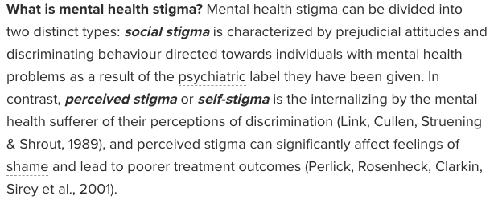

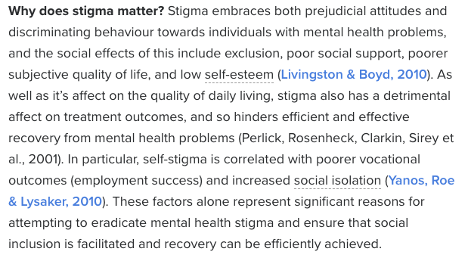

Break the stigma

* Talk openly about mental health
* Educate yourself and others
* Be conscious of language
* Encourage equality between physical and mental illness
* Show compassion for those with mental illness
* Chose empowerment over shame
* Be honest about treatment
* Do not harbor self stigma

Texts found from:

Davey C. (August 2013) Mental Health & Stigma, Mental health symptoms are still viewed as threatening an uncomfortable. *Psychology today [online].* Retrieved from:

<https://www.psychologytoday.com/ca/blog/why-we-worry/201308/mental-health-stigma>