DEPARTMENT OF STATE



INCOMING TELEGRAM

Moscow via War

Dated February 22, 1946

I apologize in advance for this burdening of telegraphic channel; but questions involved are of such urgent importance, particularly in view of recent events, that our answers to them, if they deserve attention at all, seem to me to deserve it at once.

USSR [believes it] still lives in antagonistic "capitalist encirclement" with which in the long run there can be no permanent peaceful coexistence. As stated by Stalin in 1927 to a delegation of American workers:

*"In course of further development of international revolution there will emerge two centers of world significance: a socialist center, drawing to itself the countries which tend toward socialism, and a capitalist center, drawing to itself the countries that incline toward capitalism. Battle between these two centers for command of world economy will decide fate of capitalism and of communism in entire world."*

Wherever it is considered timely and promising, efforts will be made to advance official limits of Soviet power. For the moment, these efforts are restricted to certain neighboring [nations]. Russians will participate officially in international organizations where they see opportunity of extending Soviet power or of inhibiting or diluting power of others. Moscow sees in UNO not the mechanism for a permanent and stable world, but an arena in which aims just mentioned can be favorably pursued.

In summary, we have here a political force committed fanatically to the belief that with US there can be no permanent modus vivendi that it is desirable and necessary that the internal harmony of our society be disrupted, our traditional way of life be destroyed, the international authority of our state be broken, if Soviet power is to be secure. This is admittedly not a pleasant picture. Problem of how to cope with this force undoubtedly [the] greatest task our diplomacy has ever faced and probably greatest it will ever have to face. I cannot attempt to suggest all answers here. But I would like to record my conviction that problem is within our power to solve.

1. Soviet power is highly sensitive to logic of force. For this reason, it can easily withdraw--and usually does when strong resistance is encountered at any point. Thus, if the adversary has sufficient force and makes clear his readiness to use it, he rarely has to do so.
2. Gauged against Western World as a whole, Soviets are still by far the weaker force. Thus, their success will really depend on degree of cohesion, firmness and vigor which Western World can muster. And this is factor which it is within our power to influence.
3. Success of Soviet system is not yet finally proven. We here are convinced that never [before have the] mass of Russian people been emotionally farther removed from doctrines of Communist Party than they are today.

Source: _________________________________________

Cold War

Source One

Type of Source: __________________________________

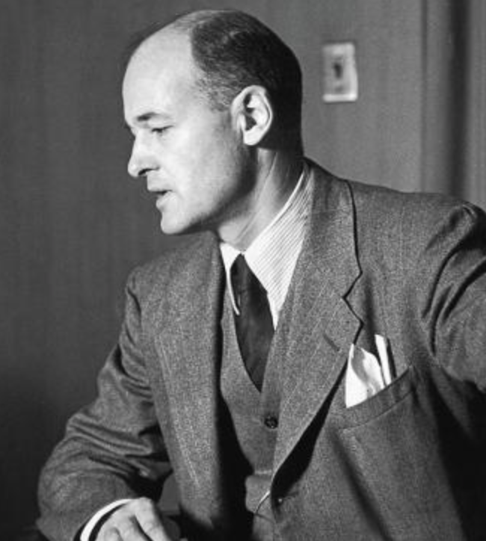

**What does Kennan think about the USSR?**

**What does Kennan think about US-USSR relations?**

Using Kennan’s final three points, predict what you think will be

the strategy of the US in dealing with the Soviets



