Physical and Health Education 10

Cassandra Grohmann

Lesson: Mental health and Illness and the difference and how stigmas influence people

Key terms:

* Mental Health: is a state of well-being in which the individual realizes his or her own abilities, can cope with the normal stresses of life, can work productively and fruitfully
* Mental Illness: is a recognized, medically diagnosable illness that results in the significant impairment of an individuals cognitive, affective or relational abilities
* Stigma

- Social and perceived stigma (found in text below)

Lesson:

* Have the students make up their own definitions of mental health and illness with a partner, then share out in the main group (1 minute)
* Go over the definitions (1 minute)
* Have the students come up with different types of mental illnesses (1 minute)
* Go over the list of mental illnesses (2 minutes)

- Mood disorders (affective disorders): Depression, mania and bipolar

- Anxiety disorders: Generalized anxiety disorder, post-traumatic stress disorder, obsessive-compulsive disorder, panic disorder

- Psychotic disorders: schizophrenia

- Concurrent disorders: addictions and substance abuse

- Personality disorders: antisocial personality disorder, obsessive-compulsive personality disorder

- \*\*Recovery means that the person has stabilized and regained their role in society, not that the individual no longer has their mental illness

- Why does stigma matter? Have the students go over why using stigmas matter, how can it influence the person? (2 minutes) (text shown below)

- How can we break the stigma? Students work in pairs for 1 minute and then as a group share, and then go over the list below

- Have students work on the 3-2-1 chart at the end of the lesson for the rest of the time remaining (seen below)

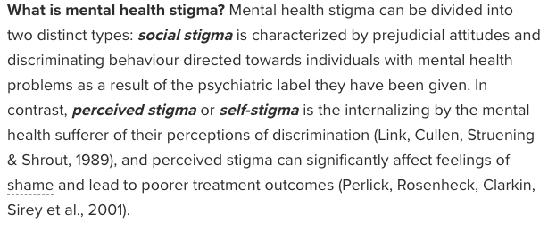

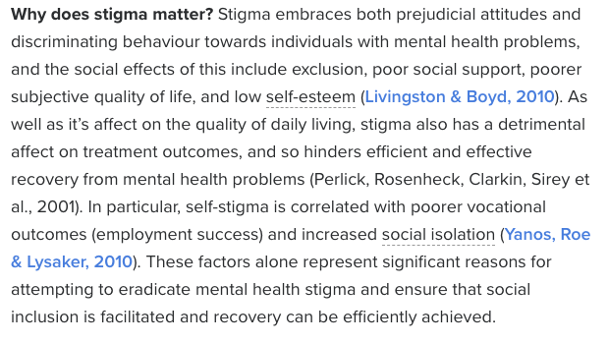

Break the stigma

* Talk openly about mental health
* Educate yourself and others
* Be conscious of language
* Encourage equality between physical and mental illness
* Show compassion for those with mental illness
* Chose empowerment over shame
* Be honest about treatment
* Do not harbor self stigma

Texts found from:

Davey C. (August 2013) Mental Health & Stigma, Mental health symptoms are still viewed as threatening an uncomfortable. *Psychology today [online].* Retrieved from:

<https://www.psychologytoday.com/ca/blog/why-we-worry/201308/mental-health-stigma>

