Recipe for Natural Selection

Natural selection is a powerful force that creates biodiversity. When a population of organisms possesses different traits and the environment favours certain traits over others, the species slowly changes over time. This is called adaptation. Natural selection is always happening in nature, since certain species will always survive and reproduce better than others.

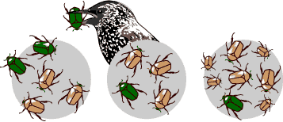

Ingredients:

1. **One population** – a group of individuals within a species who use the same habitat (eg. Beetles on Grouse Mountain)
2. **One heritable trait** – characteristics that can be passed on from parents to their offspring (eg. Colour)
3. **Two or more versions of the heritable trait** (eg. Green or brown)
4. **An environment that favours one trait over another** – conditions that allow individuals possessing one trait to survive and reproduce more than individuals with the other trait(s) (eg. Brown rocks for camouflage)

Steps:

1. Combine all ingredients.
2. The frequency of one trait will increase since individuals with the favourable trait will survive and reproduce better than individuals without it.
3. After many generations, the entire population may become a new species.

Although nature is unpredictable, over many generations we would expect the numbers of brown beetles to increase and the numbers of green beetles to decrease. This is because beetles are prey to birds and survive and reproduce at higher rates when they are able to camouflage. The end result is a species that has adaptations that allow it to thrive in it’s environment.

