**Overview of Simulation**

Students will be split into different battalions. Each battalion will be required to determine a list of necessary supplies for their invasion and construct a uniform.

**Simulation**

- students will be each given a set of cards representing the supplies necessary to support their army.

- students will march as a class into Russia (the tech wing)

- at each station, students will find a series of sources posted for them to study. Students will reflect briefly on each source.

**1. Departure**

- the battle commencing on June 24, 1812

- after sending a final demand for peace to the Tsar, the Russians refuse and we are forced to march into Russia

**2. Crossing the Nieman and the Road to Lithuania (June 24-28th)**

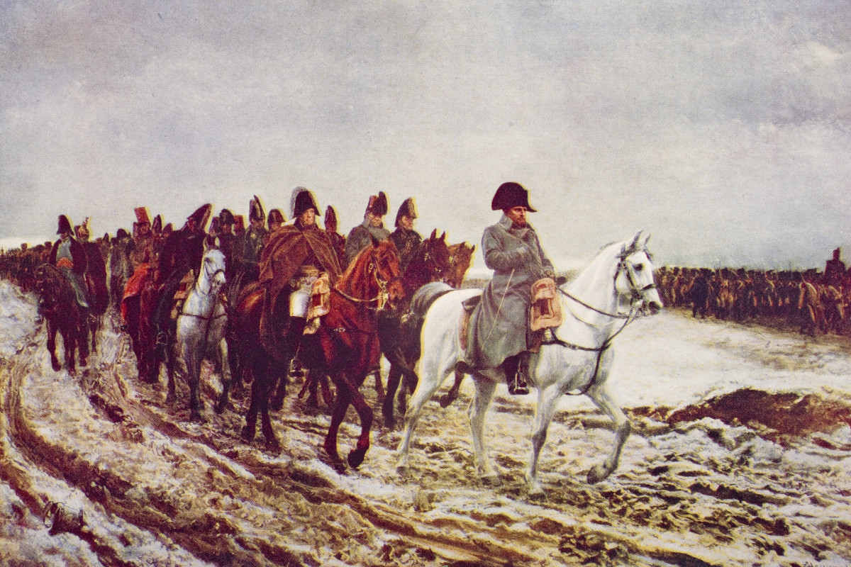

*Source 1*

June 24-28th, 1812

Upon entering Russia, we realize that the roads are practically non-existent. We are forced to continue on in an even tighter single file line/ causing great delay. Columns of soldiers are miles long. Troops at the back of the column are unable to receive food and water and many died of dehydration. Rough terrain is difficult for the horses to travel across and many die of exhaustion and injury.

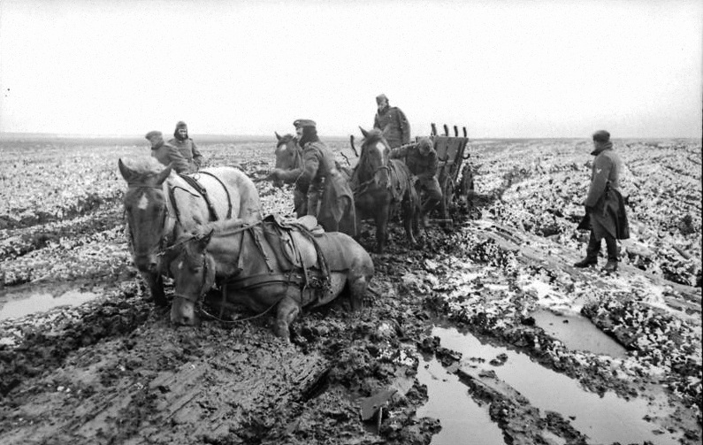

**Crossing the Nieman and the Road to Lithuania (June 24-28th)**

*Source 2*

“The thunderstorms of the 24th turned into other downpours, turning the tracks—some diarists claim there were no roads in Lithuania—into bottomless mires. Wagons sank up to their hubs; horses dropped from exhaustion; men lost their boots. Stalled wagons became obstacles that forced men around them and stopped supply wagons and artillery columns. Then came the sun which would bake the deep ruts into canyons of concrete, where horses would break their legs and wagons their wheels.”

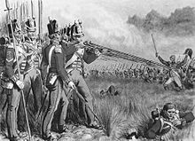

**Crossing the Nieman and the Road to Lithuania (June 24-28th)**

*Source 3*

Desertion was high among Spanish and Portuguese formations in the Grande Armee. These deserters proceeded to terrorize the population of Russia, looting whatever lay to hand. Unsure of where to go, these soldiers continued fighting a guerilla war against the civilian population. The areas in which the Grande Armee passed were devastated. A Polish officer reporting that areas around him were entirely “depopulated.”

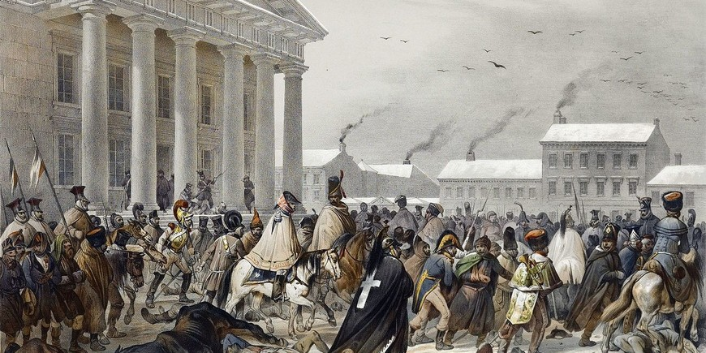

*Source 4*

Reaching Vilna JUNE 28, 1812

We have reached the city of Vilna. We experienced light fighting upon capturing of the city. We quickly claimed victory in the name of Napoleon and lost very few men capturing the city. We wait in anticipation of Russia’s surrender, but have heard no word. We must move on.

The journey has been tough. In our travels we have already lost over 10,000 horses. These horses were vital in providing supplies to our already suffering troops. Retreating Russian forces burned all of the bridges in their retreat and we must find an alternative way to Moscow.

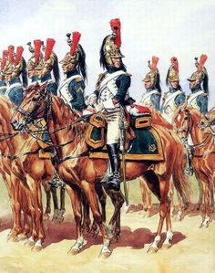

*Source 5*

The French light Cavalry was shocked to find itself outclassed by Russian counterparts so much so that Napoleon ordered that infantry be provided as back up to French light cavalry units. This affected both French reconnaissance and intelligence operations. French soldiers were now unable to ride ahead of the column to scout out Russian soldiers. This led Napoleon to desperately send cavalry in every direction is search of the Russian army, often leading to disastrous results.

**Smolensk August 18, 1812**

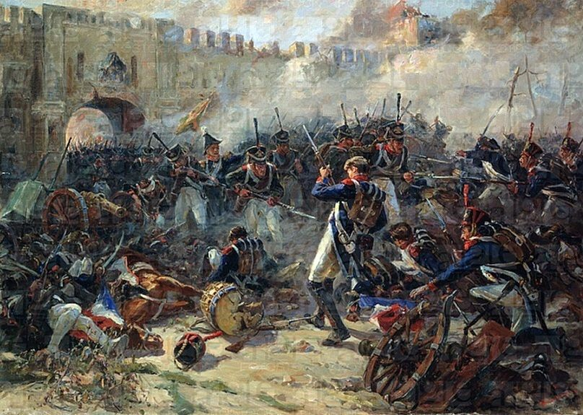

*Source 1*

Two French columns crossed the [River Dnieper](https://www.britannica.com/place/Dnieper-River) at night, and a forced march took them within 30 miles (48 km) of Smolensk before they met any resistance. The Russian proved stubborn and refused to withdraw from the city, despite being severely outnumbered.

French [artillery](https://www.britannica.com/technology/artillery) pounded much of the city to burning ruins, but the Russian infantry defended their positions with a grim tenacity that stunned the French. Having brought the enemy to battle, Napoleon intended to encircle them. However, the Russian commanders feared such a move and ordered a withdrawal during the night. The Russians retreated over the river and burned the bridges behind them. The possession of burned ruins was all that Napoleon had achieved. The Russians lot over 14,000 men.

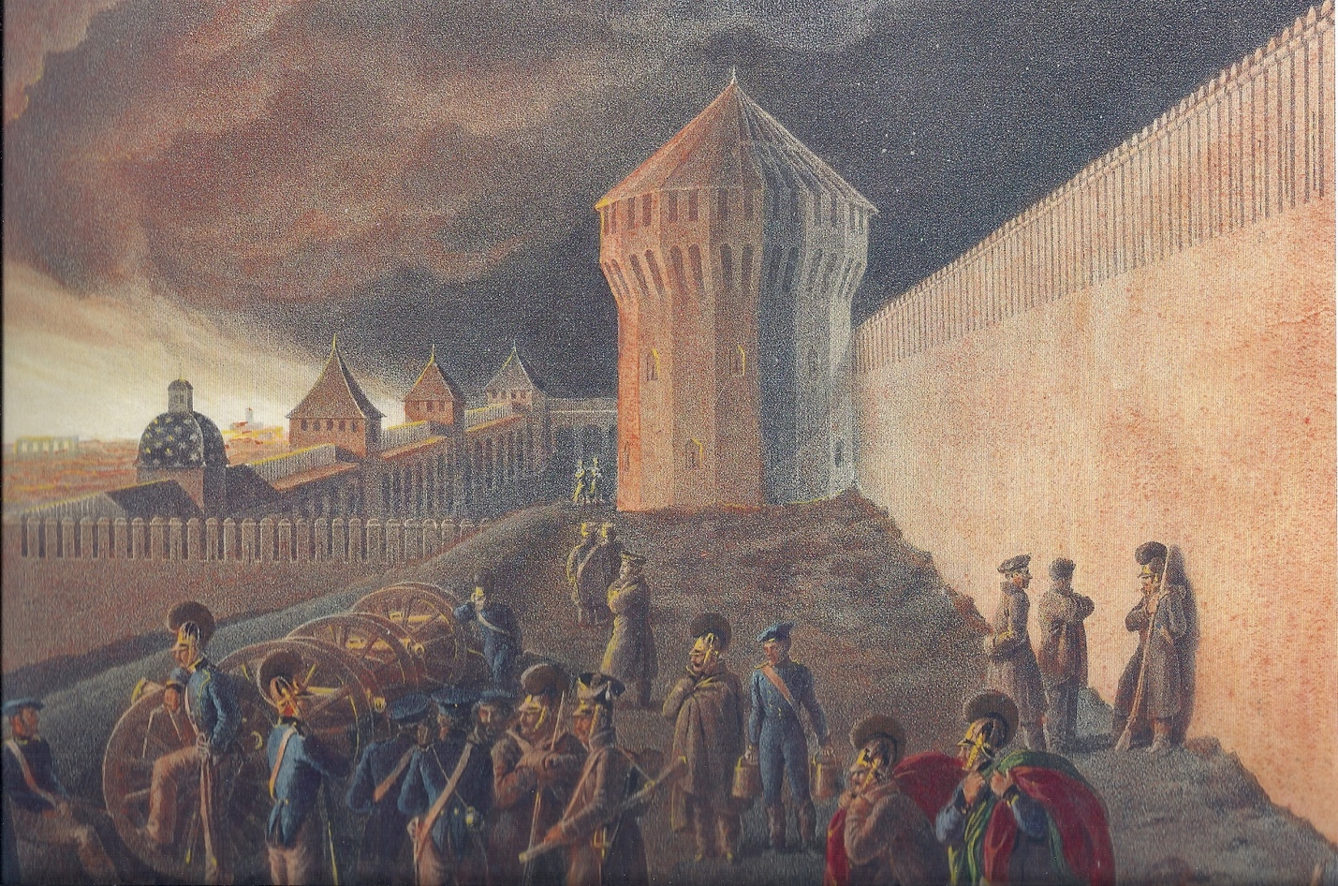

*Source 2*

Napoleon has offered our men some much needed rest. I am not sure we could have gone any longer. An extreme heat wave drove us to near complete exhaustion. Temperatures averaged 30 degrees Celsius. Lack of water and protection from the sun took the lives of thousands of horses and men. We are expecting the Russians to surrender; however, we still have heard no word. Onwards we must march to Moscow. Napoleon predicts we will take Moscow by 1813 and will be marching home by 1815. It is a three-year war he claims.

Approximately 30,000 men would die of disease and exposure in Smolensk.

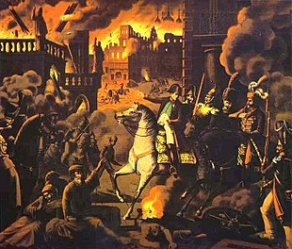

*Source 3*

August 28th

Napoleon sent columns of troops in every direction to secure food and supplies for his exhausted army. Upon arrival in Vyaz'ma, 114km from Borodino, we found that the retreating Russians were attempting to burn the city to the ground as they retreated – destroying any food, medicine, shelter, or ammunition we can use. Fortunately, we managed to put out the fire and salvage the food and medicine. Troops we be relieved to receive a much-needed meal.

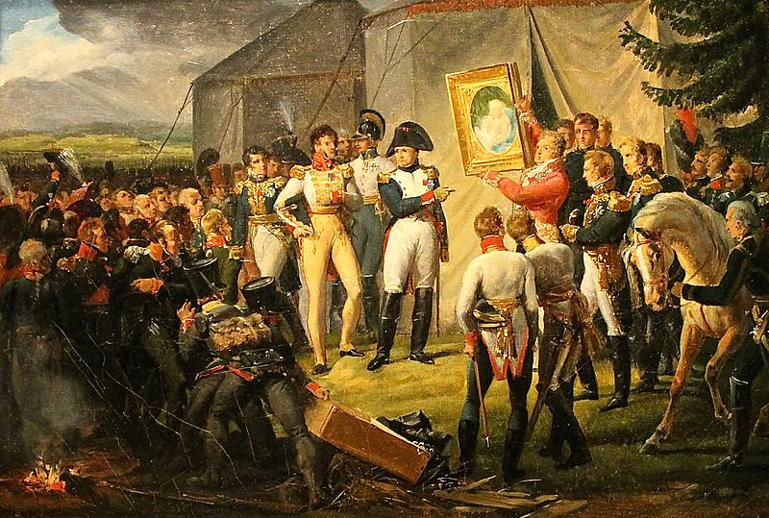

**Borodino**

*Source 1 Napoleon to his troops, September 7, 1812*

“Soldiers! Here is the battle that you have so much desired. From now on victory depends on you: it is necessary to us. It will give you abundance, good winter quarters, and a prompt return to the fatherland. Conduct yourselves as at Austerlitz, at Friedland, at Vitebsk, at Smolensk, and let the most distant posterity point with pride to your conduct on this day. Let it be said of you, 'He was in that great battle under the walls of Moscow.'”

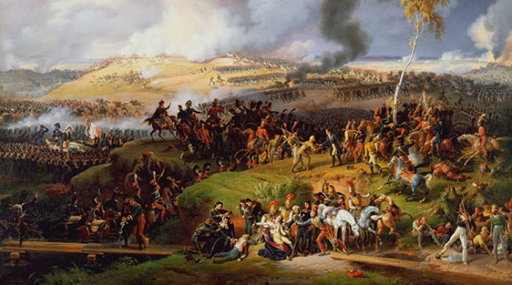

*Source 2 Secondary source describing the battle*

The massed ranks of Russian troops formed a thick curtain of troops, whilst the battlefield and troop arrangement made any military manoeuvres almost impossible. The battle has gone down in history not for its strategic brilliance but for the sheer destruction of life on both sides. After the battle, General Lariboisière estimated that the French artillery – all 587 guns – had fired about 60,000 times, with the infantry having gone through 140,000 cartridges: it is thought that the Russians fired slightly fewer cannon shots (50,000) and 20,000 fewer cartridges. For a battle that lasted about ten hours, this works out at about three cannon shots per second and more than 430 musket shots per minute (figures in Marie-Pierre Rey, *L'Effroyable Tragédie*, 2012, pp. 156-157). The Russian artillery numbered over 600 pieces, but problems in supplying enough ammunition coupled with a failure to concentrate their fire where it mattered meant that they proved less effective than the French guns.

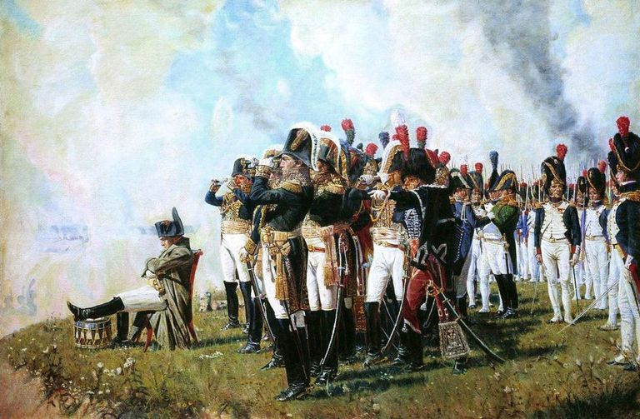

*Source 3 The End of the Battle*

Finally, **around 6pm**, the cannon fire stopped, and the two sides retired to their headquarters: Napoleon to Shevardino, Kutuzov to Moshaysk, 15km to the east. Although Napoleon anticipated picking up where he had left off the next morning, in reality the battle was over. The battle was to prove one of the bloodiest in the entire history of the Napoleonic Wars: the Russians had 45,000 dead, wounded or missing, whilst Napoleon's losses totalled between 28,000 and 35,000. Dominique Jean Larrey, chief surgeon, estimated that he had performed about two hundred amputations – most as a result of artillery fire – in the first twenty-four hours after the battle. The victory – in terms of territory won and losses inflicted – was Napoleon's. It was not to be however the decisive one he so craved: the remnants of the Russian armies retreated back towards Moscow, leading Napoleon to declare “La paix est à Moscou”.

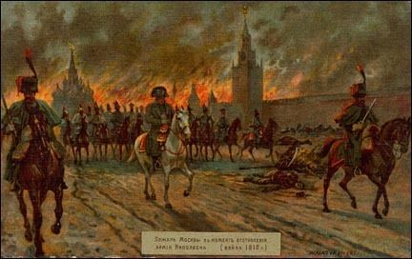

**Moscow**

Source 1, 14 September 1812

We have arrived in Moscow and are expecting the surrender of the Russian army any day now! We sense a great victory in the air. The city, however, is in complete ruins. The retreating army burned the capital to the ground and there is little food or shelter remaining. We are unable to treat our wounded, and many are dying.

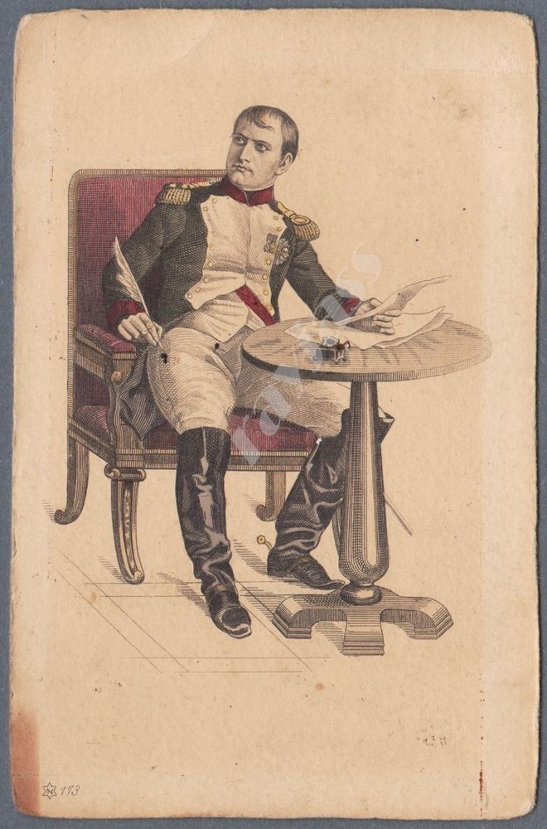

Source 2

Letter from Napoleon

On **20 September**, Napoleon wrote to Alexander:  
“The beautiful and fine city of Moscow is no more: Rostopchin has had it burnt down. Four hundred arsonists have been caught in the act; they all declared that they were lighting the fire on the order of this governor and the director of police: they have all been shot. The fire now seems to have abated. Three-quarters of the houses have been burnt, one quarter remains. […] How is it possible to destroy one of the most beautiful cities in the world and the work of centuries in the achievement of such a weak aim? […] The fire has opened the way to pillage, in which the soldiery is competing with the fire for the remains. If I once for a moment imagined that such things had been done on Your Majesty's order, I would not be writing this letter; however, I am convinced that it is impossible, given your principles, your spirit and your enlightened ideas, that you ordered such excesses, unworthy as they would be of so great a sovereign and so great a nation. […] I made war against your majesty without bitterness; one word from you, whether before or after our recent battle, would have stopped my advance and I would even have agreed to forgo the advantage of entering Moscow.”

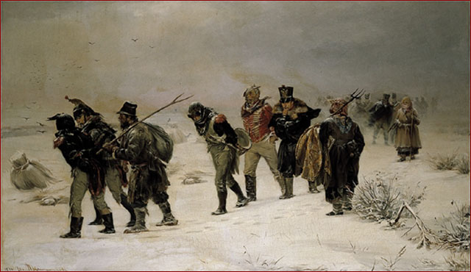

*Source 3:*

October 4, 1812

We still have heard no word from the Tsar of Russia. The weather has quickly turned for the worst and Russian winter will shortly be upon us. Little is left of the city of Moscow. The city has been burned to ashes. There is little food or supplies here. Deteriorating road conditions have made it nearly impossible for supplies to reach us in Moscow and it appears we have two choices. We must either push deeper into Russia and try to brave the cold in seek of a quick victory and more food or retreat south back to the Ukraine where we have food and shelter waiting for us and lose all we have gained.

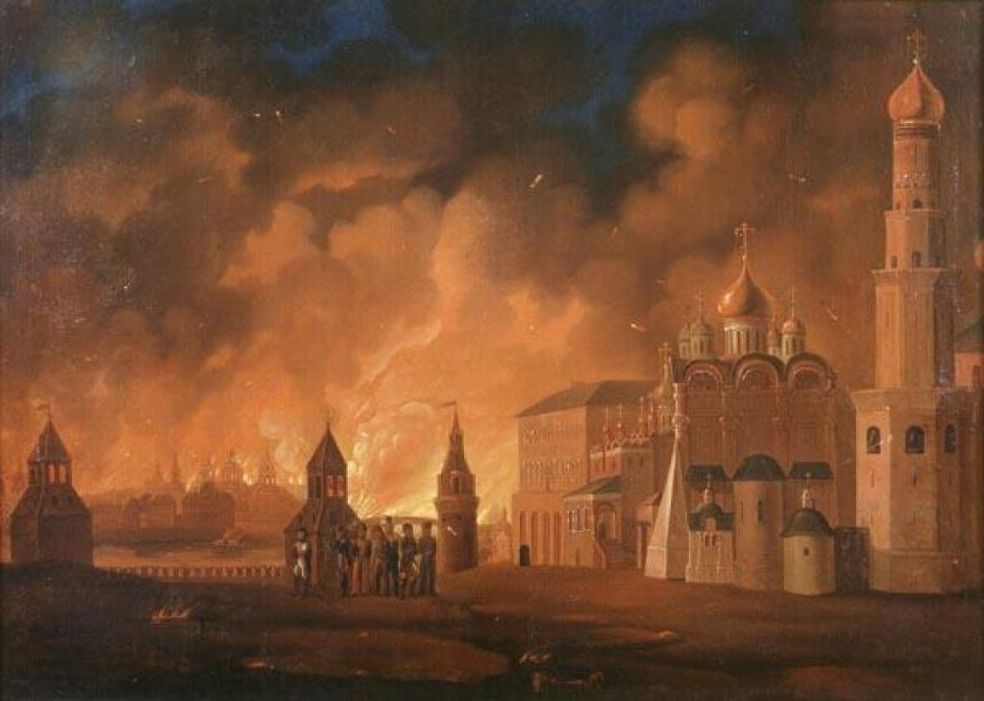

*Source 4:*

Secondary Source

After entering Moscow, the *Grande Armée,* unhappy with military conditions and no sign of victory, began looting what little remained within the city. Already the same evening, the first [fires](http://www.newworldencyclopedia.org/entry/Fire) began to break out, spreading and re-emerging over the next few days.

Two thirds of Moscow was comprised of buildings made of wood. It burnt down almost completely (it was estimated that four-fifths of the city was destroyed), effectively depriving the French of shelter in the city. French historians assume that the fires were due to Russian [sabotage](http://www.newworldencyclopedia.org/entry/Sabotage).

[Leo Tolstoy](http://www.newworldencyclopedia.org/entry/Leo_Tolstoy), in *War and Peace,* claimed that the fire was not deliberately set, either by the [Russians](http://www.newworldencyclopedia.org/entry/Russia" \o "Russia)or the [French](http://www.newworldencyclopedia.org/entry/France), but was the natural result of placing a wooden city in the hands of strangers in wintertime. He speculated that the cause was the quite natural need of the invading army to make small fires to stay warm, cook their food, and other benign purposes, with the inevitable consequence that some of those fires got out of control. Without an efficient Fire Department, those house fires likely spread to become neighborhood fires and ultimately a city-wide conflagration.

**Retreat**

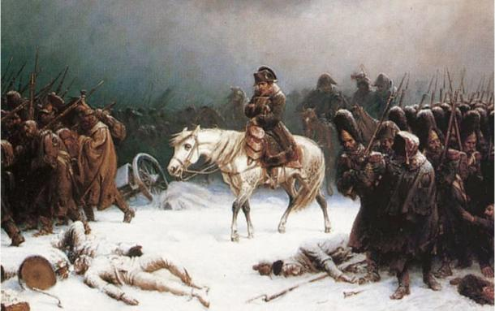

**Source 1**

Supplying the army became an impossibility; the lack of grass weakened the army's remaining [horses](http://www.newworldencyclopedia.org/entry/Horse), almost all of which died or were killed for food by starving soldiers. With no horses the French cavalry ceased to exist, and cavalrymen were forced to march on foot. In addition, the lack of horses meant that cannons and wagons had to be abandoned, depriving the army of artillery and support convoys.

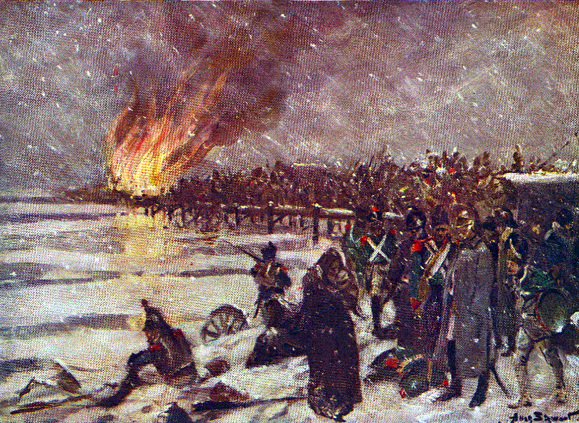

**Source 2**

As starvation and [disease](http://www.newworldencyclopedia.org/entry/Disease) took their toll the desertion rate soared. Most of the deserters were taken prisoner or promptly executed by Russian peasants. Badly weakened by these circumstances, the French military position collapsed. Elements of the *Grande Armée* were defeated by the Russians at Vyazma, Krasnoi, and Polotsk.

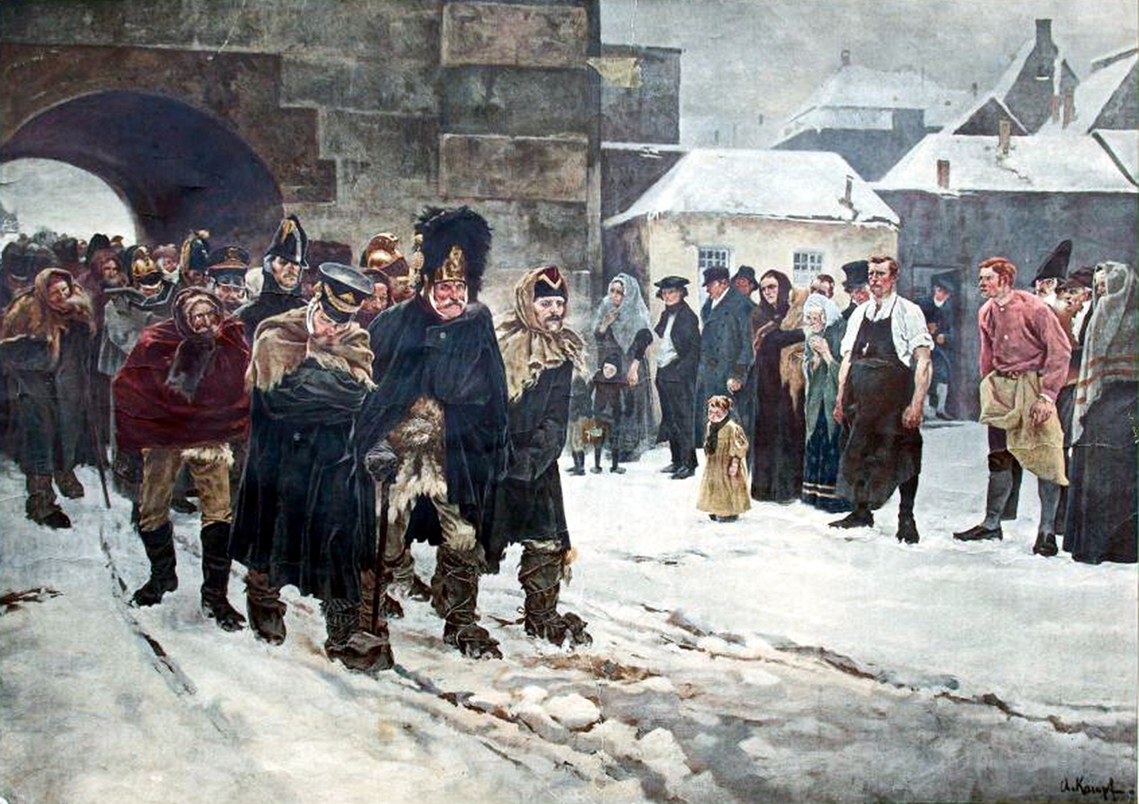

**Source 4**

In early December 1812 Napoleon learned that General Claude de Malet had attempted a coup d’état back in [France](http://www.newworldencyclopedia.org/entry/France). He abandoned the army and returned home on a sleigh, leaving Marshal Joachim Murat in charge. Murat later deserted in order to save his kingdom of Naples, leaving Napoleon's former stepson, Eugene de Beauharnais, in command.

In the following weeks, the remnants of the *Grande Armée* were further diminished, and on December 14, 1812 they were expelled from Russian territory.