Name: Date:

MLK Jr. Malcolm X

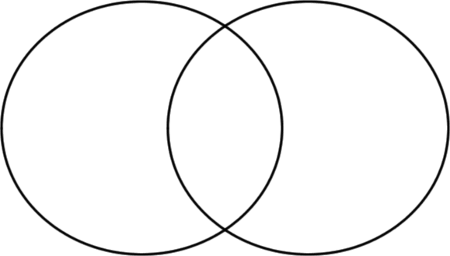

From: <https://www.lucidchart.com/pages/examples/venn_diagram_maker>