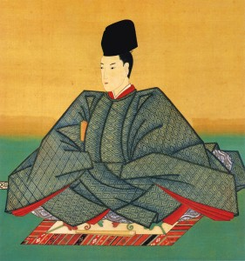 *Emperor* 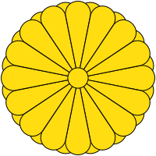

The Emperor is the symbolic ruler of Japan. It was largely a ceremonial role for much of feudal Japan.

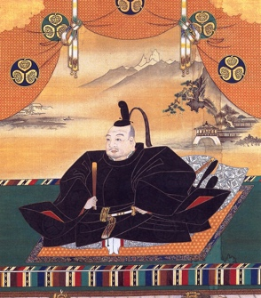 Shogun 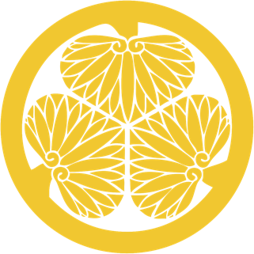

A military leader who ruled Japan under the leadership of the emperor until 1868. He controlled taxes, issued laws, and commanded samurai and daimyo to serve him.

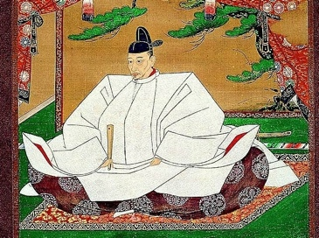 Daimyo 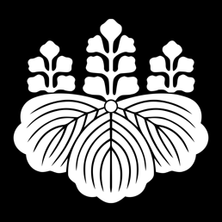

The lord of a large agricultural fief in feudal Japan who supported the shogun.

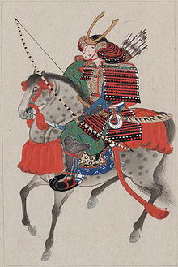 Samurai 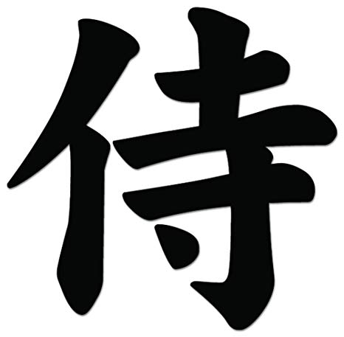

The feudal military aristocracy of Japan, who followed a code of honour called *bushido* or ‘The Way of the Warrior’. They were often vassals of shogun and daimyo.

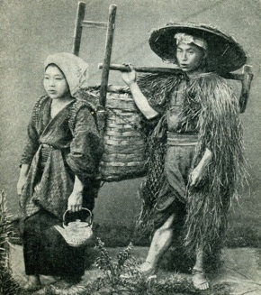 Peasants 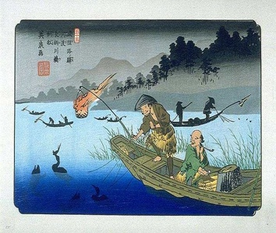

Farmers and fishermen who worked on lands controlled by the upper class and produced most of the food for everyone else. They made up about 90% of the population but they were often quite poor.

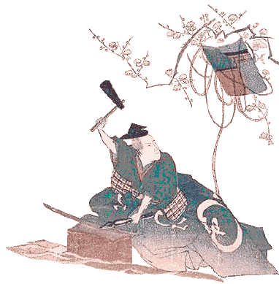 Artisans 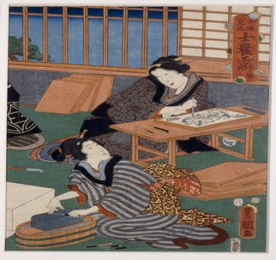

Workers who were skilled in a particular trade and produced beautiful and necessary goods such as sword smiths, carpenters, woodblock artists, etc.

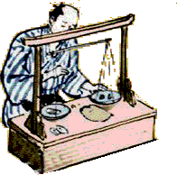 Merchants 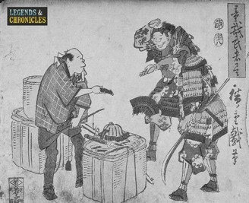

Business people who bought and sold goods that others made. They could become quite wealthy by engaging in trade.