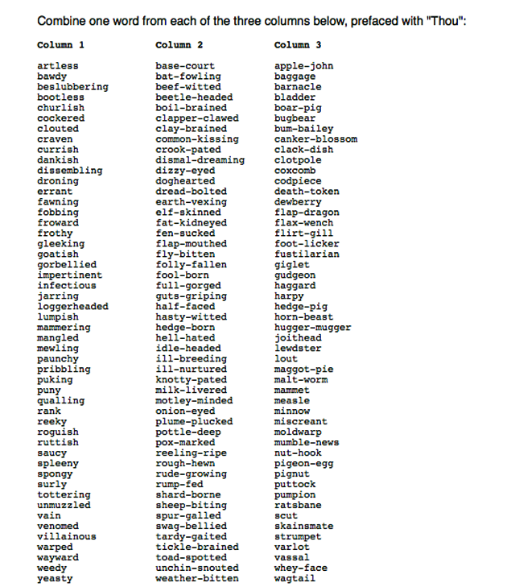

***THE ACTOR’S LIFE***

As actors, we work very hard.

There isn’t any choice.

We work to train our intellect,

Our body and our voice.

We breathe, we stretch, we speak, we move,

Monologues and scenes.

The Drama room is fine for now,

But bigger stages are in our dreams.

We put in hours (and hours…) of work,

Just trying to memorize.

And if we should forget our lines,

We’ll have to improvise.

The teeth, the lips, the tip of the tongue,

Projection and tone are key,

Don’t forget to enunciate and articulate

It’s the actor’s life for me!

SELF-ASSESSMENT – READING ALOUD

|  |  |  |  |  |  |  |  |
| --- | --- | --- | --- | --- | --- | --- | --- |
| DATE | TITLE | PROJ. | RATE | TONE | ENUNC. & ARTIC. | WHAT HAS GOTTEN BETTER? | WHAT AM I STILL WORKING ON? |
| 9/14 | *The Jabberwocky* | 5 | 2 | 4 | 4 | My projection was great today! Good volume. | I spoke too quickly. I will work on slowing down. |
|  |  |  |  |  |  |  |  |
|  |  |  |  |  |  |  |  |
|  |  |  |  |  |  |  |  |
|  |  |  |  |  |  |  |  |
|  |  |  |  |  |  |  |  |
|  |  |  |  |  |  |  |  |
|  |  |  |  |  |  |  |  |
|  |  |  |  |  |  |  |  |
|  |  |  |  |  |  |  |  |
|  |  |  |  |  |  |  |  |

**DRAMATIS PERSONAE**

**WILLIAM SHAKESPEARE’S**

**ROMEO AND JULIET**

ESCALUS, Prince of Verona.

PARIS, a young Nobleman, Kinsman to the Prince.

MONTAGUE & CAPULET, Heads of two Houses at variance with each other.

ROMEO, son to Montague.

MERCUTIO, Kinsman to the Prince, & BENVOLIO, Nephew to Montague: Friends to Romeo.

TYBALT, Nephew to Lady Capulet.

FRIAR LAURENCE, a Franciscan.

BALTHASAR, Servant to Romeo.

LADY MONTAGUE, Wife to Montague.

LADY CAPULET, Wife to Capulet.

JULIET, Daughter to Capulet.

NURSE to Juliet.

**JABBERWOCKY**

**Lewis Carroll**

(from *Through the Looking-Glass and What Alice Found There*, 1872)

`Twas brillig, and the slithy toves  
  Did gyre and gimble in the wabe:  
All mimsy were the borogoves,  
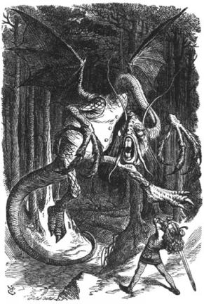  And the mome raths outgrabe.

"Beware the Jabberwock, my son!  
  The jaws that bite, the claws that catch!  
Beware the Jubjub bird, and shun  
  The frumious Bandersnatch!"

He took his vorpal sword in hand:  
  Long time the manxome foe he sought --  
So rested he by the Tumtum tree,  
  And stood awhile in thought.

And, as in uffish thought he stood,  
  The Jabberwock, with eyes of flame,  
Came whiffling through the tulgey wood,  
  And burbled as it came!

One, two! One, two! And through and through  
  The vorpal blade went snicker-snack!  
He left it dead, and with its head  
  He went galumphing back.

"And, has thou slain the Jabberwock?  
  Come to my arms, my beamish boy!  
O frabjous day! Callooh! Callay!'  
  He chortled in his joy.  
  
`Twas brillig, and the slithy toves  
  Did gyre and gimble in the wabe;  
All mimsy were the borogoves,  
  And the mome raths outgrabe.

|  |
| --- |
| **THE FAULTY BAGNOSE (From *A Spaniard in the Works*)**  **By John Lennon**  **Softly, softly, treads the Mungle**  **Thinner thorn behaviour street.**  **Whorg canteell whorth bee asbin?**  **Cam we so all complete,**  **With all our faulty bagnose?**  **The Mungle pilgriffs far awoy**  **Religeorge too thee worled.**  **Sam fells on the waysock-side**  **And somforbe on a gurled,**  **With all her faulty bagnose!**  **Our Mungle speaks tonife at eight**  **He tells us wop to doo**  **And bless us cotten sods again**  **Oamnipple to our jew**  **(With all their faulty bagnose).**  **Bless our gurlished wramfeed**  **Me cursed cafe kname**  **And bless thee loaf he eating**  **With he golden teeth aflame**  **Give us OUR faulty bagnose!**  **Good Mungle blaith our meathalls**  **Woof mebble morn so green the wheel**  **Staggaboon undie some grapeload**  **To get a little feel**  **of my own faulty bagnose.**  **Its not OUR faulty bagnose now**  **Full lust and dirty hand**  **Whitehall the treble Mungle speak**  **We might as wealth be band**  **Including your faulty bagnose**  **Give us thisbe our daily tit**  **Good Mungle on yer travelled**  **A goat of many coloureds**  **Wiberneth all beneath unravelled**  **And not so MUCH OF YER FAULTY BAGNOSE!**  ***VOCALIZING ACTIVITIES***  **NAME & ADJECTIVE**  Skills focused on:   * Icebreaking/getting to know one another * Creating trust through low-risk vulnerability * Connecting speech & movement   Each participant thinks of an alliterative adjective to compliment their first name. (Ex: Magic Matt, Lazy Louise, etc.) They then think of a gesture that compliments or accentuates their adjective.  HOW TO SCAFFOLD DOWN: Remove the adjective, and simply connect a gesture to your name.  **SHAKESPEAREAN INSULTS**  Skills focused on:   * Icebreaking * Creating trust through low-risk vulnerability * Playing with language * Getting comfortable with Shakespeare   Good for quieter groups, second language learners or students tackling Shakespeare for the first time. Everyone builds an insult using the provided list. To begin, practice verbalizing the insults at different speeds (slow, medium, fast). Then, moving around the space, begin vocalizing the insults at each other. For strong groups, add a gesture to the insult.  HOW TO SCAFFOLD DOWN: For overly “enthusiastic” groups, have them simply vocalizing the insults (in general, not to each other), and remove the movement/gesture portion.  **VOCALIZING POETRY**  Skills focused on:   * Reading aloud * Verbal confidence * Verbal vocabulary   Good for lower-grade secondary English classes and classes with a high number of second language learners. Using any short poem, divide the class into four groups. Each group becomes an “expert group” in one vocalization skill: Tone, rate, projection, and  articulation/enunciation. The group interprets the poem focusing solely on their assigned skill, playing with the text as much as possible through their vocal lens.  HOW TO SCAFFOLD UP: For higher levels, have them choose a longer piece of text and/or write a piece that focuses on language that requires a variety of tone, rate, etc. A radio play script can work very well to get the class vocalizing as well.  **CONNECTING VOICE TO CHARACTER AND RELATIONSHIP**  Skills focused on:   * Text interpretation/vocalization * Text physicalization * Character interpretation * Character relationship   Using any text with a fair number of characters and conflicts, each person is assigned a character and a line from the text. They develop a gesture that compliments or embodies their line. The line can be delivered in a positive manner (as to a friend), in a negative manner (as to an enemy), or in a neutral manner (as to a stranger), and the gesture can be performed with similar energy. Moving around the room, the characters stop, face one another, and based off of the character’s relationship, they deliver their line and gesture accordingly. Great way to review quotes or relationships before the end of a unit!  **GIBBERISH POETRY**  Skills focused on:   * Text interpretation/vocalization * Creating trust through low-risk vulnerability * Playing with language * Creating a safe space to make mistakes   Using gibberish or nonsensical poetry (Lewis Carroll is good for younger folks, John Lennon for older), using tone, rate, projection and articulation/enunciation, perform the poem for the class. This activity works well near the start of the year, as it breaks down the fear of pronouncing words the “right” way.  HOW TO SCAFFOLD UP: Have students create human storyboards for each stanza. One person narrates, the other physicalize! |