English 10-1: Psycho–Analysis

“The point is to draw the audience right inside the situation instead of leaving them to
watch it from outside, from a distance. And you can do this only by breaking the action
into details and cutting from one to the other, so that each detail is forced in turn on the
attention of the audience and reveals its psychological meaning.”
My Own Methods, Hitchcock, 1937.

Answer the following questions on a separate sheet of paper and in complete sentences while using details from the film to support your answer.

PART I: Examining Character.
- Examine Marion’s character. Is she easily influenced? Think back at the movie and examine the ‘triggers’ that lead Marion to her plan. For example, the money almost being shoved in her face. Was she thinking of the plan before? During the office scene?
- Examine Norman’s character. What kind of person is he? Does the audience feel sorry for him? What is the significance that his ‘hobby’ is taxidermy? How is it significant when he corrects Marion by saying “Thank you, ‘Norman’”?
- Why does Norman suddenly get angry? How is this scene seen as the turning point in the movie, and potentially Marion’s life?
- Identify how the director gets the viewer to identify with Marion, then forces the viewer to identify with Norman. How, in a sense, has the director placed the viewer in a problematic position?
- Answer the following question with a clear argument: In what sense does Psycho "really take[s] place in the mind of the viewer"?

PART II: Combining Character and Film Shots

The people we see on screen in Psycho are characters created at first by a writer and then interpreted by actors cast to play the roles.

What this means is that they present the formal elements that make up a character - voice, expressions, body language, etc. - in a consistent and meaningful way. If Anthony Perkins began winking at us or kept reminding us that he was not really a murderer, then we would quickly cease to be involved in the drama of his situation.

- ‘Voyeurism’ can be translated to mean ‘observer’ or ‘seer’. More specifically though, a voyeur is someone who is looking at something or has seen something they are not supposed to. For Norman Bates, looking through the peephole, it is for arousal. However, there are many instances where the camera acts as a voyeur (A subjective shot reproduces the viewpoint of the character, it is as if we are looking through their eyes). What were some of these instances and why are they significant?

- Look at the following point-of-view shots. Remember that at each moment we are meant to feel we are seeing things through the eyes of a character. What emotions do we experience alongside them and how do the shots contribute to our feelings for the character? Are we made to experience sights that implicate us, make us share the guilt or voyeurism of certain characters?

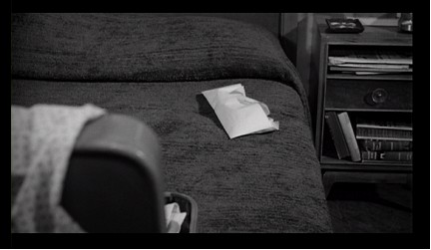

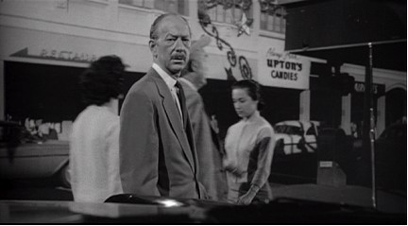

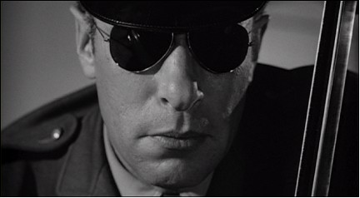

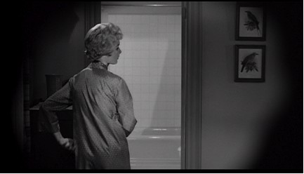

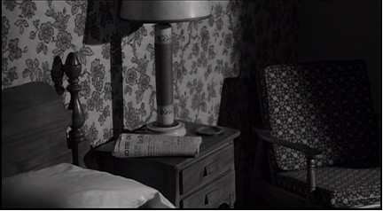

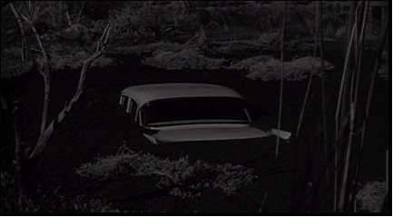

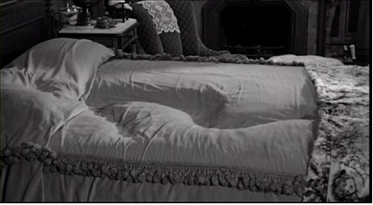

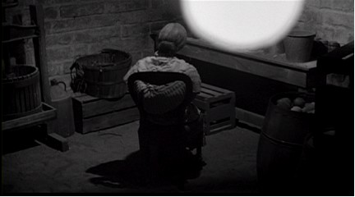

PART III: Literary Techniques & Film

Hitchcock planned every part of Psycho long before the filming began and little that is in the film is there by accident. To give a story shape, a director may often include motifs. That is repetitions of events, themes or even objects. Motifs are often a helpful way of discovering the deeper meanings of a film. For instance, what significance can you spot in the change of Marion’s underwear before/after her crime?

Think about the following scenes where mirrors occur:
* Marion packing her bags.
* Marion in the second-hand car lot's lavatory.
* Marion's view of her eyes in the rear view mirror as she drives.
* Marion as she checks into the Bates Motel.
* Arbogast as he questions Norman about Marion's disappearance
* Lila and Sam as they check into the Bates Motel.
* Lila in Mrs Bates' bedroom.
In each of these scenes, what is the character thinking, planning or pretending to be?
What is the possible symbolic significance for the use of mirrors throughout this film? (Can be more than one.) What/where else are there examples of repetition?

E.g.
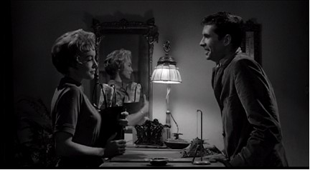 VS 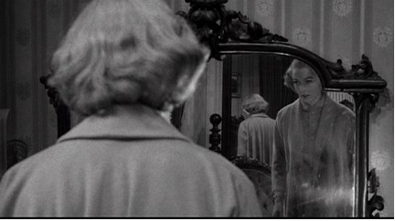

PART III: Cinematic Techniques (The spaces provided in this section are not for your answers but for brainstorming ideas when we revisit the scenes.)

- The rhythm of Psycho is: three minutes of dialogue; three minutes of non-verbal footage, or multiples of three. Almost half of this film is without language.
  - Examining the opening of the movie. Even though you may not know what the movie is about, how does the music make the audience feel?

  - The most effective use of music in this movie is during the shower scene. Initially, Hitchcock wanted the scene to be without any music. Examining the scene again, without music, what seems to be missing? In what ways does the music complement the actions of the ‘mother’? Marion’s reaction?

- Look at the following two scenes. The camera movement and angles seem a little odd, almost awkward. List what shots you see and how the scene makes you feel.

  - Norman looking at the hotel’s register book with Arbogast.

  - Norman walking up the stairs to his ‘mother’s’ room and taking her down the stairs.

- One of the most significant scenes, when paused and analyzed is when Norman Bates is sitting in jail and the ‘mother’s’ thoughts are being read aloud. What effects are used to change to the final scene of the movie? (What is the technique called?) Why did the director choose to include some of these images at the end? What is the symbolic significance of this scene?

