English 20-2: The Sixth Sense Study Questions

Answer the following questions on a separate sheet of paper and in complete sentences.

- What game did Cole agree to play at the birthday party? How did the balloon foreshadow something was going to happen?
- What does Cole frequently take from church? Why? Where does he keep them?
- a. What is Malcolm’s suggestion to Cole that might make the spirits go away?
b. Which restless spirit did Cole help first? (Describe what she was doing and
what she said to Cole.)
- When does Cole finally tell his mother he can see ghosts? How does he convince her? What is her reaction?
- What is unusual about Malcolm Crowes’s clothes? Why is this the case?
- When did Malcolm Crowe first realize he was one of the ‘restless’ from the spirit world?

A Deeper Analysis:

- The colour red is absent from the first part of the movie, but reappears in some scenes, such as: the colour of the balloon, Cole’s sweater at the birthday party, the tent where he talks to Kyra, Malcolm’s tape player, the doorknob to the basement, the grieving mother’s dress. What is the purpose of having this colour present in only these scenes?
- What time of year is this movie set in? How is that significant?
- Symbolism is an important factor in any piece of literature. What is the cold breath of air symbolic of? How is it important that this symbolism was established at the beginning of the movie? I.e. how does it help with the understanding of the ‘twist’ at the end?
- What is light used as a symbol of? (Think about where you see light, who uses it and why.)

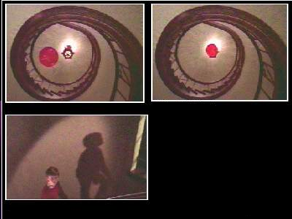

- Considering your response to the importance of the colour red and light, and reflecting on the notes you took previously on film techniques, and what other new pieces of information you see in these photographs, write an analysis of these scenes in about 8-10 sentences.

Be thorough, and reflect back on when you were watching this scene, what feelings is the director wanting you to feel? If you can, reflect on the music as well.

