Up! Film Analysis

“Adventure is out there!!!”

Combining Literary Devices & Film

1a. Carl, as an elderly senior, has quite distinct facial features. What do you notice about the way he looks? How does this reflect his personality? How does it contrast to the other main characters?
b. Explain how Carl is seen as a dynamic character. Focus on his personality traits, how they change, but also on how is overall outlook on life changes.

2. Examine the still shot of Carl and Ellie’s chairs and the items that surround them. How are they different and how do they reflect the personalities of the characters?

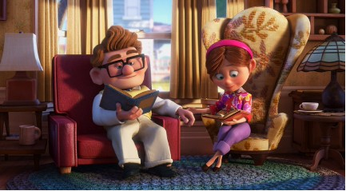

3a. Define juxtaposition.
b. Examine the still shot of Carl’s house in the middle of the construction site. In what ways can this be seen as a juxtaposition?

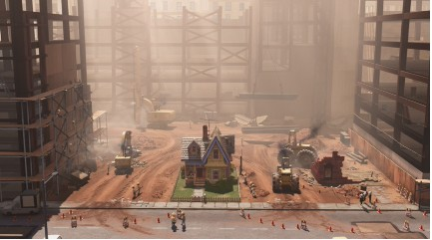

4. During the scenes that show Carl and Ellie climbing up the hill, the first two times it appears to be summer. The last climb, the season is fall. What might the seasons symbolize?

5. What might be the significance of the names “Shady Oaks” and “Paradise Falls”?

6a. After Ellie, passes away, Carl is left alone in his house. Besides Carl still talking to Ellie, how does it appear, in various places even, that Ellie is still with him?
b. During Carl’s adventure with Russell, how does it seem that Ellie is watching over them? (Besides Carl talking to her and the house.)

7. The idea of going on an adventure is a common idea throughout the movie. How is this the theme of the film? Explain how the idea of an adventure can have multiple meanings to different people.

8. What parallels are seen that occur near the beginning of the movie and re-appear again later?

9. Examine the following quotations and explain their significance.
a. “The wilderness isn’t quite what I expected…it’s not how they made it sound in my book (Get used to that kid…), My dad’s real good at camping… he used to come to all my meetings, then afterwards we’d go get ice cream…I like that curb. It might sound boring, but I think the boring stuff is the stuff I remember the most.
b. “Thanks for the adventure- now go have a new one!”
Film Techniques
For this section, the space provided is for brainstorming only. You must rephrase your notes from the film into coherent sentences/paragraphs for full marks.

1. Music:
Examine the montage scene showing the progression of Carl and Ellie’s life together. Pay close attention to the music. Think about how it makes you feel, the notes that are used, etc. Also, think about how the music is the same, but different.

2. Colour:
Pay attention to the use of colour throughout the film. How does the overall colouring change throughout Carl’s life? Examine what colours are used to portray certain characters and why it is significant.

3. Scene Analysis:
‘Taking in’ everything, examine the scene where Carl has finally arrived at Paradise Falls with the house. He has entered the house, is sitting on his chair and begins looking through the ‘adventure book’. What angle is used at one point- why? Examine other aspects, like change in colour, the use of music and other techniques you may find to be significant. When Carl is beginning to throw things out of his house, what items are zoomed in on, and how is it significant?

