WHAT DO I REMEMBER OF THE EVACUATION
By Joy Kogawa
I remember my father telling Tim and me
About the mountains and the train
And the excitement of going on a trip.
What do I remember of the evacuation?
I remember my mother wrapping
A blanket around me and my
Pretending to fall asleep so she would be happy
Although I was so excited I couldn't sleep
(I hear there were people herded
Into the Hastings Park like cattle.
Families were made to move in two hours
Abandoning everything, leaving pets
And possessions at gun point.
I hear families were broken up
Men were forced to work. I heard
It whispered late at night
That there was suffering) and
I missed my dolls.
What do I remember of the evacuation?
I remember Miss Foster and Miss Tucker
Who still live in Vancouver
And who did what they could
And loved the children and who gave me
A puzzle to play with on the train.
And I remember the mountains and I was
Six years old and I swear I saw a giant
Gulliver of Gulliver's Travels scanning the horizon
And when I told my mother she believed it too
And I remember how careful my parents were
Not to bruise us with bitterness
And I remember the puzzle of Lorraine Life
Who said "Don't insult me" when I
Proudly wrote my name in Japanese
And Tim flew the Union Jack
When the war was over but Lorraine
And her friends spat on us anyway
and I prayed to the God who loves
All the children in his sight
That I might be white.

Analysis
Introduction
In her poem, Kogawa discusses her experience travelling to a Japanese Internment Camp in Hastings Park. 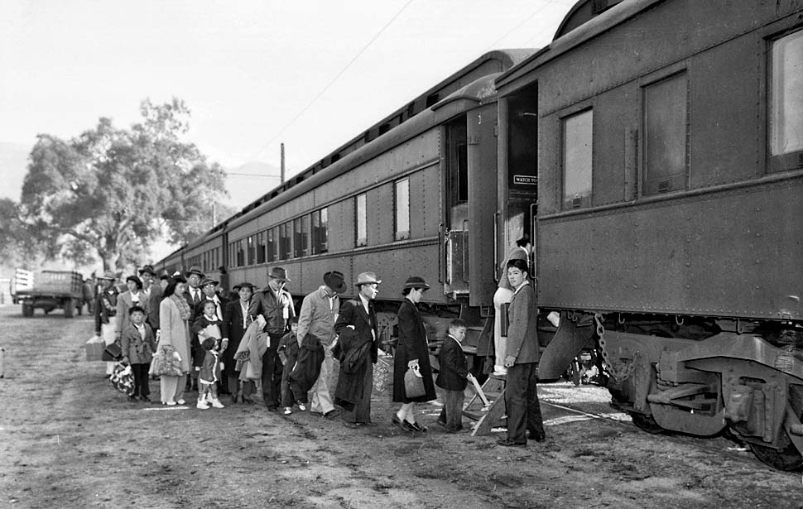
The poem discusses the issues of racism, discrimination and persecution of people of Asian descent during World War II. Before the attack on Pearl Harbor on December 7, 1941 Japanese Canadians were forced to register with the government as enemy aliens. This classification allowed the Canadian Government to force the Japanese Canadians into internment camps. During the forced registration and throughout the war the Canadian Government stripped the Japanese Canadians of their property. After the attack on Pearl Harbor and until 1949 – four years after World War II ended – about 22,000 Japanese Canadian Citizens remained in internment camps. The Canadian Government was also pressuring the Japanese to accept mass deportation even after the war ended.
Speaker
While Joy Kogawa is writing about herself, she is discussing what she remembers about being a six year old child being sent to an internment camp. Through lines such as “the excitement of going on a trip”, “I was so excited I could not sleep” and “I missed my dolls” Kogawa has shown the reader that the child speaking in the poem does not understand the severity of her situation. Her parents are also clear participants in this as they do not dissuade her thoughts; rather they try to enforce a certain level of happiness so that they children do not fear their unknown (or perhaps known) fate.
Voice
Joy kogawa writes this poem in a narrative style rather than a poetic style. She is relating to the reader that she is asking and answering the question of “What do I remember of the evacuation”. While it may have been something that was asked of her at the start of the poem, it is clear by the repetition of the words that she is using this question as a means of furthering her narrative.

Is innocence needed in order for the spirit to survive? Or should innocence be destroyed in order to ensure survival?
Kogawa uses her words to illustrate the innocence of her childish 6 year old nature, an innocence that her parents and some other adults try to maintain.
“I remember my mother wrapping/ A blanket around me”
“gave me/A puzzle to play with on the train”
“And I remember how careful my parents were/ Not to bruise us with bitterness”
Is this something that should be maintained?
If children are allowed to maintain their innocence then their hearts may not become hardened. This may mean that in situations like internment camps, children may not survive, they may be killed because they are unwilling to adapt to the harmful environment. However, if the children with innocence maintained do come out of the internment camps than they may live a better life because they know that they did not succumb to the harsh realities forced upon them in the camps.
“The puzzle of Lorraine Life/ Who said “Don’t insult me” when I/ Proudly wrote my name in Japanese”
“Her friends spat on us anyway/ and I prayed to the God who loves/ All the children in his sight/ That I might be white”
Outlines the idea that conforming and fitting into the outline of “human” that is created by the oppressor is an easier way to survive. But is this just a way for people to make it through with their body intact but, perhaps, not with their spirit intact?

Allusion
“Six years old and I swear I saw a giant/ Gulliver of Gulliver's Travels scanning the horizon/ And when I told my mother she believed it too”
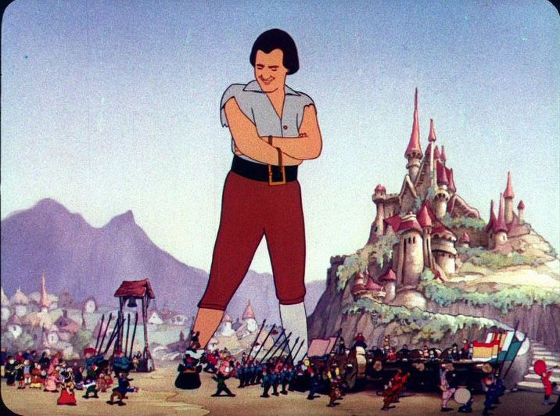
The first part of Gulliver’s Travels by Jonathan Swift depicts Gulliver as a giant (in later sections of the novel he is depicted as average sized or smaller). He travels to the land called Lilliput. The Lilliputians are a race of mini men who are at war with another group of mini men. Gulliver is the giant that comes in and attempts to end the war between these two groups. This could be why he was brought in as an image in Kogawa’s poem.The idea that Kogawa and her mother are seeing this giant savior of a race, even though he is a fictional character, they could be establishing this faith that they will not be abandoned, there will be someone coming to save them.
Possible resources
Obasan Joy Kogawa
Open Text B.C. article about Joy Kogawa’s story:
https://opentextbc.ca/abealfreader4/chapter/the-story-of-joy-kogawa/

