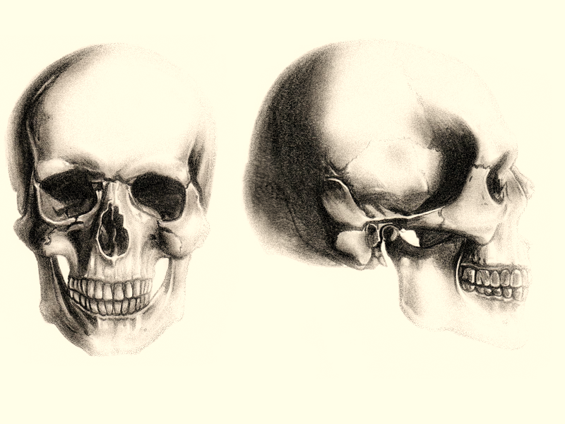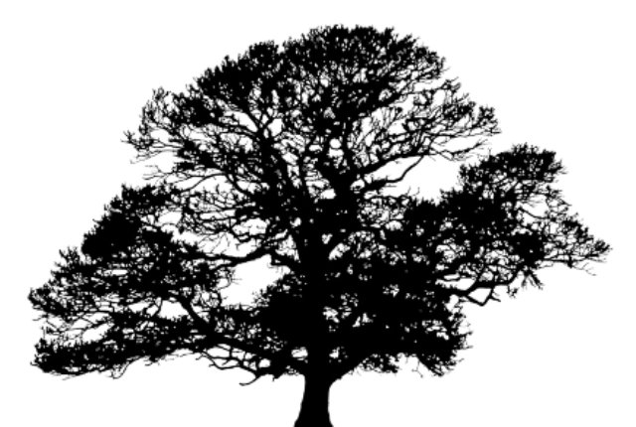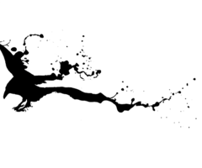

**in a hanging god’s place**

**sun-burnished and**

**green-crowned**

**immortal**

**are you**

**in the sapling**

**the groping roots**

**the up-thrusting limbs**

**The acorn in the heart**

**the heart in the earth**

**the earth a mote**

**in the eye of the unknown**

**And there**