Lauren Mah LLED 449 Text Presentation

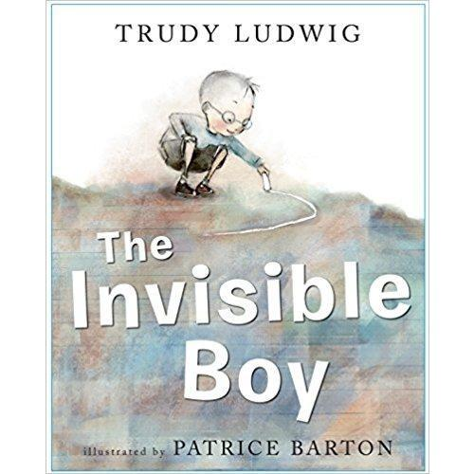https://kitaabworld.com/products/the-invisible-boy

Text (Picture Book): The Invisible Boy by Trudy Ludwig

- Plot: Nobody ever seems to notice Brian, the invisible boy, who is always alone. He doesn’t get included in conversations in the lunchroom, during cooperative games at the playground, or invited to classmates’ birthday parties. A new student named Justin notices Brian’s kindness since he was the first to welcome him and Justin pays attention to Brian’s artistic talent. Justin includes Brian into his group when a classmate wants to exclude Brian and this is when Brian slowly begins to shine. At the beginning of the story, Brian is drawn in black and white with the world around him in colour, which symbolizes his isolation. As he feels more accepted and included, he becomes colourful.

Ages & grades for which the book is appropriate: 6-9 years, K-3

Outline the themes of the book:
- Acts of Kindness-When new student Justin was eating in the lunchroom he ate Bulgogi which is Korean barbecued beef. A classmate teased Justin by saying he wouldn’t eat “Booger-gi.” The next day Justin finds a handwritten note from Brian in his backpack that said “Justin, I thought the Bulgogi looked good, from Brian.” This small act of kindness brightened up Justin’s day. Justin paid it forward by inviting Brian to join his team for a class project even though Emilio wanted to exclude him. Brian’s act of kindness was reciprocated.

- Social Responsibility: Empathy- Don’t talk about a birthday party if you know that not everyone was invited. Understand that it’s difficult being the new student and try to help them adjust and invite them to play. If someone doesn’t have a partner invite them to join your group.

- Inclusion- Multicultural classroom instead of making fun of cultural food, try it and respect it. Include others in play. Teacher should ensure all their students feel visible. Develop relationships and build class community. Invite the class to birthdays? Celebrating individual strengths, skills, and self.

Discuss the merits of the book for teaching:
- Text-to-Self connections of being invisible (e.g. being left out at recess, left out of conversations at lunch, playing alone in class) and how small acts of kindness can change someone’s world/perspective.
- Power of illustration- showing Brian as “invisible” in black and white then gradually becoming colourful is a great visual for young students.
- Diverse representation of classmates
- Great book at the beginning of the year to develop class community and the importance of being kind, empathetic, and including others.

Discuss the challenges of the book for teaching:
- Main character is a boy, so girls may not be able to fully connect to the text if they’re not represented as the main character.
- Both Brian and Justin are male characters, the story could’ve included a female character as the main or secondary character to depict a variety of friendships.
- Brian didn’t seem bothered by being alone, he didn’t stand up for himself.

- Activities to complete over 2 days (45mins each):

Day 1: Kindness

The class will discuss the examples of Kindness shown in the book and how it only took one person to change someone’s world. The activity is about having students visualize how others’ kind words and actions can positively influence our lives.

For this activity, students will receive a black and white image of a child and they’ll write down a time they felt invisible. Some examples can include not being invited to a birthday party, being left out of a tag game at recess, parents not paying attention to them, etc.

Next students will read their response to a partner. Their partner will use a pencil crayon to write a word(s) of encouragement or a kind action to help the student feel more visible. Then the partner will colour in some of their picture. Students will rotate around to their classmates repeating the same thing which will get their pictures completely coloured and a page full of encouraging words. These pictures will be posted up in the classroom for most of the year for individuals to refer to when they have moments of feeling invisible.

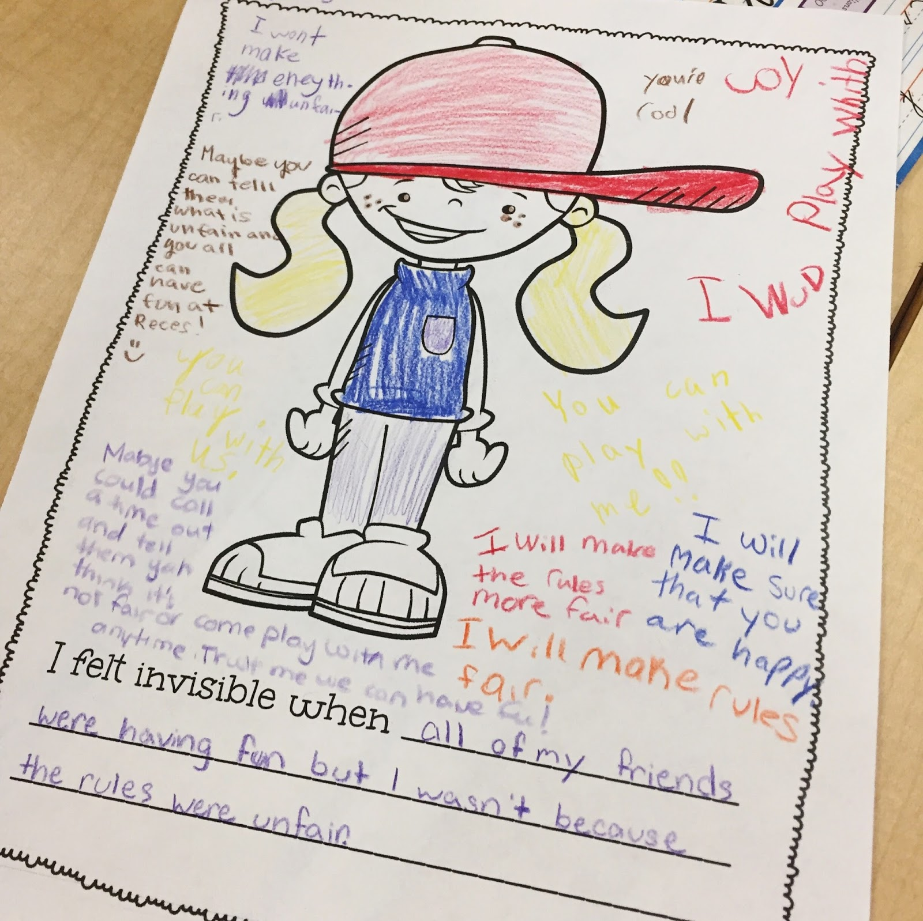

http://www.topfloorteachers.com/2017/03/the-invisible-boy-reflection-activity.html

Day 2: Inclusion

As a class we will make an anchor chart on chart paper of the different ways we could include others at school. An example:

How Can You Include Others?

Classroom | Recess/Lunch
Greet each other and ask how they’re doing. | If you see someone standing by themselves, invite them to play.
During partner tasks ask someone other than your close friend. | If more people want to play your game, start a new game and invite them to play.
Share your supplies (markers, pencil crayons, scissors) with others who need them. | If someone is eating their lunch alone, invite them to your table.
Listen when your classmates are talking to you or during class discussions. | Play with others from different grades.
Give meaningful compliments to classmates. | Talk to everyone eating at your table not just one person.

Next, students will create comics depicting situations where they had opportunities to include others. They can use the anchor chart as reference if they’re having difficulties thinking of personal experiences. Comics will be shared with the class using the document camera so students can see the illustrations as well as the written word to convey the importance of inclusion in each example.

______________________________

An extension or early finisher activity is having students write a letter or note to Brian. Reminding students that Justin was incredibly happy receiving Brian’s note in his backpack validating his lunch. What would they write to Brian after learning about his experience and invisibility in school.

http://beauty-on-house.ru/11-2015-56.php

