Larry David: The Most Important Meal of the Day
By Larry David

Mr. David is the creator of “Curb Your Enthusiasm.” His typical breakfast consists of poached eggs with a bagel.
- July 23, 2018
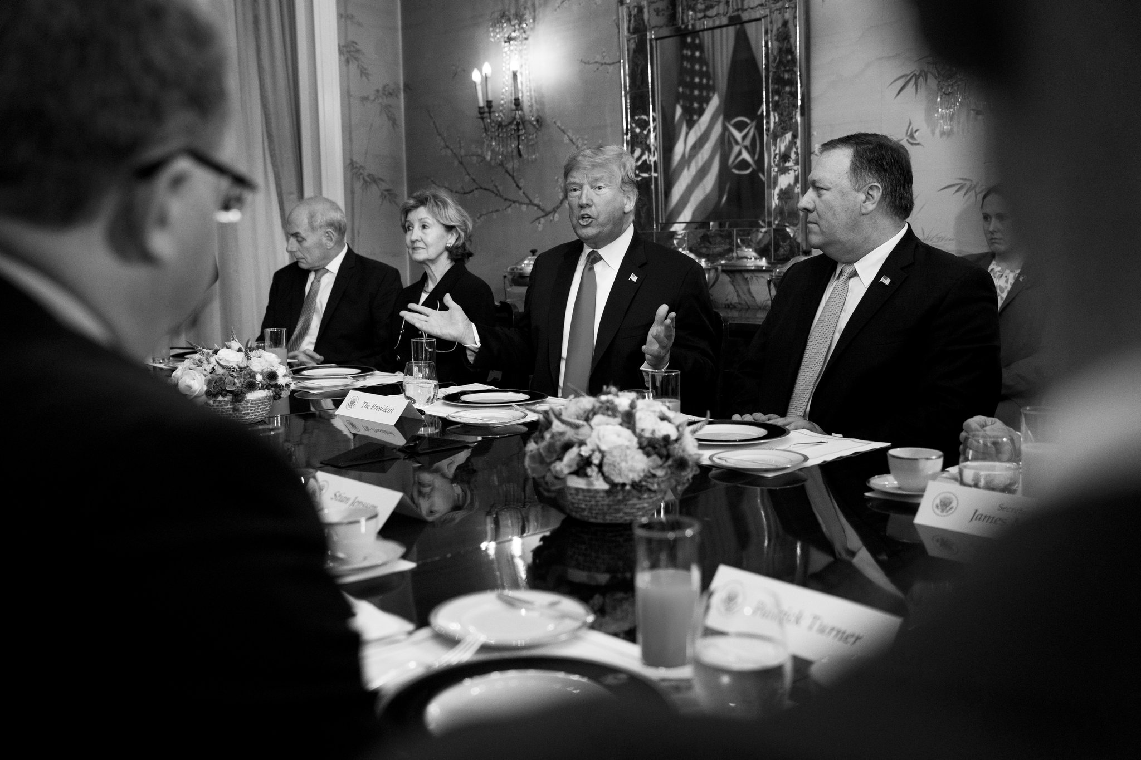
The White House chief of staff, John Kelly, left, with Kay Bailey Hutchison, the American ambassador to NATO; President Trump; and Secretary of State Mike Pompeo in Brussels last week.
Credit
Doug Mills/The New York Times
There have been a number of highly publicized walk-backs by the White House of late, the most notable being “wouldn’t” replacing “would.” The week before, however, there was one during the NATO Conference in Brussels that went somewhat under the radar. While President Trump was berating Germany, Gen. John F. Kelly, his chief of staff, was clearly seen grimacing at the table. Within hours, Sarah Huckabee Sanders issued a statement saying the reason Kelly grimaced was not because of anything Trump said; rather, Kelly was displeased “because he was expecting a full breakfast and there were only pastries and cheese.”
Sanders was roundly mocked for that explanation, but being a big breakfast fan, I withheld any criticism until I could gather more information about the incident. And gather I did. I have since concluded that Sanders was, in fact, correct. And although the last thing I’d ever want to do is defend the White House, the facts are irrefutable. I present them herein.
The night before the aforementioned conference, Kelly had a light supper consisting of fresh halibut and peas. By 11 o’clock that evening, he was starving and lightheaded. He eyed the Pringles in the mini bar, but then decided it made more sense to go to bed hungry and gorge himself the next morning on a huge breakfast. (Note: In speaking with some of Kelly’s friends and family, I’ve learned he’s always been a big breakfast guy. Legend has it he made his first bacon and eggs unsupervised while standing on a chair when he was 2 and a half. Even when he was stationed in Iraq, he made sure to have his breakfast brought in every morning, sometimes at great personal risk to the aide-de-camp.)
Back to the night in question … At 11:03 p.m., he called the young Belgian assigned to him, Romain De Stedt, to find out when the conference was starting in the morning so he would have enough time to have breakfast in the hotel without rushing. (He considered a rushed breakfast a crime against nature.) But young De Stedt told him he could sleep in, assuring him they’d be serving breakfast at the conference.
“Are you sure?”
“Definitely. And it’s gonna be a good one, from what I’m told. Pancakes.”
Kelly couldn’t believe his ears. “Pancakes? You’re kidding.”
“I wouldn’t kid about that. With real maple syrup.”
Kelly’s mouth watered. “Gee, it’s been a while since I had pancakes with real maple syrup. You know this for a fact?”
“Yes. I’ve got an in with the guy who’s in charge of the whole thing and he confirmed it. Actually, why don’t you tell me now what you want so it’ll all be ready for you when the conference starts.”
“O.K., well definitely the pancakes. Can I get eggs too?”
“Sure.”
“Really? I don’t want them to think I’m a pig.”
“No, they don’t care. Get the eggs.”
“And make sure not to put the eggs on the pancakes — I want them on the side. The pancakes are not a substitute for toast.”
“How do you take them?”
“Over-easy. And if the yolk is broken, don’t bother. I’m not eating anything with a broken yolk. I swear, if I find any broken yolk, there’s gonna be hell to pay.”
“No worries, sir.”
“And maybe a toasted English muffin. But it has to be toasted. English muffins are awful when they’re not toasted enough.”
“Sir, those muffins will be toasted. You can bank on it.”
“O.K., this is fantastic. When are you gonna put the order in?”
“Soon as I wake up. I’ll set the alarm.”
Kelly was so excited at the prospect of his big breakfast that he could barely sleep that night. Pancakes! Real maple syrup! … There is a God. Kelly turned his pillow over, adjusted the blanket … and then the fretting began. Maybe I should’ve ordered two English muffins. One is not enough for dunking in the yolk. You are so stupid. You know one muffin’s not enough … Holy cow, did I forget the bacon?!
The next morning, Kelly arrived at the conference table, dark circles under his eyes. He could barely pay attention to anyone, so focused was he on breakfast. But where was it? Where’s that idiot, De Stedt?! I knew there was something about that guy! He wears those colorful socks! They look ridiculous.
Then, just as Trump started to speak, De Stedt burst in, spotted Kelly, and with as much apologetic fervor as he could muster, mouthed, “No breakfast … Sorry.” Kelly was incredulous. “What happened?!” he mouthed back. De Stedt hung his head. “My alarm didn’t go off.” Kelly sat back, crushed. He thought about the pancakes and maple syrup and his face twisted into a sour knot.
EDITORS’ PICKS
Maria Butina, Suspected Secret Agent, Used Sex in Covert Plan, Prosecutors Say
Republicans Push to Overhaul Law Meant to Protect At-Risk Species
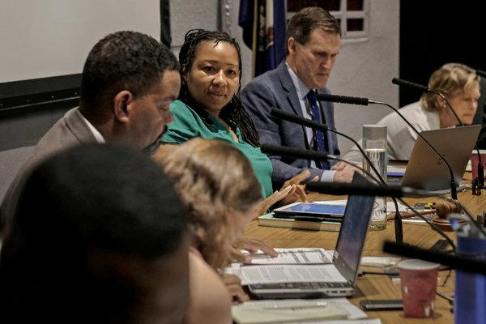
A Year After Deadly Rally, a Protester Runs Charlottesville
Kay Bailey Hutchison, who was sitting next to him, was also expecting breakfast that morning. It was just Greek yogurt and berries, but her disappointment was palpable and it was all she could do to keep it together. When the conference ended, the two of them made haste to the nearest restaurant.
While they were waiting for their food, they checked their phones — both were lit up with texts commenting on how the two of them were grimacing during Trump’s remarks. Kelly was nonplused.
“Grimacing?! That’s ridiculous!”
Hutchison agreed. “Nothing could be further from the truth!”
Kelly was beside himself. “Damn. This could turn into some kind of international incident. Maybe cost me my job. What shall we do?”
Hutchison pondered that for a second. “Let’s just tell them the truth.”
It was at this point that the waiter placed their breakfast on the table. Kelly looked it over, quite pleased. “Good idea.” Then he rubbed his hands together. “Let’s eat!”

