Integrating Ultrasonic scaling at Pediatric Dental Practice in Winnipeg, Manitoba

for
Johan Schalkwyk
Faith Fay
Dr. Amir
Dr. Mangat
Dr. Yve
Dr. Abdukar
Dr. Shah
Dr. Sandhu

By
Lovin Kahlon
English 301 student

July 21, 2022
Table of Contents
Abstract ……………………………………………………………………………………………………………………
Introduction………………………………………………………………………………………………………………
Background and Description………………………………………………………………………….
Purpose of the report…………………………………………………………………………………….
Intended Audience…………………………………………………………………………………………
Method of Inquiry…………………………………………………………………………………………..
Limitations of Study………………………………………………………………………………………..
Scope of the Enquiry……………………………………………………………………………………….
Conclusion……………………………………………………………………………………………………….
Plan………………………………………………………………………………………………………………………………
Compare and Contrast Ultrasonic and Handscaling……………………………………………………..
Pros and cons of ultrasonic scaling and handscaling to provider, patient and management…………………………………………………………………………………………………….
Types of ultrasonic scalers (Magnetostrictive and piezoelectric)……………………..
Budget………………………………………………………………………………………………………………………….
Cost……………………………………………………………………………………………………………………
Training……………………………………………………………………………………………………………..
Additional maintenance of ultrasonic scaler………………………………………………………
Revised Recare System………………………………………………………………………………………………….
Plan to redesign the dental hygiene recare system…………………………………………….
Data Section……………………………………………………………………………………………………………………
Eligibility Criteria………………………………………………………………………………………………..
Analyze survey results and informational questions……………………………………………
Analyze secondary sources…………………………………………………………………………………
Limitations of Survey and Studies……………………………………………………………………………………
Limitations of Primary research sources………………………………………………………………….
Limitation of secondary research studies…………………………………………………………………
Conclusion
Summary and interpretation of findings…………………………………………………………………..
Recommendations……………………………………………………………………………………………………
References……………………………………………………………………………………………………………………………
Glossary………………………………………………………………………………………………………………………………..
Appendix 1……………………………………………………………………………………………………………………………
Figures and Tables
Figure 1 Ultrasonic Unit (Magnetostrictive)…………………………………………………………………………
Figure 2 Piezoelectric unit………………………………………………………………………………………………….
Figure 3: Power scaler makes the dental hygiene visit time efficient…………………………………..
Figure 4: Power Scaler enhance patient comfort as compared to handscaler during dental hygiene care……………………………………………………………………………………………………………………………
Figure 5: Power scaler causes less fatigue to the dental provider as compared to handscaling……………………………………………………………………………………………………………………………..
Figure 6: Use of Power Scaler is directly related to the severity of calculus on teeth instead of the patient’s age………………………………………………………………………………………………………………….

- INTRODUCTION
- Background and description
Registered Dental Hygienists (RDH) are licensed, oral health professionals who focus on preventing and treating oral disease. RDHs use a variety of tools to remove plaque, calculus, and stains from teeth to improve oral health and prevent disease. Primarily, RDH employs two types of scaling: hand and ultrasonic scaling. Handscaling refers to manual scaling performed by hand to scrape teeth to remove plaque and calculus from teeth. Ultrasonic scaling (power scaling) is a water scaler that blasts plaque and calculus mechanically with high vibrational energy. Handscaling is the traditional method that requires physical strength to scrape the teeth with a metal instrument. Alternately, ultrasonic scaling is a power-driven scaling device that requires gently holding the scaler against the tooth and the vibration produced by the scaler cleans the teeth.
ABC pediatric dental group opened its door 15 years ago welcoming birth to 18 years of age children from Winnipeg and surrounding areas. Currently, the dental group has 4 dental hygienists and 6 dentists that strive to provide the highest standard of care to patients. ABC dental group only uses handscaling for cleaning teeth. As the practice grew over the years, a significant majority of patients over 14 years of age required alternative method to clean teeth to provide comprehensive care.
- Purpose of the Report
Dental cleanings are done manually by hand resulting in several inefficiencies at the ABC dental practice. These inefficiencies include time management issues as hand scaling takes a long time, painful experience for an older patient who needs enhanced therapy, special needs patients who allow limited working time, and musculoskeletal problems for the dental hygiene care provider. This report aims to evaluate the feasibility of implementing ultrasonic scaling in conjunction with hand scaling at a Pediatric Dental Practice in Winnipeg, Manitoba to reduce the above-described inefficiencies.
- Intended Audience
The report is prepared for Johan Schalkwyk, Faith Faye, Dr. Amir, Dr. Mangat, Dr. Yve, Dr. Abdukar, Dr. Shah and Dr. Sandhu respectively.
- Method of Inquiry:
Thirteen dental providers including dentists and dental hygienists responded to a short survey designed to analyze their preference for including ultrasonic scaling in conjunction with handscaling to provide comprehensive patient care. An analysis of potential costs and revenue is performed to determine the feasibility of implementing ultrasonic scaling. In addition, interviews are conducted with the management to assess their preference to implement ultrasonic scaling. Lastly, a detailed literature review is conducted regarding handscaling Vs ultrasonic scaling.
D. Limitations of the study
The small and convenient sample size of survey respondents is a major limitation of the study. Further, an informational interview is subject to the respondent’s bias. Secondary sources of research included also have various limitations which may affect the result of this study.
E. Scope of the Inquiry
This report covers 8 topics: what are the benefits of ultrasonic water scaling to the patient and dental hygienist, what are the benefits and constraints to office management, what is the cost of an ultrasonic water scaler, will there be an added cost to maintain an ultrasonic scaler, what are the different types of ultrasonic scalers available in the market, does the staff need additional training to use ultrasonic water scaler, can ultrasonic scaler makes dental hygiene visits more efficient and profitable, when will the ultrasonic scaler pay for itself.
- Conclusion of the Inquiry
The report concluded that the addition of an ultrasonic scaler is a feasible option and will benefit the staff of ABC dental practice and the management.
II. PLAN
A. COMPARE AND CONTRAST ULTRASONIC AND HANDSCALING
- Pros and cons of ultrasonic scaling and handscaling to provider, patient and management.
Ultrasonic scalers were initially introduced in 1950 (Ontario Dental Hygiene Association, 2020). Increased research on the effectiveness of ultrasonic scaling and its improved technology led to a paradigm shift to ultrasonic scaling becoming a predominant treatment modality for nonsurgical periodontal therapy (Ontario Dental Hygiene Association, 2020).
For dental providers, the advantages of ultrasonic scaling are less provider hand/wrist fatigue and risk of musculoskeletal injury, shorter treatment time as compared to handscaling with similar clinical outcomes, water lavage washes away debris from under the gums, less need for rinsing the teeth, and less chance of provider injury because there are no cutting edges on the tips used by ultrasonic scaler (Ontario Dental Hygiene Association, 2020).
Disadvantages of ultrasonic scaler include root roughness caused by ultrasonic scaler if the dental provider is not using the correct angle and the production of contaminated aerosols (Ontario Dental Hygiene Association, 2020).
The advantages of handscaling are no aerosol contamination as it became a staple of dental hygiene practice during covid 19 pandemic (Ontario Dental Hygiene Association, 2020).
The disadvantages of handscaling are added time consumption and the risk of hand/wrist injury (Ontario Dental Hygiene Association, 2020).
The patient can also benefit from ultrasonic scaling as it is comfortable and less time-consuming. Disadvantages may include teeth sensitivity by ultrasonic scaler depending on the patient’s oral condition.
The advantage to the management to add ultrasonic scaling is efficient time management that can result in reduced appointment times and the ability to see the additional patient. Disadvantages include the cost of purchasing the ultrasonic unit.

Types of ultrasonic scalers (Magnetostrictive and piezoelectric).

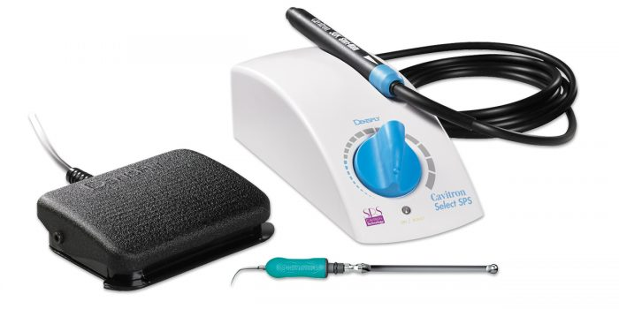
Figure 1: Ultrasonic Unit (Magnetostrictive)
Source: Magnetostrictive scaler units (ultrasonic units) (n.d.). Retrieved July 19, 2022, from Wise Dental Repair website: https://www.wisedentalrepair.com/product/magnetostrictive-scaler-units-ultrasonic-units-repair/

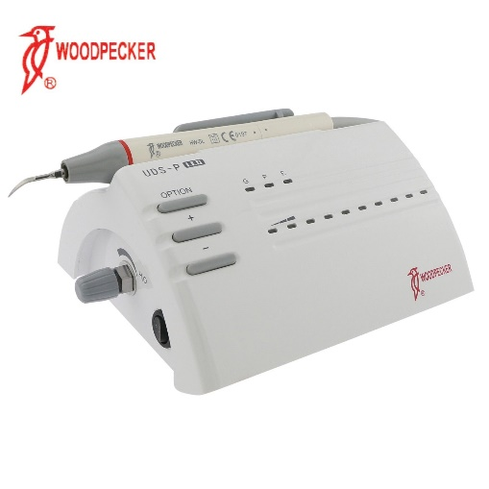
Figure 2: Piezoelectric unit
Source: Woodpecker dental piezoelectric ultrasonic scaler handpiece UDS-P LED HW-5L EMS (110V). (n.d.). Retrieved July 19, 2022, from Canadawidedental.com website: https://canadawidedental.com/product/woodpecker-dental-piezo-electric-ultrasonic-scaler-hand-piece-uds-p-led-hw-5l-ems-110v/
Magnetostrictive and piezoelectric are two types of power scalers used while delivering dental hygiene care. Both have been clearly proven to be effective for plaque, calculus and stain removal. The differences lie in how the two devices function. Magnetostrictive power scalers (Figure 1) operate at an optimal frequency of 20 kHz to 40 kHz, whereas piezoelectric power scalers (Figure 2) operate at a slightly higher optimal frequency of 29 kHz to 50 kHz (Sebero & Kelly, 2016). In magnetostrictive scalers, energy is converted to vibrations from the elliptical stroke patterns of the unit's metal rod or stack of metal sheets (Sebero & Kelly, 2016). All surfaces of the tip are active in the removal of debris (Sebero & Kelly, 2016). For the piezoelectric scaler, strokes occur in a linear pattern via crystals activated by the ceramic handpiece. Only the lateral sides are effective in the removal of debris (Sebero & Kelly, 2016).
B. BUDGET
- Cost
Magnetostrictive unit range from $1500- $2000 Canadian dollars depending on the features and Piezoelectric unit range from $800- $1500 (“Sinclair dental, “n.d.). The cost of purchasing tips is similar for both units (“Sinclair dental, “n.d.).
- Training
Complimentary lunch and learn can be arranged with the supplier to train the staff on the use of the units (“Sinclair dental, “n.d.). Dental Hygienists and dentists often are familiar with the operation of the units as they have used them during their education or other training.
- Additional maintenance of ultrasonic scalers
These units do not require additional maintenance as long the manufacturer recommendations are followed and the units are flushed with water before use first thing in the morning and in between patients. New units also come with a warranty for any future issues (“Sinclair dental, “n.d.). Tips need to be purchased for units depending on the wear and tear of the existing tips. Typically, tips are ordered every 6-12 months as per supplier for a high-volume office.
C. REVISED RECARE SYSTEM
- Plan to redesign the dental hygiene recare system.
ABC Dental bills one unit of scaling (15 minutes of time) at the rate of $ 60. Generally, each appointment is booked for 30-60 minutes. 30-minute appointments often have ½ to 1 unit of scaling billed, the 45-minute appointment has 1-2 units of scaling and the 60-minute appointment has 2.5 or 3 units of scaling. Dental hygiene appointments often run behind when back-to-back 30-minute appointments are scheduled especially when the patient tends to need more scaling than anticipated since their last cleaning. This can be quickly resolved by adding a power scaler as it will decrease the treatment time. 60-minute appointments can also be shortened to 45 minutes with the addition of a power scaler. This decrease in appointment time can open up additional time slots to see an extra patient to counteract the cost of adding a power scaler unit. This will not decrease the quality of service provided and will also be comfortable for dental providers. It can be foreseen that the ultrasonic scaler can pay for itself in 4 months.
D. DATA SECTION
1. Eligibility Criteria
Surveys are anonymous and only completed by practicing dentists and dental hygienists. Secondary research included is level 1 and level 2 evidence which consists of systematic reviews and randomized controlled trials.

- Analyze survey results and informational questions
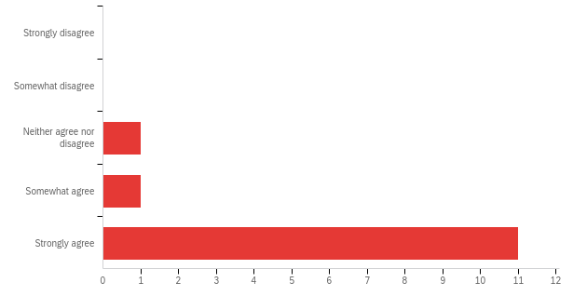
Figure 3: Power scaler makes the dental hygiene visit time efficient

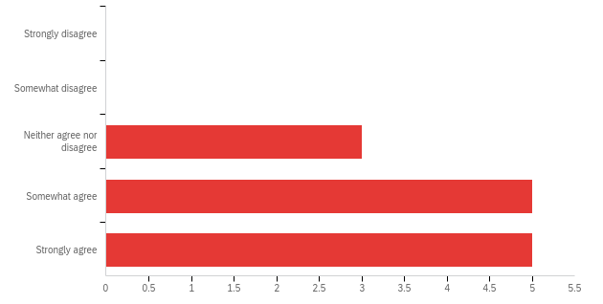
Figure 4: Power Scaler enhance patient comfort as compared to handscaling during dental hygiene care. 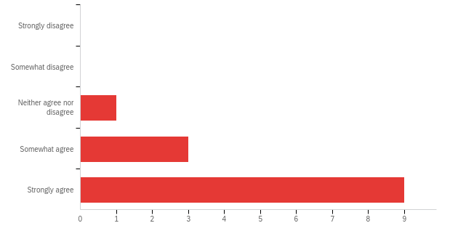
Figure 5: Power scaler cause less fatigue to dental providers as compared to handscaling.

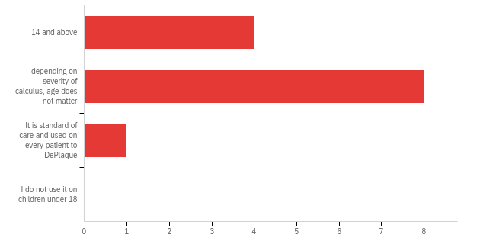
Figure 6: The use of a Power Scaler is directly related to the severity of calculus on teeth instead of the patient’s age.
Survey results revealed that 84.6% of respondents agree that a power scaler makes the dental hygiene visit time efficient. 61.5 % cumulatively agree that power Scaler enhances patient comfort during dental hygiene care. 84.6% agree that power scalers cause less fatigue to dental providers thus decreasing the risk of musculoskeletal injuries. Further, 61.5% agree that the use of a power scaler is directly related to the severity of calculus on teeth instead of age for most clinicians. Survey results also showed a preference for the ultrasonic unit over the piezoelectric unit by dental providers. These statistics confirm that dentists and dental hygienists prefer to use power scalers in conjunction with handscaling while providing dental hygiene care.
Additionally, Informational interviews of ABC dental practice clinical staff revealed that 80% of clinicians have used power scaler at some point in their career and will use it if it is implemented in the practice. The remaining 20% of staff will not use an ultrasonic scaler and will prefer to hand scale.
ABC management revealed that being a pediatric practice they did not think that the addition of ultrasonic is necessary but they are willing to see if this addition can resolve time management issues.
- Analyze secondary sources
Suvan et al. (2019) concluded that the removal of calculus is important while providing dental hygiene care irrespective of the type of instrument or mode of delivery.
When instrumenting on clients with heavy calculus deposits, dental hygienists use additional strength and lateral pressure for controlled function during hand scaling. Åkesson, Balogh, & Hansson, (2012) suggest ultrasonic scalers as a prevention method to minimize the load from hand-scaling and can decrease the risk of musculoskeletal injuries.
Sanz et al. (2020) recommended that the choice of instrument should be based upon the experience, skills, and preference of the clinician together with client preference.
Johnston et al. (2020) concluded that ultrasonic instrumentation resulted in shorter treatment time compared to handscaling with similar clinical outcomes.
E. LIMITATIONS OF SURVEY AND STUDIES
- Limitations of primary research sources
The limitation of the surveys is the small sample size of respondents and lack of time to administer the survey. The informational interview may also present respondent bias as the answers may be affected by the interviewer's position in the company. It can also be subjected to sampling bias as the only sample chosen was readily available and may not be representative.
- Limitation of secondary research studies
Limitations of secondary research include that several of the relevant studies included in the systematic review of “Suvan et. al.” was conducted before the development of instruments available today. The parameter to be included in the systematic review was not consistently followed as it did not represent the PICO questions. Sanz et al (2020) declared a major conflict of interest which exposed them to researcher bias by receiving funding, researcher and consultant fees to conduct their research. The inclusion of non-randomized observational studies in the research also increased the risk of bias and confounding, and cannot be used to demonstrate causality. Åkesson, I., Balogh, I., & Hansson (2012) had a very small sample size of 12 dental hygienists to conduct their research. An observational and objective method to score pain and discomfort was used which may reflect researcher and respondent bias. Johnston et al., 2020 research was funded were Dentsply Sirona, a manufacturer of ultrasonic scalers in North America.
CONCLUSION

- Summary and interpretation of findings

The primary and secondary research concludes that ultrasonic is a valuable tool to use as an adjunct

to handscaling while providing dental hygiene care. The addition of ultrasonic will reduce the risk of

musculoskeletal injuries to dental providers and decrease the treatment time without compromising

the quality of care. It further reiterates the fact that clinical outcomes of dental hygiene treatment

are not dependent on the type of instrument (hand vs ultrasonic scaling) but rather on the provider

and patient discretion. The clinical and non-clinical staff of ABC dental practice will also appreciate

the implementation as it will resolve the current time management issues and also will pay for the

ultrasonic scaler by adding an additional patient to the dental provider schedule. Further, it will also

help in decreasing the amount of overtime paid to the staff by running appointments on time.

Patients will also appreciate this as they are provided with more than one option for their dental

hygiene therapy. Time off requests due to repetitive motion injuries by the dental staff will also be

reduced.

- Recommendations

My recommendation is to install the ultrasonic scaler in every dental hygiene operatory. One portable unit should also be placed in the dental assistant treatment area so dentists can also benefit from it if the need arises. A one-month trial run can be completed at the current time allocated for appointments. An evaluation can be done after one month to add an additional patient to start recouping the cost of adding an ultrasonic scaler. Any future repairs and cost of changing tips for ultrasonic scalers can be adjusted from the profit of seeing additional patients.
REFERENCES
Ontario Dental Hygiene Association. (2020). Handscaling Vs Ultrasonic scaling: Episode 21. Retrieved from: https://odha.on.ca/wp-content/uploads/2019/06/Keynotes-Episode-21-%e2%80%93-Hand-scaling-vs.-Ultrasonic-Scaling.pdf
Suvan, J., Leira, Y., Moreno Sancho, F. M., Graziani, F., Derks, J., & Tomasi, C. (2020). Subgingival instrumentation for treatment of periodontitis. A systematic review. Journal of Clinical Periodontology, 47 Suppl 22(S22), 155–175. https://doi.org/10.1111/jcpe.13245
Sanz, M., Herrera, D., Kebschull, M., Chapple, I., Jepsen, S., Beglundh, T., … EFP Workshop Participants and Methodological Consultants. (2020). Treatment of stage I-III periodontitis-The EFP S3 level clinical practice guideline. Journal of Clinical Periodontology, 47 Suppl 22(S22), 4–60. https://doi.org/10.1111/jcpe.13290
Sebero K., Kelly R. (2016). Magnetostrictive vs. Piezoelectric: Survey compares merits of ultrasonic scalers. Retreived from: https://www.rdhmag.com/patient-care/article/16409218/magnetostrictive-vs-piezoelectric-survey-compares-merits-of-ultrasonic-scalers
Sinclair dental (n.d.). Retrieved July 19, 2022, from Sinclairdental.com website: https://www.sinclairdental.com/search/?text=ultrasonic+unit&Search=Search
Åkesson, I., Balogh, I., & Hansson, G.-Å. (2012). Physical workload in neck, shoulders and wrists/hands in dental hygienists during a work-day. Applied Ergonomics, 43(4), 803–811. https://doi.org/10.1016/j.apergo.2011.12.001
Johnston, W., Paterson, M., Piela, K., Davison, E., Simpson, A., Goulding, M., … Culshaw, S. (2020). The systemic inflammatory response following hand instrumentation versus ultrasonic instrumentation-A randomized controlled trial. Journal of Clinical Periodontology, 47(9), 1087–1097. https://doi.org/10.1111/jcpe.13342

GLOSSARY
Plaque: sticky soft layer on the teeth in which bacteria grows and multiplies
Calculus: hardened or calcified dental plaque
Stain: pigmented residue on teeth, can be black, brown or yellow
Scaling: removal of plaque, calculus or stain from teeth by using metal or power instruments.
Subgingival: under the gums
Supragingival: visible on the teeth
Comprehensive care: care that is coordinated around the patient’s needs.
Enhanced therapy: modern care
Non-surgical periodontal therapy: cleaning under the gums
Musculoskeletal injury: injury caused by repetitive motion. For example Carpel tunnel
Clinical outcome: the measure that reflects the end result.
Debris: plaque, calculus or stain on the teeth
Adjunct: in addition to
Cutting edges: sharp sides of a manual dental instrument.
Contaminated aerosols: droplets produced by ultrasonic while cleaning is performed.
Scaling unit: 15 minutes of dental hygienist time while scaling.
PICO question: Specific question asked and answered in research studies.

APPENDIX 1
Information interview questions for clinicians:
Q1: Have you used ultrasonic scaling?
Q2: Do you prefer ultrasonic scaling?
Q3: Do you prefer Handscaling?
Q4: If provided with an ultrasonic scaler, will you use it?
Information interview with non-clinical staff
Q1. Is there a need to add another form of scaling to handscaling?
Q2. Will there be interest if such addition can resolve existing time management issues and generate profit while providing clinical dental hygiene care?

