North Okanagan

Arron Albano, Eric Chan, Luana Yeung

GEOB 270 L1D and L1C

November, 26, 2015

Table of Contents

**Executive Summary3**

**Introduction3**

**Overview3**

**Biogeographical3**

Landcover3

Waterbody Analysis4

Soil Type Analysis4

Slope Analysis5

Agricultural Production Analysis5

**Social5**

Road Analysis5

Parks and Golf Courses6

Demographic Analysis6

**Summary7**

**Error and Uncertainty8**

**Recommendations for Future Research8**

**Appendices9**

References9

List of Data Sources9

Maps10

Flowchart of Analysis19

Team Member Contributions20

***Executive Summary***

The Agricultural Land Reserve (ALR) for the Northern Okanagan regional district is analyzed in our project. The purpose of this study is to reasses the actual amount of land in the ALR that is capable of producing food. This was carried through the spatial analysis of water bodies, buildings, roads, recreation parks, railways, logging cut blocks, and golf courses which had all been previously classified as land under the ALR. Our study also involved the analysis of different types of land cover such as rock, wetland, and, forests. Using open source data we gathered more data on soil type classification and the type of agriculture production in the ALR and calculated their individual percentages which is useful in determining the productivity of different areas. Using census profile data we also did a demographic analysis of the district and with a census tract analysis we discovered that the population density is too low for a census tract to be produced and released due to privacy concerns. The study has shown that 80.22% or 55259.5 Ha of the ALR is capable for use for agriculture production. Further study can be done to investigate the productivity of the ALR based on population and soil quality.

***Introduction***

The purpose of this study is to ascertain a better estimate of the total Agricultural Land Reserve (ALR) available in the North Okanagan Regional District, British Columbia. According to the 2011 Census of Agriculture approximately 68,890 hectares (Ha) of agricultural land is available in the North Okanagan Regional District, although, through urbanization and suitable growing land, this number is likely much less. Roads, soil type, steepness, land cover, waterways, buildings, railways and many more factors reduce the total agricultural area in which farmers can use to produce crops and will be used to obtain a more reasonable estimate of this ALR area. Data from various sources will be analyzed, as well as multiple maps produced, with the help of ArcGis, to develop a better understanding of the total ALR currently available in the North Okanagan Regional District.

***Overview***

In the North Okanagan, the total agricultural land reserve (ALR) in the area totals up to 68,885 hectares out of the entire census district area of 771,691 ha.  The proportion of ALR that occupies the North Okanagan is 8.93% before analysis.

***Biogeographical***

The types of land cover that are present in the North Okanagan ALR subpanel are as follows:

|  |  |  |  |  |
| --- | --- | --- | --- | --- |
| **COVERTYPE Code** | **Cover Type** | **Description** | **Area (Ha)** | **Area (%)** |
| 1 | Rock/Rubble | Bedrock, rubble, talus, blockfield, rubbley mine spoils, or lava beds. | 0.87 | 0.0013% |
| 2 | Exposed Land | River sediments, exposed soils, pond or lake sediments, reservoir margins, beaches, landings, burned areas, road surfaces, mudflat sediments, cutbanks, moraines, gravel pits, tailings, or other non-vegetated surfaces. | 938 | 1.36% |
| 3 | Shrub Land | Land cover composing of shrubs | 3191 | 4.63 |
| 4 | Wetland | Land with a water table near/at/above soil surface for enough time to promote wetland or aquatic processes (semi-permanent or permanent wetland vegetation, including fens, bogs, swamps, sloughs, marshes, etc.). | 206 | 0.30% |
| 5 | Herb | Vascular plant without woody stem (grasses, crops, forbs, graminoids) | 41821 | 60.7% |
| 6 | Coniferous | Coniferous Trees | 13415 | 19.5% |
| 7 | Broadleaf Dense | Broadleaf trees | 4588 | 6.66% |
| 8 | MixedWood Open | Neither coniferous nor broadleaf tree | 3617 | 5.25% |

Land cover data for our sub panel region 82L and 82E was acquired through Geobase. The data was then filtered, removing unwanted and irrelevant land cover data using the select by attributes tool. The remaining relevant data was clipped to the ALR subpanel area of our North Okanagan region. To make analysis more efficient the data was filtered again using the edit tool to merge individual types of land cover together. Area in hectares was then calculated from each individual land cover type as well as the area percentage covering our ALR subpanel shapefile area.

**Waterbody Analysis with 10 m buffer on both sides**

|  |  |  |
| --- | --- | --- |
| **Waterbody Analysis** | **Area (ha)** | **% of ALR** |
| Lake | 614.89 | 0.8 |
| River | 2436.5 | 3.54 |
| Total | 1.498*10^10 | 4.34 |

**Soil Type Analysis**

There are 7 soil types in our ALR ranging from 1 to 7.

|  |  |  |
| --- | --- | --- |
| **Soil Type** | **m^2** | **% of ALR cover** |
| 1 | 11161017.845412 | 1.6 |
| 2 | 86600307.648417 | 12.5 |
| 3 | 77378335.365779 | 11.2 |
| 4 | 220462885.107943 | 32 |
| 5 | 110688020.143087 | 16 |
| 6 | 52127968.791575 | 7.56 |
| 7 | 12688806.767465 | 1.8 |
| Total | 571107341.7 | 82.66 |

Not all of the ALR has been surveyed by the BC Agricultural Capability Mapping Project. The Boundaries of ALR land that has been surveyed is outlined in the map. Only 82.66% of the ALR regions have had their soils surveyed.

**Slope Analysis**

In the North Okanagan, about 94.3% of the land in this subpanel region is too steep for agriculture (above 30 degrees) (Appendix, Map 4).  In order to calculate this area, the digital elevation models (DEMs) specific to our district (82L and 82E) were taken from DataBC and were mosaiced into a single raster.  From then the DEM was clipped to the subpanel region.  Using the slope tool from the spatial analyst tools, the slope of the area was calculated from the DEM.  To separate the area that is too steep for agriculture, the layer was reclassified so that the area that was above 30 degrees would be given a value and highlighted while the area that is suitable for crops would be left alone.  The raster was then converted to a polygon so that the total area that is above 30 degrees could be quantified and calculated.

**Agricultural Production Analysis**

Agriculture production in the North Okanagan totals to about 21,003 hectares of land (30%) used for crops that produce products such as hay, field crops, fruits, berries, nuts, vegetables, nursery products, greenhouse flower products and christmas trees.  The total percentage that the producing land occupies within the total North Okanagan regional district (771,691 Ha) is 2.72%.  The total agricultural land reserve according to the 2011 Census of Agriculture occupies 68,890 Ha of land.

***Social***

**Road Analysis**

The types of roads that are present in the Northern Okanagan district include:

|  |  |  |
| --- | --- | --- |
| **Road Type** | **Count** | **Length (km)** |
| Gravel Road 1 Lane | 3532 | 565.50 |
| Gravel Road 1 Lane One way | 0 | 0 |
| Gravel Road 2 Lane | 1670 | 281.61 |
| Overgrown Road | 21 | 5.50 |
| Paved Road 1 Lane One Way | 5 | 0.54 |
| Paved Road 2 Lane | 3217 | 515.12 |
| Paved Road 2 Lane One Way | 19 | 7.14 |
| Paved Road 4 Lane | 121 | 3.98 |
| Rough Road | 36685 | 821.54 |

A buffer of 10 meters was added to all the roads by using the buffer tool in the proximity analysis tools.  The area was then summed from the buffered road layer.  The resulting area occupied by roads in the total boundary area was calculated to be 2200.93 (3.20%) hectares out of the total 68885 hectares in the ALR of the North Okanagan district (Appendix, Map 5).

**Parks and Golf Courses**

|  |  |  |
| --- | --- | --- |
|  | **Area in Hectares** | **Percent of ALR subpanel area** |
| Provincial Parks | 1900.24 | 2.76% |
| Golf Courses | 162.1 | 0.24% |
| **Total** | **2062.34** | **3.00%** |

Provincial park data was obtained from DataBC, whereas golf courses data was obtained from the provided TRIM resource. National parks data was obtained from Geogratis but did not cover any area of our subpanel ALR shapefile and therefore was not included in our analysis. Provincial parks were then clipped to the subpanel ALR shape file.  Area in hectares was then summed as well as the percent of the ALR subpanel this area encompassed. The golf course data had to be filtered out of the TRIM resource using the select by attribute tool. Once the golf course data had been selected a new layer was produced including only golf course data. Since this data was in line format, it had to be converted to a polygon using the feature to polygon tool. It was then clipped to the ALR shapefile and area in hectares/percent was calculated. The resulting total area of provincial parks, ecological reserves and golf courses was calculated to be 2062.34 Hectares which encompassed 3% of the subpanel ALR for the North Okanagan.

**Demographic Analysis**

There is not enough population density for there to be a census tract done for the ALR areas of the North Okanagan due to privacy concerns.

In the North Okanagan region, the population estimate according to a Statistics Canada 2011 Census is 81,237 people.   Within this demographic there are a number of interesting statistics including the median age of the population being 47.2 years which is higher than the provincial average of 41.9 years.  The proportion of women and men within the population is roughly 51.7% and 48.3% respectively (Stats Canada, 2011).

In 2011, the number of private households was 33,750 which included 79,140 individuals.  The majority of households at 23,750 (91%) are single couple - family households (with and without children) and 10,215 are non-census family households in which the individuals who share these private households are not related or are in a single person residence.  Within these households, the average census family size in private housing is about 2.3 people.

The most common threat to the ALR in the North Okanagan is urban development and steep slopes surrounding the ALR region.  The land that is most suitable for agricultural activity is centralized around lower lying, flatter areas of the valley.  This land is ideal for growing crops but also ideal for buildings and dwelling areas as it would be undesirable to build establishments on land that is too steep and non-centralized to areas where community settlements are.

|  |  |  |  |
| --- | --- | --- | --- |
| **Non-agricultural Land Use** | **Description** | **Area in Hectares** | **Percent of ALR subpanel area** |
| Railway | Total railways through ALR | 155.20 | 0.23% |
| Logging | Total cut blocks, cut blocks regenerating, selective logging and log landings in the ALR | 5078.22 | 7.37% |
| Buildings | Total buildings in the ALR | 36.67 | 0.053% |
| **Total** |  | **5270.09** | **7.65%** |

Data for railways was obtained through OpenStreetMap whereas the logging and buildings data was obtained through TRIM files. Railways were clipped to the ALR region and buffered 10m. The total area the railways encompassed was then calculated. The logging data was filtered out of the TRIM file and saved as a separate layer using select by attributes. It was then converted to polygon by features to polygon tool and clipped to the ALR region. The same process was repeated for the buildings data. The total area was then calculated from logging and buildings. The total Non-agricultural land use is 5270 Hectares (7.65%).

***Summary***

The total land use occupying the ALR is 13626.3375622533 Ha

((68,885 Ha - 13626.3375622533 Ha) / 68,885 Ha) * 100 = 80.22% is the total agricultural land in the final processed shapefile for the North Okanagan Regional District.

|  |  |
| --- | --- |
| **Layer** | **Area in Hectares (Ha)** |
| Lakes | 614.89 |
| Rivers | 2609.10 |
| Roads | 4355.39 |
| Buildings | 36.67 |
| Logging | 5078.22 |
| Golf Course | 162.10 |
| Provincial Park | 1900.24 |
| Railways | 155.20 |

The shapefile consists of the processed, lakes, rivers, roads, buildings, railways, logging, golf courses and provincial parks that encompass the North Okanagan ALR region. 19.78% of the ALR for the region was eliminated from the original shapefile.

The research and analysis in this report shows that the current estimates of hectares are not accurate for the ALR. Researching the North Okanagan ALR region shows that approximately 19.78% (13626.34 Ha) of the 68,885 Ha is not able to be used for agriculture.

***Error and Uncertainty***

Resolution of the GeoBases Land cover data is reduced at lower scales which could lead to discrepancies and errors in calculated calculated area. There was a region where there was no soil data available and therefore is not complete in the calculations. The census data does not incorporate areas with a an insufficient amounts of population and due to suppression the North Okanagan Region has incomplete census.

***Recommendations for Future Research***

There is an incomplete data region for soils (only about 83%), if this was complete the calculations for soils would be more precise. Also further analysis done on the productivity of the soil areas for agricultural production can be done to assess the productivity of the area. Other research into wind patterns and animal migratory paths can be done to assess the capability for wind farm construction and the impact of the ALR on the wildlife. Groundwater table analysis should be done to assess the impact of fertilizers and other sources for groundwater contamination and the local water supply and/or waterbodies. Slope stability analysis and risk assessment in the ALR region is recommended due to the steep nature of the region and its impact on the resident farmers and their property.

***Appendices***

**References**

1. DataBC Operations[creator](2012):Digital Elevation Model for British Columbia – CDED – 1:250,000. Ministry of Forests, Lands and Natural Resource Operations - GeoBC[publisher]. Data Extract. GeoBC(2012). http://catalogue.data.gov.bc.ca/dataset/digital-elevation-model-for-british-columbia-cded-1-250-000
2. Statistics Canada. 2012. *North Okanagan, British Columbia (Code 5937) and British Columbia (Code 59)* (table). *Census Profile*. 2011 Census. Statistics Canada Catalogue no. 98-316-XWE. Ottawa. Released October 24, 2012. http://www12.statcan.gc.ca/census-recensement/2011/dp-pd/prof/index.cfm?Lang=E (accessed December 3, 2015).
3. “Terrain Resource Information Management Program – (TRIM)”, <http://hdl.handle.net/11272/10166>BCGOV ILMB Crown Registry and Geographic Base Branch [Distributor] V3 [Version]

**List of Data Sources**

1. DataBC
2. Geogratis
3. Geobase
4. OpenStreetMap
5. TRIM

**Maps**

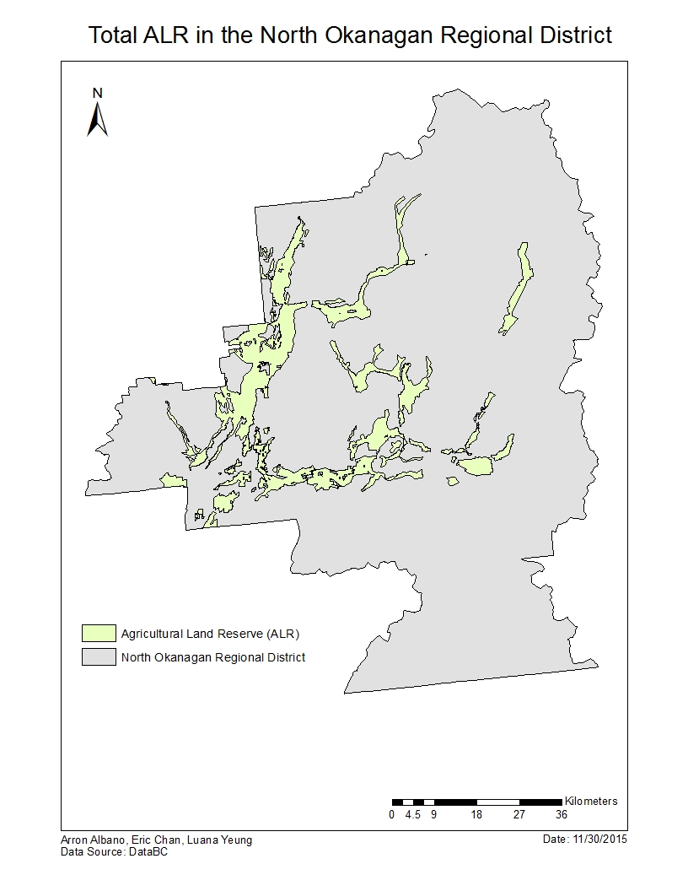

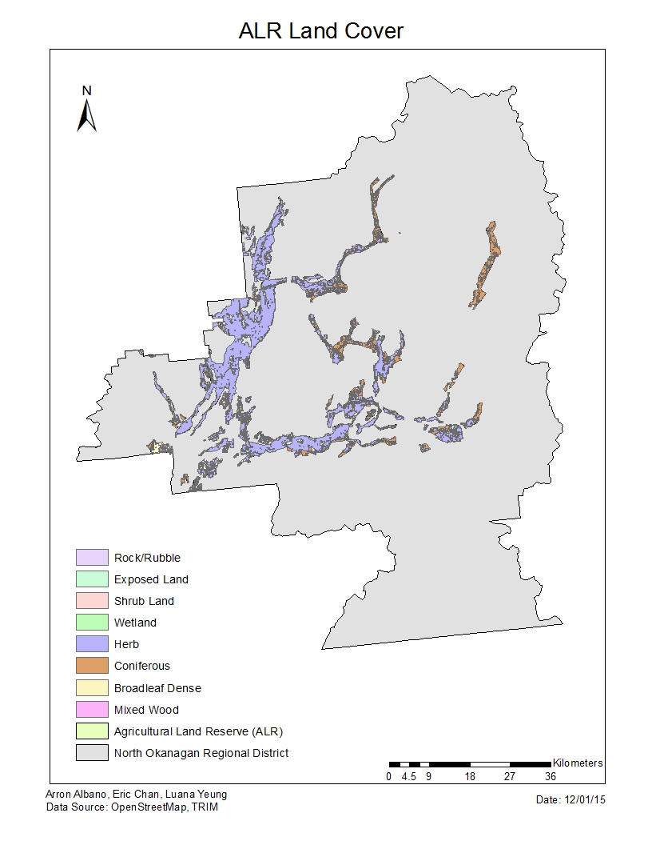

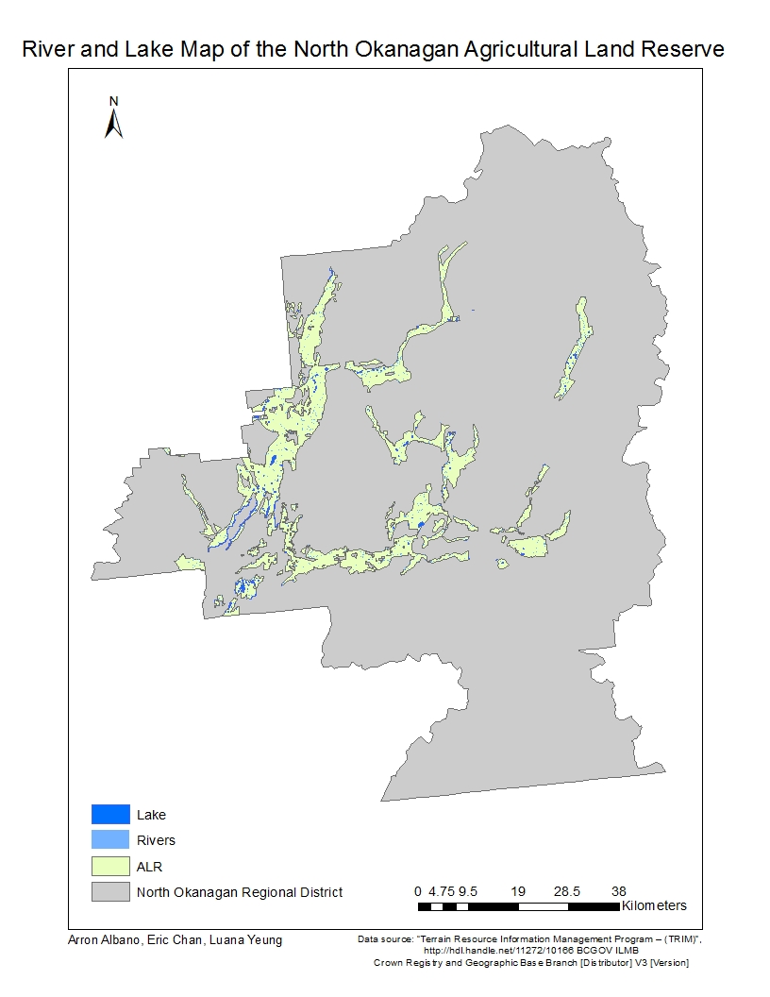

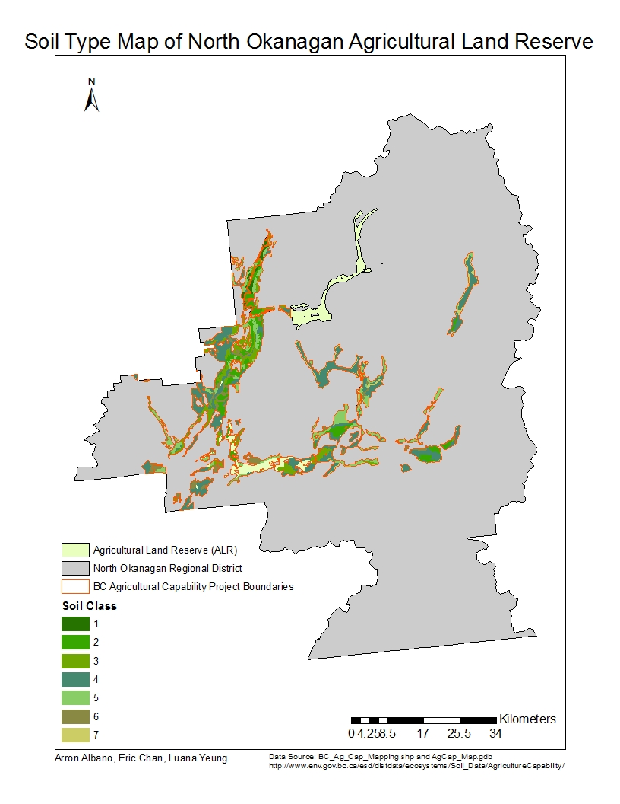

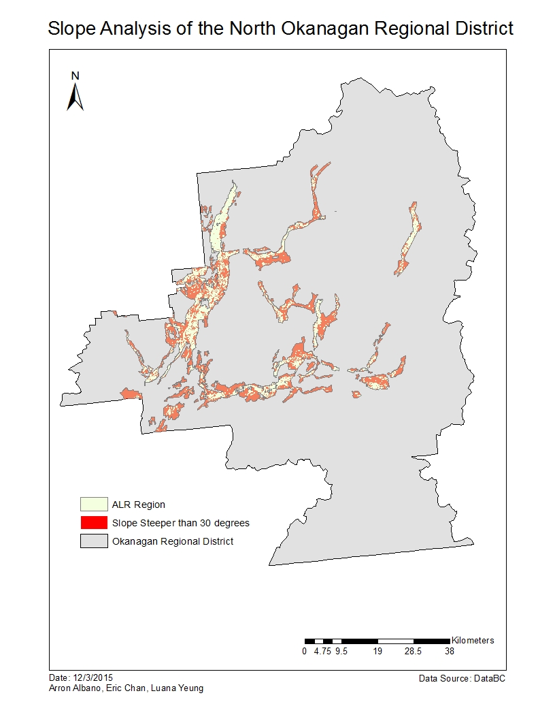

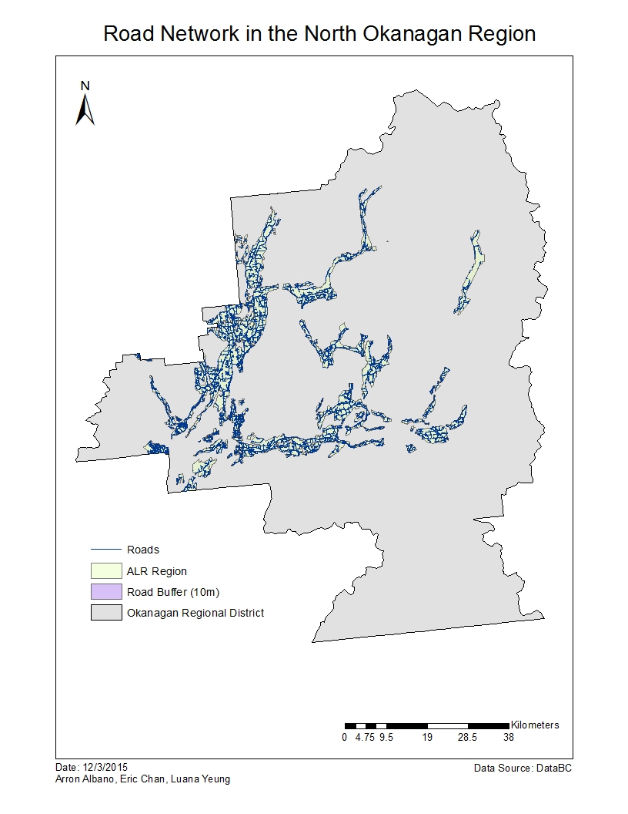

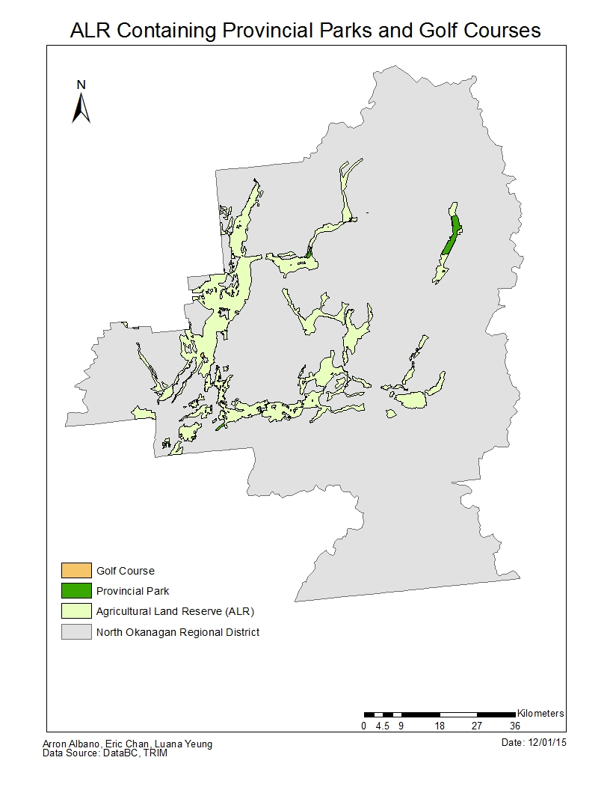

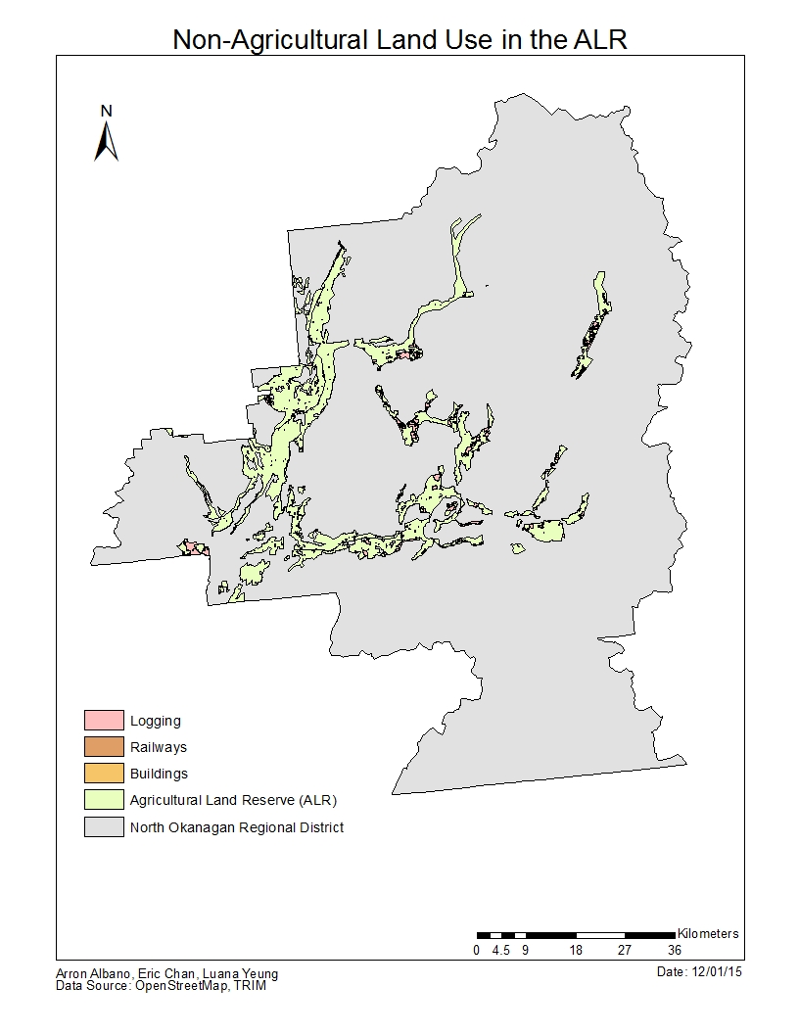

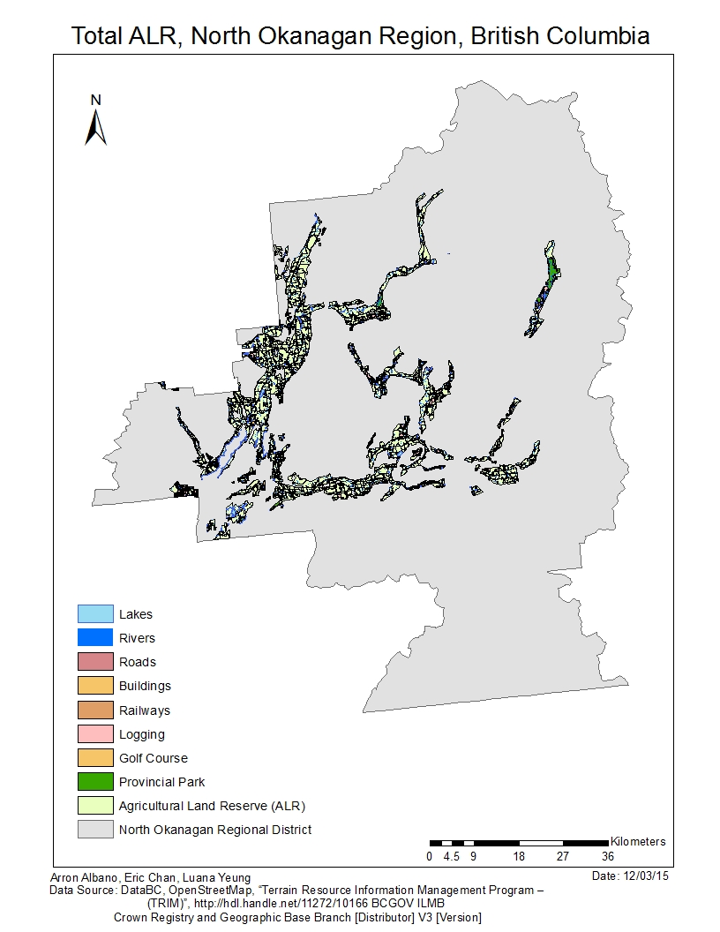

**Flowchart**

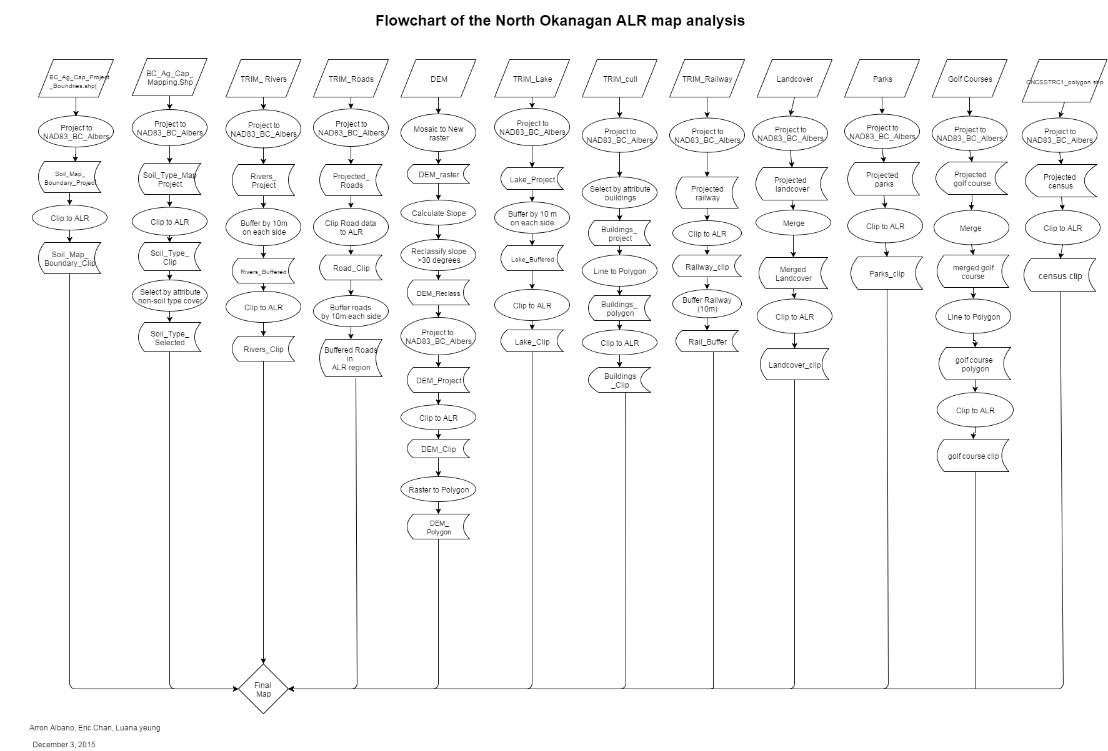

**Team Member Contributions:**

**Arron Albano:**

* Completed Maps 2, 6, 7, 8
* Report writing associated with above mentioned maps and introduction

**Eric Chan:**

* Completed Map 3 (soil and water data)
* Report writing associated with above mentioned maps and conclusions
* Flow chart production

**Luana Yeung:**

* Completed Map 1, 4, 5
* Report writing associated with above mentioned maps and demographics
* Flow chart production