Feasibility Analysis of Placing a Clothing Donation Bin at the UBC Bus Loop

for
AMS council
AMS Student Nest
University of British Columbia

by
Lucy Li
ENGL 301 Student

March 16, 2022

Table of Contents
I. INTRODUCTION 3
A. Background 3
B. Statement of Problem 3
C. Purpose of this report 3
D. Brief description of data sources 4
E. Scope of the report 4
II. DATA SECTION 5
A. Clothing donation bin or donation services at UBC 5
1. Residences 5
2. AMS Student Nest 6
B. Survey from UBC staff and students 6
1. Clothing Purchase Habit 6
2. Use of clothing bin or clothing banks 7
3. Thoughts if a clothing donation bin is available 8
C. Benefits of having a clothing donation bin 9
III. CONCLUSION 9
A. Summary of overall findings 9
B. Recommendations 10
Works Cited 12

INTRODUCTION

Background
Clothing donation bins are the big containers that are found in public and private areas where individuals can donate their clothing. These clothing donation bins help recycle clothing that many people do not use anymore to donate to people in need and raise funds for programs, charities, and the food bank. Every season, many individuals would purchase new clothing to add to their closet, and at the same time, many pieces of well-kept garments would be disposed of and end up in landfills. With over 50,000 students attending UBC, it is essential to decrease the amount of clothing going into landfills and increase positive impacts on the environment and the community.

Statement of Problem
Many students in UBC do not know about clothing recycling, which causes them to dispose of their clothing in garbage bins. The students living on-campus and off-campus have limited access to clothing donation bins, and even if they know of the donation bin’s existence, many of them are in a distanced location. Considering the long commute time and the location of the nearest donation bins, it discourages the student from travelling to a specific location to donate clothes, which results in disposing of them at the nearest garbage bin.

Purpose of this report
This report aims to present the findings on the data sources and propose a solution to the problem of the inconvenience of access to clothing bins on campus by placing a clothing donation box on campus. The solution will provide easier access to clothing donations for students and staff. At the same time, contribute to sustainability by reducing the textile garbage going into landfills.

Brief description of data sources
The primary data source in this report is the results from the surveys filled by UBC students and staff. The survey consists of nine multiple choices to ask for the students' and staff’s opinions on clothing donation and the use of clothing donation bins. The secondary source of data is from the findings from online resources that are related to clothing donation bins and the university’s involvement.

Scope of the report
To assess the feasibility of placing a clothing donation bin at the bus loop, the paper will address the following:
- What do students do with their unwanted clothing?
- What locations in UBC collect clothing or accept clothing donations?
- What are the costs and safety measures of the donation bins?
- How to maintain the organization and collection of clothing from the bins?
- How do students feel about using clothing donation bins?

DATA SECTION

Clothing donation bin or donation services at UBC
UBC has put in many efforts through recycling stations and other events to contribute towards zero waste by waste diversion (“Zero Waste Action Plan”). The efforts include the sort-it-out stations in multiple locations on campus and the different events and groups that contribute to a more sustainable lifestyle.

Residences
According to the UBC student residence website, every residence has a sorting area with bins for food scraps, recyclables, cardboards, garbage, electronic waste, and charitable donations (“Services & Amenities”). The students living in residence have access to the sorting area and can identify which bin the different types of waste belongs to.
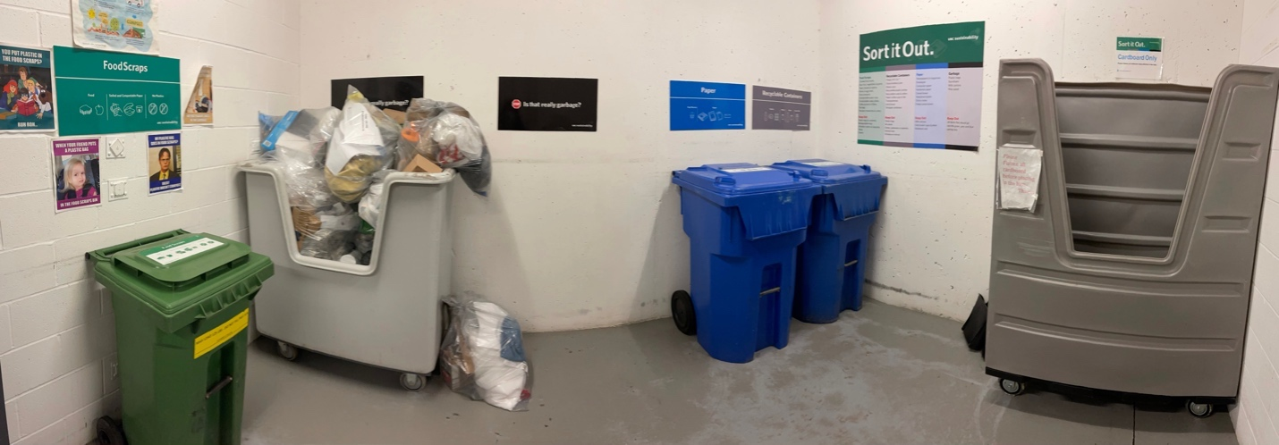
Figure 1: Sorting Area at Ponderosa Commons
However, these sorting areas do not have all the bins stated on the website and do not have a bin that accepts clothing. These bins and labels leave students to dispose of their clothing as garbage since the other bins do not accept clothing.

AMS Student Nest
There is a UBC Free Store located in Room 2102 in the AMS Student Nest is a store that focuses on environmental awareness through circulating products, clothing, and consumer good within the UBC (“UBC Free Store”). Individuals from UBC can take what they need with no costs and donate what they do not need for others. However, not everyone knows of this store since its marketing still needs improvement compared to the other stores or services in the Nest.

Survey from UBC staff and students
A survey consisting of nine multiple choice questions was designed and sent to UBC students and staff to obtain their opinions on clothing donation bins and their clothing purchase habit. The results from the completed surveys are voluntary and anonymous and does contain questions that identifies the participant.

Clothing Purchase Habit
There are over 50 000 students enrolled at the Vancouver UBC campus, of which 11 000 students of them live in UBC housing (University of British Columbia, 2021). It is natural for such a large population to purchase many multiple pieces of clothing articles throughout their lifetime and, at some point, dispose of them when not in need anymore.
As shown in Figure 2, 28% of the participants purchase clothing more than ten times a year, while 24% only purchase once or twice. The trend shows two main types of clothing purchase habits amongst the students; some students purchase a lot while the others seldomly purchase.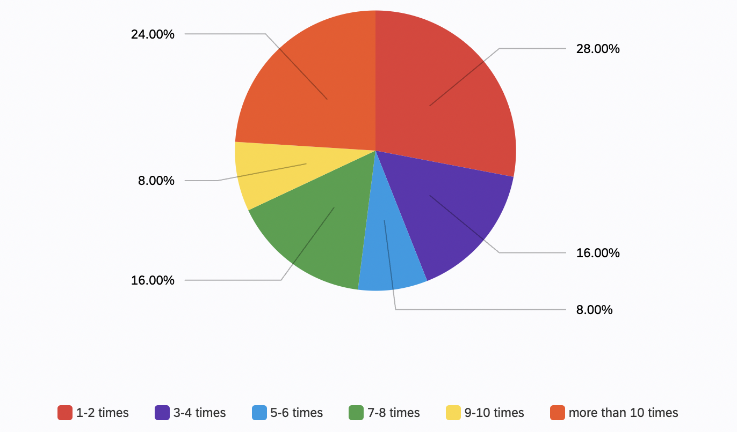
Figure 2: Survey - Q1 How often do you purchase clothing per year?
The students who purchase clothing more than ten times a year are likely to dispose of the same amount of clothing, especially when they continue to purchase more in the following years.

Use of clothing bin or clothing banks
Out of all the responses for question 2, 80% of the participants indicated using donated clothing or clothing donation bin, while 20% indicated the opposite. The results show that the student has the motivation to participate in donating their unused clothing.
Figure 3: Survey - Q2 Have you donated clothing through a clothing bin or donation services before

Thoughts if a clothing donation bin is available
Figure 4 consists of 7 questions with results from the participant’s opinions about clothing donation bins. Over 50 % of the participants state that they have access to a clothing bin or clothing donation service and know they can donate clothes they do not wear anymore. In addition to this, over 60% of the participants think that it would be convenient to donate clothes at a clothing donation bin of it is located at the UBC bus loop. There is a strong agreement of 92% that they will use a clothing donation bin instead of disposing of the clothing in a garbage bin.
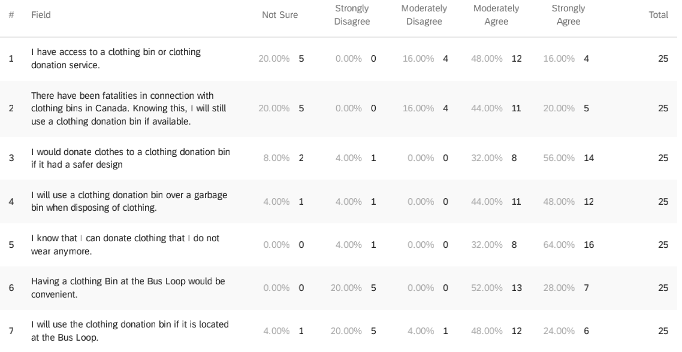
Figure 4: Survey Matrix Table– Do you agree or disagree with each of the following?
Although, there have been fatalities connected with clothing donation bins in Canada, which led to a consideration banning the use of clothing donation bins. The participants expressed that they would continue to use a clothing donation bin if it is available and has a safer design.

Benefits of having a clothing donation bin
On average, Canadians purchase seventy pieces of clothing a year, contributing to the twelve million tons of textile waste in the North American landfills (“Clothes from Canada”). This is why it is important to have access to clothing donations or clothing donation bins. Clothing donation bins are well known for collecting used clothing. A significant portion of the clothing collected is sorted and resold, which decreases the amount of textile waste going into landfills. These clothing donation bins have been creating jobs for people who collect the clothing and transport them and at the same time can raise up to $15 000 a year by selling them to stores like Value Village (Little and Stewart, 2019). Even if not the choice is not to sell the clothing, it can still benefit by transferring it from individuals who do not need them and provide it to the individuals who need them.

CONCLUSION

Summary of overall findings
To summarize all the information from the survey completed by UBC students and staff and the sources on clothing donation bins, it suggests that placing a clothing bin accessible to students and staff will positively impact the environment and the community. UBC is making significant efforts to be sustainable and focus on their environmental awareness and can continue to positively impact by decreasing the textile waste that ends up in landfills. In addition, placing a clothing donation bin will create job opportunities for some individuals and raise funds for meaningful services or events. The students and staff at UBC have expressed their opinion through the survey. They agree that having a clothing donation bin will benefit the convenience of access for donating clothing.

Recommendations
A solution to the problem is placing a clothing donation bin at the University of British Columbia’s bus loop. The bus loop is the area on campus where all busses that arrive on campus will drop off the passengers. Having a clothing donation box at this location would allow students and staff easy access to donate their clothes. In Figure 5, a green squared object is placed and displays a possible placement location for a clothing donation bin. This location is right at the bus loop drop-off area and next to the UBC Aquatic Centre.
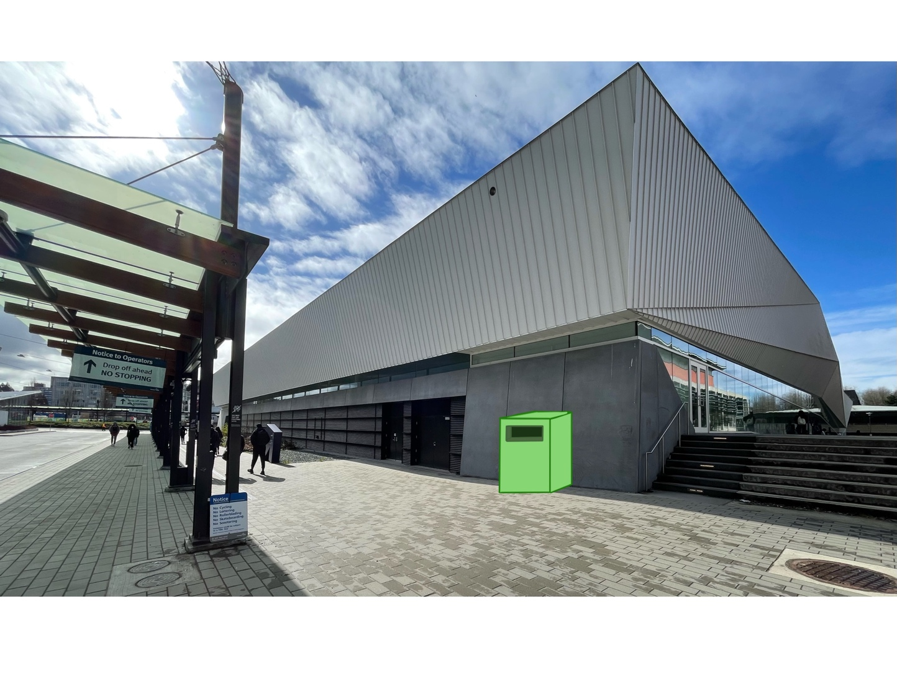
Figure 5: Mock-up clothing donation bin at Bus loop drop-off and UBC Aquatic Centre
With the number of students in UBC taking the bus daily to and from school, this location acts as the most convenient place to drop off unwanted clothing for donations. Student can pack their clothing, commute to school, and drop off the package on their way to class when they get off the bus. To further support this solution, more individuals need to know about the existence of this clothing donation bin. Therefore, AMS can post this on their social media to increase the students’ and staff’s awareness of the clothing donation bin and encourage them to be more environmentally friendly.
Overall, the addition of this clothing bin can help raise funds to support other programs at UBC like the AMS Food Bank. This proposal will be able to collect from the many UBC individuals and give back to the UBC community in another way.

Works Cited
“Clothes from Canada Account for Huge Waste | CBC Marketplace.” CBCnews, CBC/Radio Canada, 18 Jan. 2018, https://www.cbc.ca/player/play/1140389443838.
Little, Simon, and Nadia Stewart. “Don't Overlook Benefits of Donation Bins Amid Safety Movement: B.C. Non-Profit.” Global News, Global News, 10 Jan. 2019, https://globalnews.ca/news/4832835/benefits-donation-bins-safety-movement-non-profit/.
“Services & Amenities.” Vancouver, https://vancouver.housing.ubc.ca/residence-life/services-amenities/. Accessed 13 March 2022.
“UBC Free Store.” The UBC Student Environment Centre, 23 Nov. 2017, https://secubc.com/ubc-free-store/.
University of British Columbia. (2021). University of British Columbia Annual Enrolment
Report 2020/21. Retrieved from https://academic.ubc.ca/sites/vpa.ubc.ca/files/ documents/UBC-Enrolment-Report-2020-21.pdf
“Zero Waste Action Plan.” Sustain.ubc.ca, https://sustain.ubc.ca/campus/recycling-waste/zero-waste-action-plan. Accessed 13 March 2022.

