Unit Test: Atoms, Elements, and Compounds

Circle physical or chemical change for the following questions. (8 marks)

1) Metal glowing red when heated | Physical / Chemical
2) Calcium metal placed in water and hydrogen gas was released | Physical / Chemical
3) Soaking your clothes in water | Physical / Chemical
4) Folding a paper airplane | Physical / Chemical
5) Sliced avocadoes browning in your fridge | Physical / Chemical
6) Your stomach acid breaking down ingested protein | Physical / Chemical
7) Baking bread | Physical / Chemical
8) Plants making food and growing under sunlight (photosynthesis) | Physical / Chemical

Draw Bohr diagrams for the following (5 marks each):

9) C

10) O²⁻

11) Ca²⁺

12) Cl

Given two elements/polyatomic ions, write the proper chemical name and chemical formula for the following (3 marks each):

Elements/Polyatomic ions | Chemical Name | Chemical Formula
13) Cobalt (III) + Oxygen
14) Hydrogen + Iodine

15) Tin (II) + Hydroxide
16) Calcium + Sulphur

17) Aluminium + Chromate
18) Ammonium + Hypochlorite

19) Niobium (V) + Perchlorate
20) Potassium + Oxygen
21) Zinc + Cyanide
22) Barium + Selenium

***You can do it!!! Keep going!***
23) A typical substance changes from gas -> liquid -> solid.

a) What is the state change from gas to liquid? (1 mark)

b) What is the state change from liquid to solid? (1 mark)

c) Draw pictures to describe the motion and the spacing between particles in a gas, liquid, and solid. (2 marks each)

Gas Liquid Solid

d) Is the empty space between particles increasing or decreasing during this process:
(gas -> liquid -> solid)? (1 mark)

e) Explain how the motion of particles are changing to justify your response in #d. (1 mark)

f) During which state is this substance the densest? The least dense? (2 marks)

g) How does the spacing between particles explain why your response in #f is the densest? (Hint: what is the equation to calculate density?). (3 marks)

24) For any element: Atomic Mass - Atomic number = __________________________(1 mark)

25) A student claims that compounds cannot be pure substances because compounds are composed of more than 1 different type of element. Is this student correct? Why or why not? (1 mark).

26) What do elements in the same row have in common? (1 mark)

27) What do elements in the same column have in common? (1 mark)

28) Why does an Aluminium ion typically have a +3 charge? Why not a + 5 or +1 charge? (1 mark)

29) Metals have many unique properties. Choose a property of metal from the list below and describe this physical property. (1 mark)
- Malleability
- Ductility
- Magnetism
- Conductivity

30) What did Bohr contribute to the model of the atom? (1 mark)

31) Write an example of a chemical or physical change. State whether it is a chemical or physical change, endothermic or exothermic, and reversible or irreversible. Justify why it is physical/chemical, endothermic/exothermic, and reversible/irreversible. (7 marks)

Bonus Questions:

1) A student added solution A to solution B and a precipitate immediately formed. This student claims solidification has happened because liquids turned into a solid. Is this student correct? Why or why not? Is this a physical or chemical change? (3 marks)

2) a) Covalent bonds are formed by atoms sharing their electrons. Although this is different in ionic compounds, what are the atoms in both types of compounds trying to achieve? Why?
(1 mark)

b) Based on what you know about the valence shell of metals, why are covalent bonds almost never formed with metal elements? (1 mark)

c) Electronegativity is the tendency of an atom to attract electrons. Below is an electronegativity chart of your periodic table.
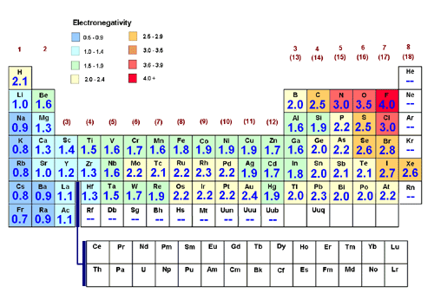
The larger the number in the box, the more electronegative is the element. Find trends on this chart and use what you know about periodicity (valence electrons, energy levels) to explain why these trends occur. (2 marks)

