Graphing Acceleration

A Velocity-Time Graph shows how an object's velocity changes over time.

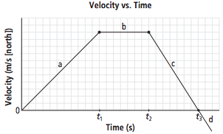
Time plotted on the x-axis.
Velocity plotted on the y-axis.

Constant acceleration: acceleration is not changing. Object is speeding up/slowing down at the same rate.

Slope of a Velocity-Time Graph: ___________________________________________

Slope = rise/run = Δv/Δt = ________________________________________

Let's try finding a slope!

Assume every box is 1 unit for the graph above. For example, at t₁ time elapsed would be 11s because there are 11 units from t = 0s.

Find the slope from t = 0 to t₁. Don't forget units and direction!

Where is the slope positive? a / b / c

This means that the average acceleration is_______________________________________

Where is the slope negative? a / b / c

This means that the average acceleration is_______________________________________

Where is the slope zero? a / b / c

This means that the average acceleration is_______________________________________
and that the velocity__________________________________________.

Find the slope from t₂ to t₃.

**Challenge!

Find the area under the graph. To do this you multiply the velocities by their time (be careful of triangles). What do you get when you multiply the velocities by their time? Use the units as hints. Lastly, multiply this value by the total time at t₃. What are the new units? What did you just find?

