Chromatin DNA Structure and Protein Expression
It is well understood today that the hereditary blueprint of our cells is stored in the form of chromosomes, made up of individual genes that are themselves composed of DNA. The DNA of each gene encodes the information needed for the production of a specific protein that is needed for the structure and/or function of cells.
The process of protein expression involves two key steps:
- Transcription of the DNA sequence of the gene to a molecule of messenger RNA (mRNA), and
- Then translation of the mRNA structure into the amino acid sequence of the protein product.
There are tens of thousands of individual proteins that are coded for by tens of thousands of individual genes, required for every cell of the human body. Hence, a large amount of DNA must be stored in the relatively small volume of the cell nucleus.
The Chromatin Structure
To accommodate the large mass of genetic material within the nucleus, DNA is packaged into a condensed structure referred to as chromatin. Chromatin is actually composed of a combination of DNA, proteins (mainly proteins known as histones) and some RNA. The histones form disc-like structures around which portions of the DNA wrap itself to form structural units, called nucleosomes, resembling beads along a string (Figure 1).

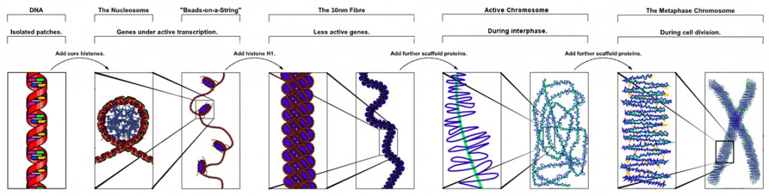

Figure 1 – The increasing structural complexity of genetic information from the double-helical structure of DNA (left) through nucleosome and chromatin structures (middle) to the chromosome (right).

Chromatin can exist in two conformational states:
- Heterochromatin, which is largely transcriptionally inactive preventing gene expression, and
- Euchromatin, which is transcriptionally active allowing gene expression

Heterochromatin
The chromatin can fold upon itself to compact the nucleosomes, forming a highly condensed structure, referred to as heterochromatin. This provides an effective mechanism for storing a large quantity of DNA in a very small volume.

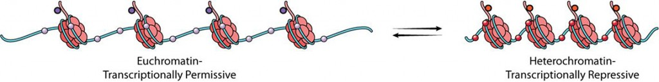
Euchromatin
This more relaxed chromatin structure is referred to as euchromatin. These reversible modifications, which result in chromatin relaxation, are performed by selective enzymes within the cell (Reference 1, Reference 2).
Figure 2 – The conformational transition between heterochromatin and euchromatin. Copeland et al (2012) Targeting Genetic Alterations in Protein Methyltransferases for Personalized Cancer Therapeutics. Oncogene, submitted.

Source (with modifications): http://www.epizyme.com/epigenetics/about-epigenetics/chromatin-dna-structure-and-protein-expression/

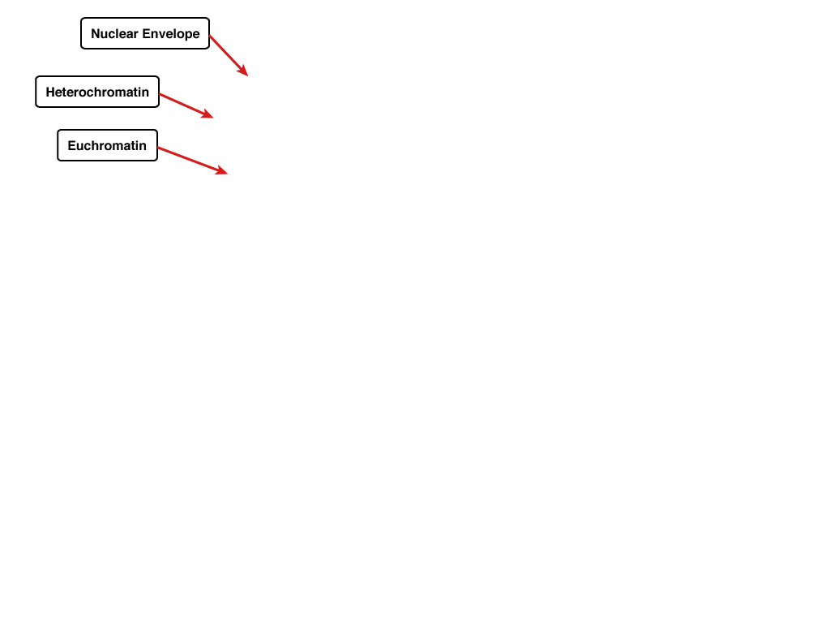
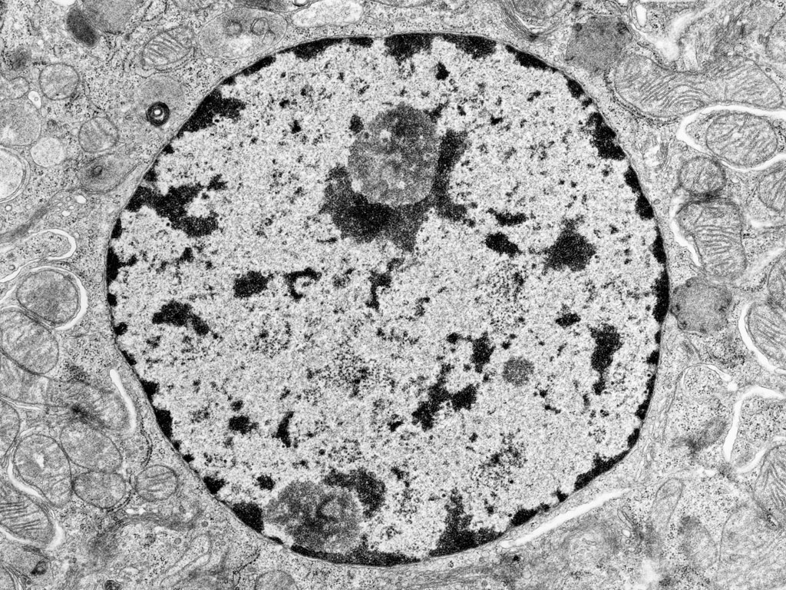
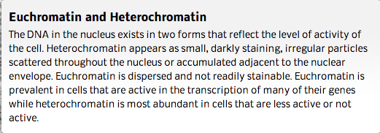

Source: http://medcell.med.yale.edu/histology/cell_lab/euchromatin_and_heterochromatin.php

