Interference and Diffraction

Diffraction and Interference both rely on __________________________________________

_________________________________________

When two or more waves pass through a given point, they produce a new wave that is the algebraic sum of the displacements of the individual waves. The resultant wave is the interference of the individual waves.

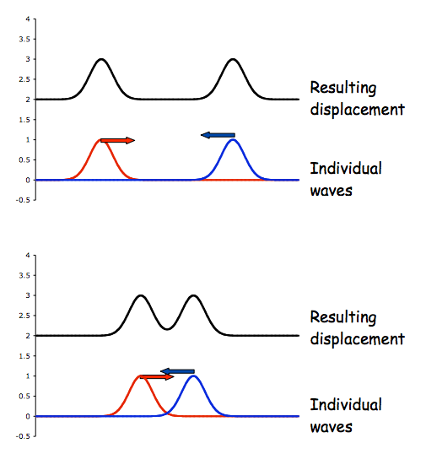
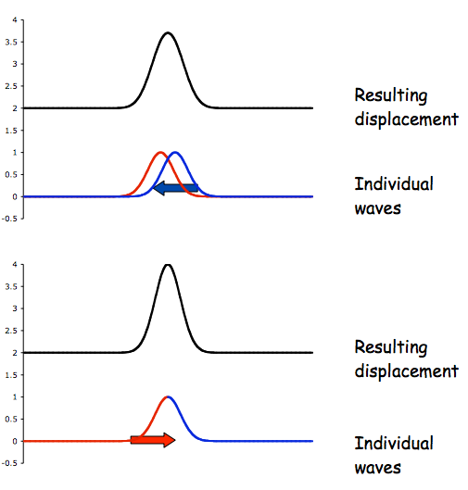
Constructive interference: the individual waves are in phase before they combine. They form a resultant wave that has greater amplitude than the individual waves.

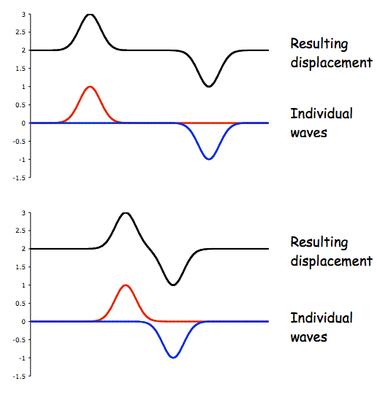
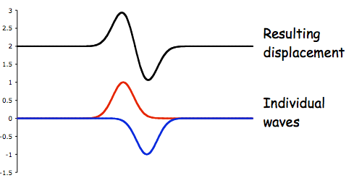
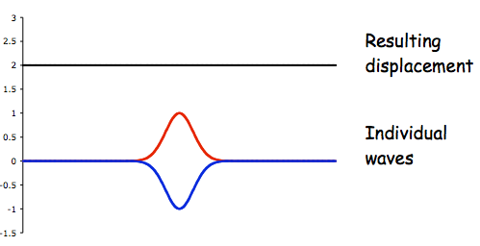
Destructive interference: the individual waves are out of phase before they combine. They form a resultant wave that has lower amplitude than the individual waves.
Coherent sources:

Path difference for
Constructive interference:

Destructive interference:

In optics:

Greater wave amplitude = ______________________________

_________________________________________

Thomas Young first demonstrated interference in light waves from two sources in 1801.

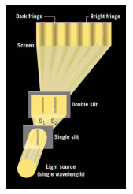
The light from 2 slits produces a visible pattern of bright and dark parallel bands called fringes on a screen.

Bright/dark bands are due to constructive/destructive interference.
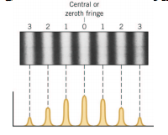

Constructive interference:

Destructive interference:

Diffraction

Definition: ____________________________________________________________________________________________________________________________________________________________

Huygens' principle: ________________________________________________________________________________________________________________________________________________________________________________________________________________________________________________________________________________________________________________________

Single-slit diffraction

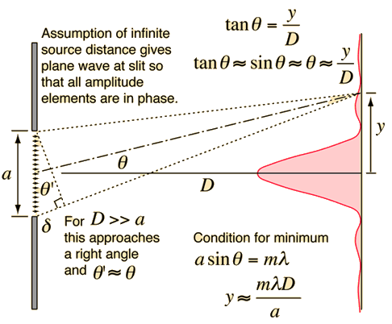
Central fringe: wide and intense

The fringes on either side of the central fringe fall off in intensity and are narrower.

Dark fringes

Width of central fringe
Problems
The Principle of Linear Superposition
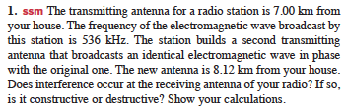
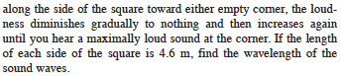
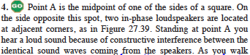
Textbook - #45 (pg 347)

Interference - Young's Double Slit Experiment
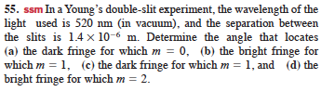
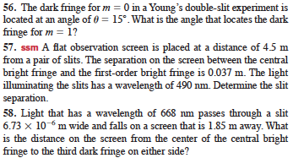
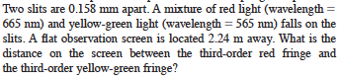
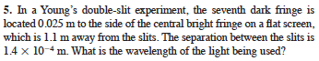
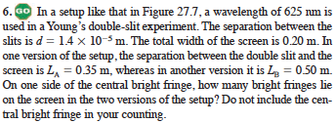
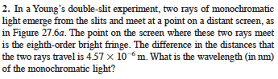

Diffraction - Single Slit Diffraction

Single Slit Diffraction
