Building an Atom

Make sure your screen looks like this:
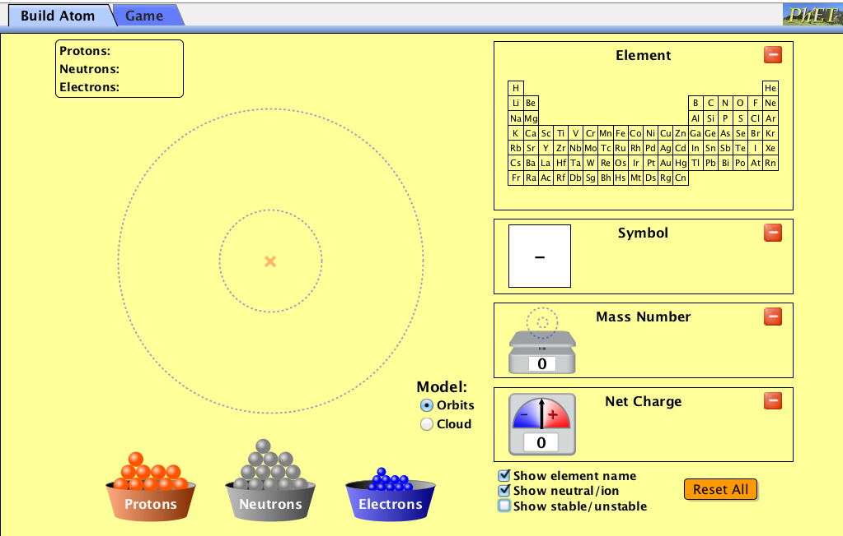
4
3
2
1

1) Maximize the symbol chart.
2) Maximize the mass number chart.
3) Maximize the net charge chart.
4) Uncheck the "show stable/unstable" option.

5) Make the following and draw the diagram under the symbol chart (periodic table box). State the mass number and net charge for each example.
5 protons
6 neutrons
5 electrons
Mass number:
Net charge:
2 protons
2 neutrons
2 electrons
Mass number:
Net charge:
6 protons
6 neutrons
6 electrons
Mass number:
Net charge:
1 protons
0 neutrons
0 electrons
Mass number:
Net charge:
7 protons
7 neutrons
10 electrons
Mass number:
Net charge:

6) When drawing a Bohr model for a positive or negative ion, how do you modify the number of electrons you add?
________________________________________________________________________________________________________________________________________________________________________________________________________________________________________________________________________________________________________________________

7) Draw the Bohr model for the below. You may use PhET to help you.
a) Be²⁺ b) F⁻

8) Draw the Bohr models for O²⁻ and Al³⁺. What do you notice?
____________________________________________________________________________________________________________________________________________________________

9) Check the "show stable/unstable" option.

10) Make the Hydrogen atom on PhET (1 proton, 1 electron).
11) Add 1 neutron. What do you notice?
______________________________________________________________________________
12) Add 1 more neutron (2 neutrons total), then add a third neutron. What do you notice?
______________________________________________________________________________

13) What questions may you have at this point?

14) Google "hydrogen unstable nucleus" (you can use your own keywords instead). Scan through a few sites and record any findings that are interesting to you.

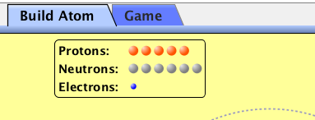

Bonus Challenge!

15) On the tab located at the top of your PhET simulation window, select the "Game" tab.
Play each level a few times and record your fastest time for perfect scores only (10/10). Don't forget to turn on the time tracker at the beginning of the game. Players with the top 3 fastest times for each level gains bonus points for this assignment. Points are stackable for the 4 levels. Ties are friendly. Save a screen shot of your fastest time for each level and e-mail them to msli.learning@gmail.com before 11:59pm on Sun Feb 22, 2015 for your time to count. *Condition: you must have completed the rest of this handout before attempting this* Individual records only.

Records
 | Level 1 | Level 2 | Level 3 | Level 4
Time

