The Physics of a Relay Race

Your group of four will be competing in Canada's National Track and Field competition for a 4 x 100m relay race that is coming up in 2 weeks! Strategy in the team design and handoffs are very important in creating your best game. You have a rule package as a guide. Propose a method for the best baton exchange between your partners. Based on your calculations, what is the fastest time that your team finishes the race?

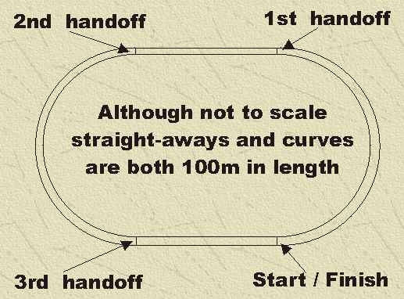

Guiding questions:
1) How fast is each runner? What might be the best way to line your team up? Who passes the baton who?
2) How long can each runner hold his/her maximum speed?
3) How long does it take each runner to speed up to his/her fastest speed? How long does this take? Why could this be important?
4) What should the runners be doing before and after the handoff?
5) How is your team going to tackle running curves?
6) Are there any assumptions made?

