Unit Test
Chapter 3: Motion
Science 10
11 pages
52 marks total & bonus 8 marks
1 hour 20 minutes

Name______________________________________________________

Date______________________________________________________

True/False. Select ONE best answer for each question. (1 mark each)

1) Displacement is a vector.
A) True | B) False

2) An object traveled a distance of 10m so its displacement must also be 10m.
A) True | B) False

3) An object with an acceleration of 0 must be at rest.
A) True | B) False

4) When an object's acceleration is in the same direction as its velocity, it's speeding up.
A) True | B) False

5) When any object's acceleration is negative it always means its slowing down.
A) True | B) False

Multiple Choice. Select ONE best answer for each question. (1 mark each)

6) The SI units for velocity are.
A) m | B) s/m
C) m/s² | D) m/s
E) s⁻¹

7) Runner A has an average speed of$s$running a relay race. If runner B takes twice the time to cover the same distance, compared to $s$, runner B's average speed is
A) The same | B) Doubled
C) Halved | D) In the opposite direction
E) 0 m/s

8) Change in position is?
A) | Distance
B) | Displacement
C) | Time
D) | Velocity
E) | Acceleration

9) A negative slope on a position-time graph describes:
A) | Displacement in the negative direction
B) | Velocity in the negative direction
C) | Acceleration in the negative direction
D) | An object going down the hill
E) | An object going back in time

10) Maggie traveled 10m [S] then 20m [N]. Her displacement was
A) 0m | B) 10m [S]
C) 10m [N] | D) 30m [S]
E) 30m [N]

11) How many km/h are in ONE m/s?
A) 1 | B) 3.6
C) 0.28 | D) 1000
E) 3600

12) Analyze the table describing the motion of an object below. What must be true?

Displacement (m) | Time (s)
0.0 | 0.0
+1.5 | 2.0
+3.0 | 4.0
+4.5 | 6.0

A) | The displacement between each time interval is equal
B) | The object is in uniform motion
C) | The object has 0 acceleration
D) | A and B
E) | All of the above

13) Mario takes 2 seconds to reach 5m/s from rest. Pikachu takes 4 seconds to reach 10m/s from rest. How do their accelerations compare?

A) | They had no acceleration
B) | Mario's acceleration is greater because he took less time
C) | Pikachu's acceleration is greater because he reached a higher speed
D) | They had the same acceleration because their rates in velocity change were the same
E) | None of the above

14) Negative velocity change means

A) | Zero acceleration
B) | Final velocity is greater than initial velocity
C) | Final velocity is less than initial velocity
D) | Acceleration is changing
E) | None of the above

15) A child throws a ball upwards with a certain velocity, which of the following must be TRUE?

A) The ball's upward velocity is NON-ZERO and the acceleration due to gravity is ZERO.
B) The ball's upward velocity is CONSTANT and the acceleration due to gravity is CONSTANT.
C) The ball's upward velocity is CONSTANT and the acceleration due to gravity is CHANGING.
D) The ball's upward velocity is CHANGING and the acceleration due to gravity is CONSTANT.
E) The ball's upward velocity is CHANGING and the acceleration due to gravity is CHANGING.

16) A positive slope on a velocity-time graph measures
A) Positive velocity | B) Positive displacement
C) Negative velocity | D) Negative velocity
E) Positive acceleration

Below is a velocity-time graph of an object's motion to answer questions 17 and 18.

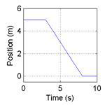
A
B
C
Velocity (m/s)
17) Where is the object's acceleration zero?
A) | A
B) | B
C) | C
D) | A and C
E) | A, B, and C

18) Where is the object not moving?
A) | A
B) | B
C) | C
D) | A and C
E) | A, B, and C

For questions 19 and 20 on the next page, use the below scenario to answer them.

A man starts at the origin, walks back slowly and steadily for 6 seconds. Then he stands still for 6 seconds, then walks forward steadily about twice as fast for 6 seconds.
19) Which of the following position-time graph best depicts the scenario?
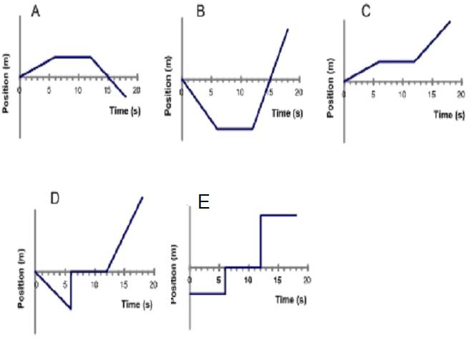
20) Which of the following velocity-time graph best depicts the scenario?

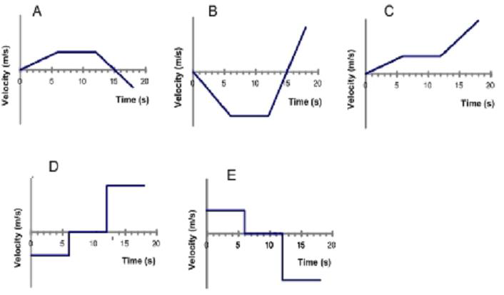

End of Multiple Choice section.
**Keep going!! You can do it!**

Written Section. Show ALL your work. (32 marks)

21) Jerry travels 8m to the right then 2m to the left in 3.5s.
a) Calculate Jerry's total distance. (2 marks)

b) Calculate Jerry's total displacement. (2 marks)

c) Calculate Jerry's average speed. (3 marks)

d) Calculate Jerry's average velocity. (3 marks)

e) Calculate Jerry's average velocity in km/h (2 marks)

22) Tom went from 1.2m/s [E] to 1.2m/s [W] in 0.25s. What was Tom's acceleration? (3 marks)

23) Jerry pushed Tom off the top of the sofa from rest. If it took Tom 0.75s to hit the ground, what was Tom's final velocity before he hit the ground? (3 marks)

24) Tom had to get a quick bite to eat before heading off to bed. He started from rest and rushed to the kitchen with an acceleration of +0.25m/s². If his final velocity was +1.45m/s at the kitchen, how long did it take for him to reach the kitchen? (3 marks)

25) Use the following position-time graph of an object to answer the following questions.
Position vs. Time

a) What is the object's position at t = 2s? (1 mark)

b) What is its velocity from t = 0s to t = 5s? (2 marks)

c) What is its total displacement from t = 0s to t = 10s? (2 marks)
26) Use the following velocity-time graph of an object to answer the following questions.
Velocity vs. Time

a) What is the object's velocity at t = 2s? (1 mark)

b) What is the object's acceleration from t = 4s to t = 8s? (2 marks)

c) What is the object's total displacement from t = 0s to t = 10s? (3 marks)

End of Written Section.

Bonus Questions. (8 marks)

I) a) Use the velocity-time graph below to draw the corresponding position-time graph. Make sure your graph fits in the designated space. Assume initial displacement = 0m. (3 marks)

b) Write a story about an object/person following the exact motion described on the graphs. Be sure to clearly describe the motion qualitatively and quantitatively. Find the distance traveled by this object/person. (3 marks)

II) Use $\vec{a}=\frac{\vec{∆v}}{∆t}$ to derive v_{f} = v_{i} + $\vec{a}∆t$. (2 marks)

End of Unit Test.

