Unit Test
Chapter 3: Motion
Science 10 Venture
11 pages
56 marks total & bonus 10 marks
1 hour 35 minutes

Name______________________________________________________

Date______________________________________________________

True/False. Select ONE best answer for each question. (1 mark each)

1) Displacement is a vector.
A) True | B) False

2) An object traveled a distance of 10m so its displacement must also be 10m.
A) True | B) False

3) An object with an acceleration of 0 must be at rest.
A) True | B) False

4) When an object's acceleration is in the same direction as its velocity, it's speeding up.
A) True | B) False

5) A zero slope on a velocity-time graph always means that an object is not moving.
A) True | B) False

Multiple Choice. Select ONE best answer for each question. (1 mark each)

6) The SI units for velocity are.
A) m | B) s/m
C) m/s² | D) m/s
E) s⁻¹

7) Runner A has an average speed of$s$running a relay race. If runner B takes twice the time to cover the same distance, compared to $s$, runner B's average speed is
A) The same | B) Doubled
C) Halved | D) In the opposite direction
E) 0 m/s

8) Change in position is?
A) | Distance
B) | Displacement
C) | Time
D) | Velocity
E) | Acceleration

9) A negative slope on a position-time graph describes:
A) | Displacement in the negative direction
B) | Velocity in the negative direction
C) | Acceleration in the negative direction
D) | An object going down the hill
E) | An object going back in time

10) Maggie traveled 10m [S] then 20m [N]. Her displacement was
A) 0m | B) 10m [S]
C) 10m [N] | D) 30m [S]
E) 30m [N]

11) How many km/h are in ONE m/s?
A) 1 | B) 3.6
C) 0.28 | D) 1000
E) 3600

12) While measuring your ticker tape, you find out that the spacing between each dot is the same. What does this mean?
A) | The displacement between each dot is equal
B) | The time between each dot is equal
C) | The object that you measured had uniform motion
D) | The object had 0 acceleration
E) | All of the above

13) Mario takes 2 seconds to reach 5m/s from rest. Pikachu takes 4 seconds to reach 10m/s from rest. How do their accelerations compare?

A) | They had no acceleration
B) | Mario's acceleration is greater because he took less time
C) | Pikachu's acceleration is greater because he reached a higher speed
D) | They had the same acceleration because their rates in velocity change were the same
E) | None of the above

14) Describe the motion of a car having an initial negative velocity and a positive acceleration.

A) | The car continues to speed up as it is reversing and crashes into a tree.
B) | The car is moving at a constant velocity going backwards and stops.
C) | The car is slowing down as it is reversing, stops for an instant, and starts speeding up going forward.
D) | The car is slowing down in the forward direction, stops for an instant, and starts speeding up going backward.
E) | The car continues to speeding up in the forward direction and crashes into a tree.

15) A plane glides through the air in uniform motion. What could change this plane's velocity?

A) | The plane exerting a thrust on its engines
B) | A strong gust of wind against the side of the plane
C) | Switching the atmosphere from air to a vacuum
D) | A and B
E) | A, B, and C
16) A child throws a ball upwards with a certain velocity, which of the following must be TRUE?

A) The ball's upward velocity is NON-ZERO and the acceleration due to gravity is ZERO.
B) The ball's upward velocity is CONSTANT and the acceleration due to gravity is CONSTANT.
C) The ball's upward velocity is CONSTANT and the acceleration due to gravity is CHANGING.
D) The ball's upward velocity is CHANGING and the acceleration due to gravity is CONSTANT.
E) The ball's upward velocity is CHANGING and the acceleration due to gravity is CHANGING.

17) A steeper positive slope on a velocity-time graph measures a
A) larger run over rise | B) greater acceleration
C) greater velocity | D) greater displacement
E) a steeper hill that a person must climb

18) Below is a graph of a ball's motion. Which one of the following CANNOT describe the ball's motion in either the vertical or horizontal direction?

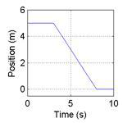
A) | The ball moves along a flat surface. Then it moves forward down a hill, and then finally stops.
B) | The ball doesn’t move at first. Then it moves forward down a hill and finally stops.
C) | The ball is moving at constant velocity. Then it slows down and stops.
D) | The ball doesn’t move at first. Then it moves backwards and then finally stops.
E) | The ball moves along a flat area, moves backwards down a hill and then it keeps moving.

For questions 19 and 20 on the next page, use the below scenario to answer them.

A man starts at the origin, walks back slowly and steadily for 6 seconds. Then he stands still for 6 seconds, then walks forward steadily about twice as fast for 6 seconds.

19) Which of the following position-time graph best depicts the scenario?
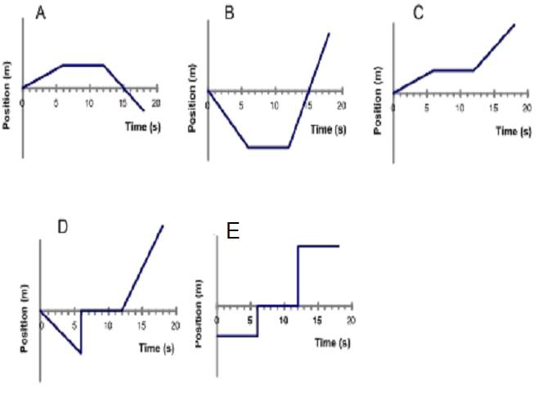20) Which of the following velocity-time graph best depicts the scenario?
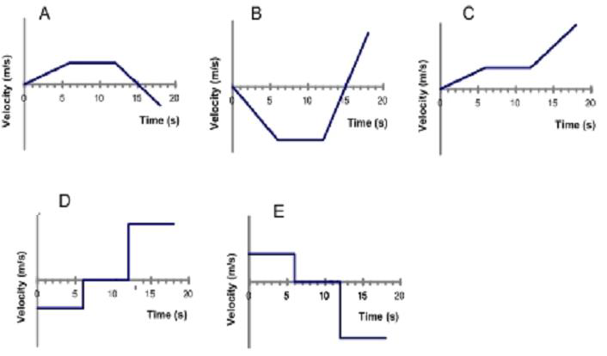

End of Multiple Choice section.

**Keep going!! You can do it!**
Written Section. Show ALL your work. (36 marks)

21) Jerry travels 8m to the right then 2m to the left in 3.5s.
a) Calculate Jerry's average speed. (3 marks)

b) Calculate Jerry's average velocity. (3 marks)

c) Calculate Jerry's average velocity in km/h (2 marks)

22) Tom went from 1.2m/s [E] to 1.2m/s [W] in 0.25s. What was Tom's acceleration? (3 marks)

23) Jerry pushed Tom off the top of the sofa from rest. If it took Tom 0.75s to hit the ground, what was Tom's final velocity before he hit the ground? (3 marks)

24) Use the following position-time graph of an object to answer the following questions.
Position vs. Time

a) What is the object's position at t = 2s? (1 mark)

b) What is its velocity at t = 1s? (2 marks)

c) What is its total displacement from t = 0s to t = 10s? (2 marks)
25) Use the following velocity-time graph of an object to answer the following questions.
Velocity vs. Time

a) What is the object's velocity at t = 2s? (1 mark)

b) What is the object's acceleration from t = 4s to t = 8s? (2 marks)

c) What is the object's average velocity from t = 0s to t = 10s? (3 marks)
26) a) Use the velocity-time graph below to draw the corresponding position-time graph. Make sure your graph fits in the designated space. Assume initial displacement = 0m. (5 marks)

b) Write a story about an object/person following the exact motion described on the graphs. Be sure to clearly describe the motion qualitatively and quantitatively. Find the distance traveled by this object/person. (6 marks)

End of Written Section.

Bonus Questions. (10 marks)
I) Use $\vec{a}=\frac{\vec{∆v}}{∆t}$ to derive v_{f} = v_{i} + $\vec{a}∆t$. (2 marks)

Use the following graph for bonus questions II to IV.
The 2 points on the graph are labeled for you and v_{i} is > 0.

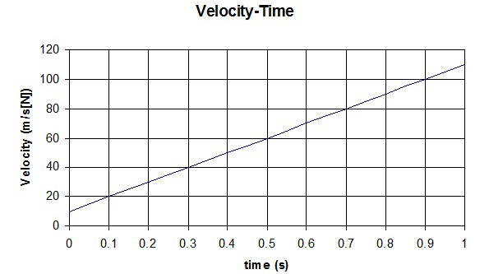
(t_{i}, v_{i})
(t_{f}, v_{f})
II) An important physics equation of motion is $∆d=\frac{1}{2}\vec{a}{∆t}^{2}+v_{i}∆t$, where $∆d$ is the total displacement. Use what you know about graphical analysis and equations on your formula sheet to derive $∆d=\frac{1}{2}\vec{a}{(∆t)}^{2}+v_{i}∆t$. (3 marks)

III) Average velocity can be calculated using another equation ${\vec{v}}_{av}=\frac{(v_{f}+v_{i})}{2}$. This equation assumes constant acceleration between times t_{i} and t_{f}. Use the graph and any equations on your formula sheet to derive ${\vec{v}}_{av}=\frac{(v_{f}+v_{i})}{2}$. (Hint: $∆d$ is the total displacement and the area of a trapezoid is $A_{trapezoid}=\frac{(b_{1}+b_{2})}{2}h$, where b₁ and b₂ are the lengths of the 2 bases and h is the height of the trapezoid) (2 marks)

IV) Another important physics equation of motion is $2\vec{a}(∆d)=v_{f}^{2}-v_{i}^{2}$. Use your answer in the previous question, the graph, and any equations on your formula sheet to derive $2\vec{a}(∆d)=v_{f}^{2}-v_{i}^{2}$. What does this equation assume between times t_{i} and t_{f}? (3 marks)

End of Unit Test.

