Acids and Bases

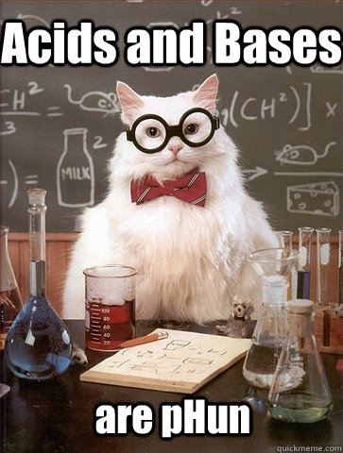
Source: http://catplanet.org/wp-content/uploads/2014/10/Acids-and-Bases-are-pHun.jpg

Ms. L. Li
Email: msli.learning@gmail.com
Office Hours: By appointment (morning, lunch, and afterschool)

Unit Description

In this unit, you will be looking at qualitative and quantitative ways to describe acids and bases. We will look at what makes an acid or base stronger than another using chemical reaction data and equilibrium positions. The idea is to think of an acid or base's interaction with water as an equilibrium process, which determines pH/pOH and chemical reactivity.

Big Ideas
- Not all acids and bases dissociate completely in water, the more they dissociate in water, the stronger they are
- The stronger the acid/base, the more they "don't want"/"want" their proton respectively
- Acid or base alone is different when they're mixed in water. Water acting as a weak acid/base sets pH/pOH limit even when strong acid/base is added
- Water is an equilibrium process that interacts with an acid's or a base's equilibrium
- Safety and application of acid/base reactions in real life situations.
Assessment
- Homework/Hand-ins (class handouts, reflections, activities, and presentations - feedback and completion marks) - 15%
- Labs and projects - 25%
- Quizzes - 20%
- Unit Test - 40%

Useful Links

Coke Cans in Acid and Base - Periodic Table of Videos
https://www.youtube.com/watch?v=WnPrtYUKke8

Other cool Chemistry videos
http://periodicvideos.com/

PhET simulations: Acid and Base solution
http://phet.colorado.edu/en/simulation/acid-base-solutions

Red Cabbage Juice
https://www.teachengineering.org/view_activity.php?url=collection/wst_/activities/wst_environmental/wst_environmental_lesson02_activity3.xml

Khan Academy
https://www.khanacademy.org/science/chemistry/acids-and-bases-topic

