Waves and Optics

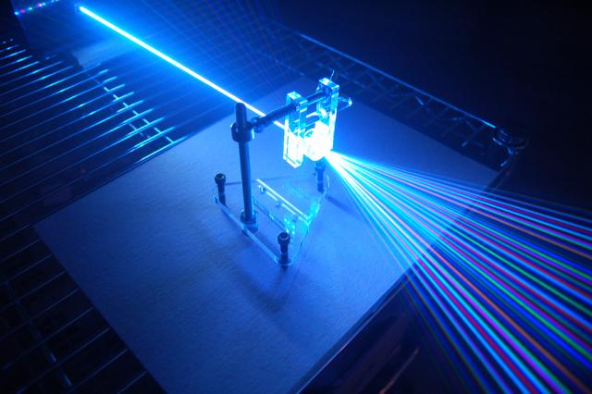
Source: http://apphysicsc.com/wp-content/uploads/2012/08/Diffraction-grating.jpg
Ms. L. Li
Email: msli.learning@gmail.com
Office Hours: By appointment (morning, lunch, and afterschool)

Unit Description
It is important to understand that energy propagated in a wave does not mean matter moves from one location to the other such as throwing a ball against the wall. The energy in a wave is transmitted through disturbances in the medium as the wave passes through. Although there are many types of waves, this unit focuses on electromagnetic waves or light. As light passes through different media, its path may stay the same, bend, or reflect from the boundary between two different media. This unit will look closely at these interactions between light and medium boundaries.

Big Ideas and Skills learned
- Waves transfer energy via oscillations of particles in the medium. Matter does not transfer.
- Decouple displacement-position vs. displacement-time graphs and use these to solve problems
- Pictorially and physically manipulate light. This means being able to position mirrors and lenses to re-direct and focus light.
- Differentiating between virtual and real images by meaning, from calculations, and ray diagrams.
- Explain the consequences when waves interact with each other and with objects with different penetrance
Assessment
- Hand-ins (classroom activities, class handouts) - 15%
- Labs and assignments - 25%
- Quizzes - 20%
- Unit Test - 40%

Useful Links

Crazy Pool Vortex
https://www.youtube.com/watch?v=pnbJEg9r1o8

PhET simulations: Waves and Sounds
http://phet.colorado.edu/en/simulations/category/physics/sound-and-waves
PhET simulations: Light and Radiation
http://phet.colorado.edu/en/simulations/category/physics/light-and-radiation

2-D Ruben's tube
https://www.youtube.com/watch?v=2awbKQ2DLRE

Power of Optics
https://www.youtube.com/watch?v=4nCIzPuLYJA

Khan Academy
https://www.khanacademy.org/science/physics/waves-and-optics

