Tom is chasing Jerry into a corner and Jerry dropped his cheese during the escape!
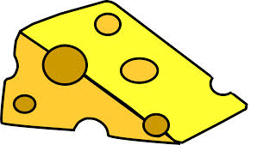
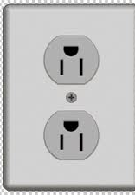
-6m -5m -4m -3m -2m -1m 0 1m 2m 3m 4m 5m 6m 7m

Jerry runs from the flowerpot towards his cheese before he rushes back to his hole behind the electric outlet.

He travels a total distance of 16 meters, but travels a displacement of -4 meters.

1) Define
a) Scalar

b) Vector

2) Classify distance and displacement as a scalar or a vector and justify your response.

3) Why are Jerry's values for distance and displacement different?

4) What would be Jerry's distance and displacement if he started from the electric outlet instead?

5) Write a brief story (1 paragraph max.) for Jerry if his displacement was +4m. What was his distance travelled?

