Now let's add to the previous story of Tom chasing Jerry into a corner as Jerry dropped his precious cheese during the escape!
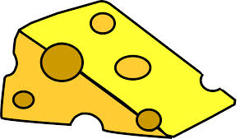
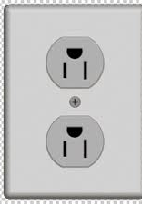
-6m -5m -4m -3m -2m -1m 0 1m 2m 3m 4m 5m 6m 7m

Jerry runs from the flowerpot towards his cheese before he rushes back to his hole behind the electric outlet. He took 8 seconds for the entire journey with a total distance of 16m and displacement of -4m covered.

1) What is the difference between speed and velocity?

2) What is the difference between average velocity and instantaneous velocity?

3) Would you use Jerry's distance travelled to calculate his average velocity? Why or why not?

4) What were Jerry's average speed and average velocity?

5) Imagine Tom started on the very left side of the wall at position -6m. Tom ate a huge meal and is feeling groggy that he's moving very slowly (+0.2m/s) towards Jerry (the right). If Jerry ran the same way he did as previously described, can he make it back to his electric outlet in time? Show your calculations below.

6) What should Tom's mimimum velocity be to catch Jerry before he hides in the electric outlet? Show your calculations below.

