Graphing time! Now let's add more to the previous story of Tom chasing Jerry into a corner as Jerry dropped his precious cheese during the escape!
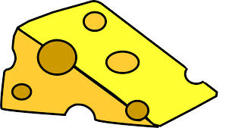
-6m -5m -4m -3m -2m -1m 0 1m 2m 3m 4m 5m 6m 7m

Jerry runs from the flowerpot towards his cheese before he rushes back to his hole behind the electric outlet. He took 8 seconds for the entire journey with a total distance of 16m and displacement of -4m covered.

1) Find Jerry's distance and displacement at each time interval below assuming he was running at constant speed:
Time (s) | 0 | 1 | 2 | 3 | 4 | 5 | 6 | 7 | 8
Distance (m)
Displacement (m)

2) Use the grid space below to draw a position-time graph of Jerry's motion. Make sure to label your intervals for each axis.
Time (s)
Position (m)
3) What is the slope between:

a) 0s and 3s

b) 3s and 8s

4) Draw a line connecting his position at time = 0s and at time = 8s. Find the slope of this line.

5) What do you notice about the slopes you've calculated above?

6) Tom was moving (+0.2m/s) towards Jerry (the right) starting at -6m and hoping to catch Jerry at the electric outlet. Draw his position-time graph below.

Time (s)
Position (m)

