Madison Strasman
ENGL 301 98A
Three Definitions for ‘Contingency’

Introduction

The purpose of this assignment is to compose three definitions for a term common in your field of studies. I chose the term ‘contingency’ and defined it for an individual that is unfamiliar with this word such as a dancer.

Parenthetical definition:

The home sale is not finalized until a thirty-day contingency (agreement required for a transaction to move forward).

Sentence definition:

Term | Class | Distinguishing Features
Contingency | A conditional agreement where a list of conditions is met | In a real estate, required for a transaction to be completed

Expanded definition:

- Analysis of parts

A contingency is an agreement in which conditions must be met to successfully finalize a transaction.
- Contingency requires a buyer and a seller. The buyer is the party responsible for creating contingency.
- Contract is a document where the contingencies are specified to provide a timeline and list specific conditions. This timeline can range from a week to months depending on the conditions set. These conditions can include repairing damaged pipes or allowing the seller a time frame to back out of the offer (The Real Estate Contingency Contract: 8 Common Clauses, 2022).

- Visuals
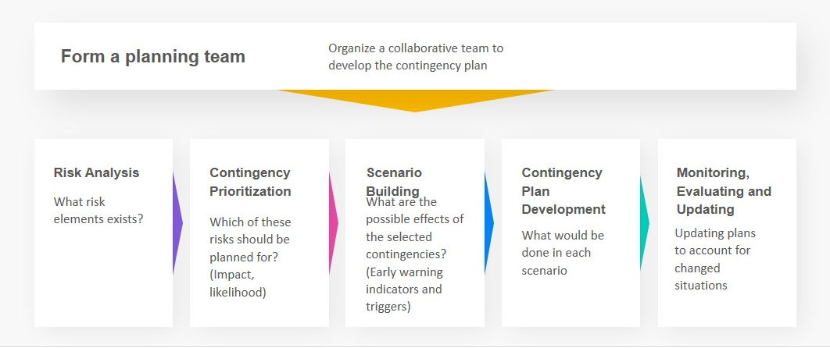
(SemiColonWeb, n.d.)

- Examples

Contingency is used in real estate transactions. It is used to ensure the home’s conditions are to the buyer’s expectations before a purchase is made. The contingency is also used for finance and ensuring the home’s price is appropriate. Contingency can also be used to collect information on the history of the house such as past owners or issues with the property (Mastroeni, 2018).

- Comparison and Contrast

Mask mandates are an example of contingency. Mask mandates are set and therefore if you do not wear a mask, you will be unable to enter the store. Similarly, contingency is the idea where if a requirement is not met successfully, the transaction will not go through.

Works Cited
Mastroeni, T. (2018, August 27). The Five Most Common Home-Buying Contingencies, Explained. Forbes. https://www.forbes.com/sites/taramastroeni/2018/08/27/the-five-most-common-home-buying-contingencies-explained/?sh=66c38a953786
SemiColonWeb. (n.d.). Contingency Plan Template | Download Contingency Templates. Powerslides. https://powerslides.com/powerpoint-business/business-plan-templates/contingency-plan/
‌
The Real Estate Contingency Contract: 8 Common Clauses. (2022, March 6). FortuneBuilders. https://www.fortunebuilders.com/real-estate-contract/

