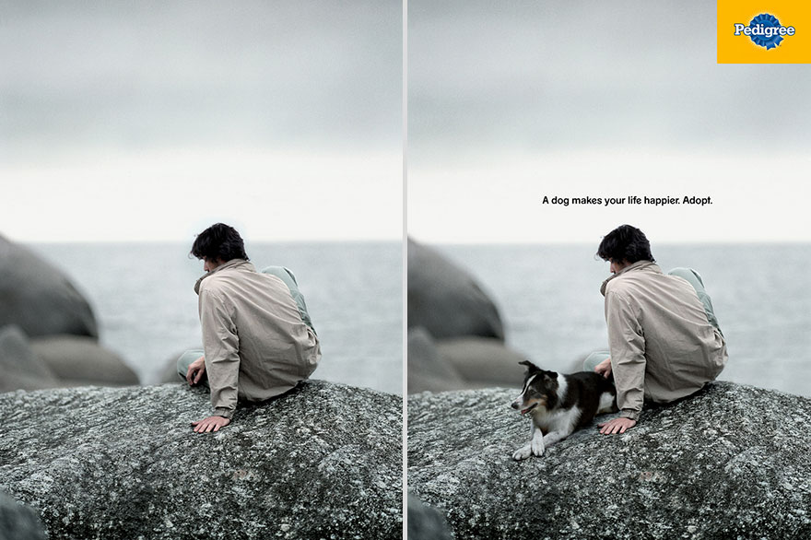
This is an advertisement for Pedigree, a dog food brand.
The ad is divided into two sides, a before and after side.
The left side (before) illustrates the human’s life without a dog, the sky is overcast, the color scheme is grey and gloomy giving the picture a lonely/depressing feel, the background is blurred making the focus on the human and his mood.
The right side (after) illustrates the human’s life with a dog. This side is identical to the left with a few additions: a dog next to the human, the phrase “A dog makes your life happier” in the center, and the Pedigree logo on the top right.
The ad is directed towards all humans, specifically those who are feeling lonely and/or down, and those who are interested in getting a dog. The ad encourages these individuals to adopt, not shop.
The ad is supposed to illustrate that adopting a dog will make you happier, less lonely, less depressed. Further, buying Pedigree for your dog will make your dog happier. However, the human’s mood, the color scheme, the depressing feel is identical on both sides. This lack of contrast doesn’t help pet adoption, Pedigree, or loneliness/depression awareness.
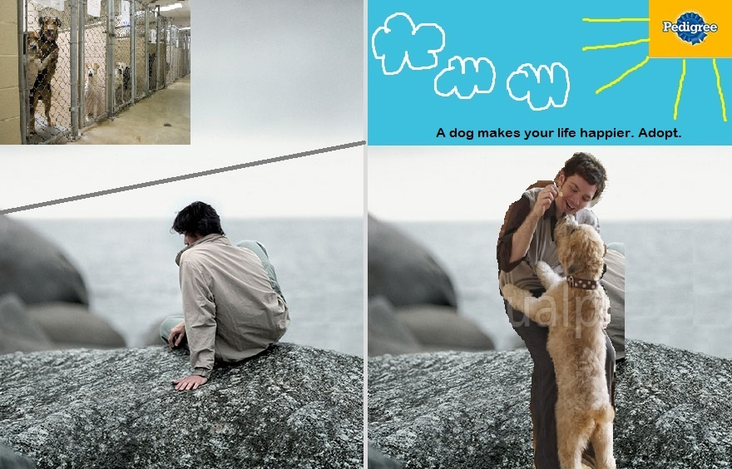
My jammed version of the ad has a few edits from the original version.
My goal was to highlight the sadness and happiness factors so the audience could clearly see a before and after side.
Therefore, on the left side, I displayed two perspectives, the human perspective and the animal perspective, by adding a picture in the top left corner of dogs in cages at a shelter waiting to be adopted. I divided these two perspectives in two by adding a grey line that separates this side’s top and bottom.
On the right side, I changed the weather from sad to happy by transforming the Pedigree logo into a sun and making the sky a brighter blue.
I included a few clouds in the sky to recognize that although adopting a dog will make a person happier, the pain, loneliness, and/or depression that the person felt on the left side, before adopting, doesn’t automatically go away in a day. Further, being adopted is a happy moment for a dog, however, it takes time for a dog to trust and adjust to a new home and a new family.
I made the caption font bigger than the original ad to make more of an impact.
I changed the man from sitting down and looking down, to standing up with a content look on his face and giving the dog a treat. I made sure to find a picture where the human was feeding the dog because this is a dog food brand ad.

I changed the dog from laying down to standing up, actively trying to get the treat. Further, the dog looks happy and free compared to the dogs that are sad and in cages on the left side.
I believe my jammed version of the ad encourages people to adopt, because adoption not only makes a human’s life happier but also makes the animal’s life happier. This concept translates into buying Pedigree. Buying Pedigree will make your dog happier and therefore will you happier it’s a win-win purchase, just like adoption.

