CULTURE JAM ASSIGNMENT
GRSJ 300 - INTERSECTIONAL APPROACHES TO THINKING GENDER - DR. CHRIS SHELLEY
MANJINDER SIHOTA

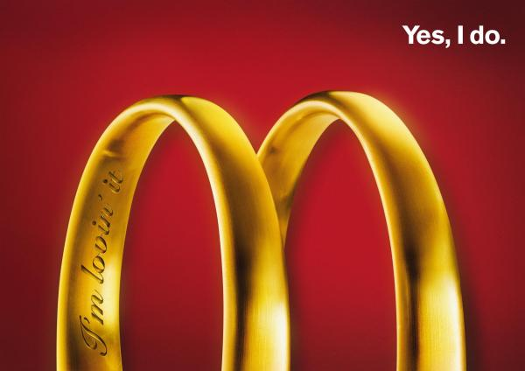

(1)

As you can see this is an advertisement for McDonald’s. It has a simple red background, centred with two enlarged golden wedding bands engraved with the saying “I’m loving it” and, the phrase “Yes I do”, in white font, on the top left corner. Here is a breakdown of this billboard:

- The colours used – the red background with two enlarged golden wedding bands – are bold, bright and therefore eye catching. These specific colours are a representation of this company. The white font used for the phrase “Yes I do” stands out against the red background.
- The two golden wedding bands seen in this billboard represent the signature symbol of this company, the famous yellow “M”. This “M” is known world-wide to be associated with McDonald’s. A wedding band itself signifies a promise/a commitment to another human being of lifelong love, devotion, and loyalty. In this specific billboard the wedding bands symbolize a lifelong commitment to McDonald’s food. It promotes the idea that McDonald’s will always be there for its consumers and vice versa.
- One of the wedding bands is engraved with the slogan “I’m loving it”. This slogan is known around the world to be associated with McDonald’s. It is a great slogan that targets the company as a whole, instead of a specific product. It triggers a reaction of recognition and desire for McDonald’s.
- The phrase in the top left of the ad - “Yes I do” – is typed out in white using a simple font. The white against the red is a great choice of colour, as it makes the phrase “pop”. The simplicity of the font makes it easy to read. The phrase itself is a declaration of acceptance/desire for McDonald’s.

As a whole this advertisement uses the concept of marriage - which represents a permanent union/lifelong pledge of togetherness between two individuals - as a symbol to endorse a lifelong relationship between McDonald’s and its consumers. In my culture jam version of this advertisement I will be addressing the repercussions of what this ad is trying to promote, a lasting relationship.

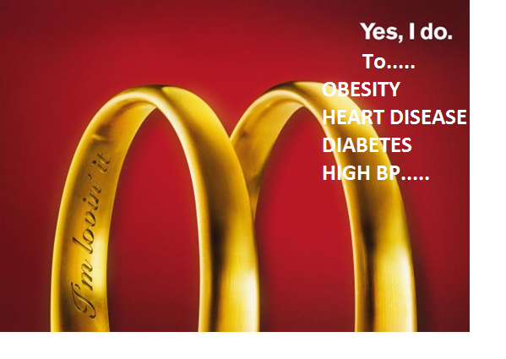
The cultured jammed version of this advertisement is not much different from the original. In my version I’ve made a simple addition by highlighting some health conditions that can be associated with consuming fast foods, such as the product advertised in this billboard, McDonald’s. I’ve used the same white, simple font against the red background to help make my message stand out. As previously mentioned this advertisement promotes a long lasting commitment between McDonald’s and its consumers. With my culture jammed version I am trying to bring attention to the possible consequences of such a commitment.
McDonald’s thrives off of its promotion of affordability, easy access, family meals, and variety of food selection. However it fails to be transparent with its consumers about the negative effects of its prodcuts. It is a known fact that fast foods are high in fat, sodium, and sugar which can all contribute to the cause of diabetes, heart disease, and obesity (2). McDonald’s in particular uses excessive salt and sugar to help make their meals more tasteful and lucrative (2). Excessive consumption of sugars and salts can lead to an increased chance of diabetes and hight blood pressure (2). The combination of french fries, chicken nuggets, burgers, and coke is a lethal mixture of processed oil and calories (2). Burning off such a vast amount of calories would require a rigorous workout. Ingesting such foods on a frequent basis can lead to obesity, particualry if one is not doing much to burn off these calories (2). Fast foods such as McDonald’s may be easy to access and easy on the budget, however regular consumption of such unhealthy foods can cause tremendous harm to the human body, and therefore should make one think twice before making such a purchase. The most effective way in which to get these fast food companies to be more up front about how they run their operations is to hit them where it would hurt most, their pockets.

References:

- [Internet]. I.pinimg.com. 2017 [cited 13 October 2017]. Available from: https://i.pinimg.com/originals/03/bb/62/03bb628d11212cdae30686f21b3d8bc9.jpg
- Chattterjee C. 10 Reasons why you should not eat Food at McDonalds - Listovative [Internet]. Listovative. 2017 [cited 13 October 2017]. Available from: http://listovative.com/10-reasons-why-you-should-not-eat-food-at-mcdonalds/

