Language Preservation Activity

In this activity we are going to be exploring the concept of languages being endangered, meaning they are at risk of not being spoken any more. UNESCO estimates that half of the 7,000 living languages spoken today will disappear if nothing is done to preserve them. Three-quarters of these languages are spoken by Indigenous peoples, that is, people who lived on the land prior to conquest by colonial powers. In America, as in many other countries, the loss of traditional languages is tied to larger issues of cultural erasure. Education, specifically, has often been a tool of oppression.

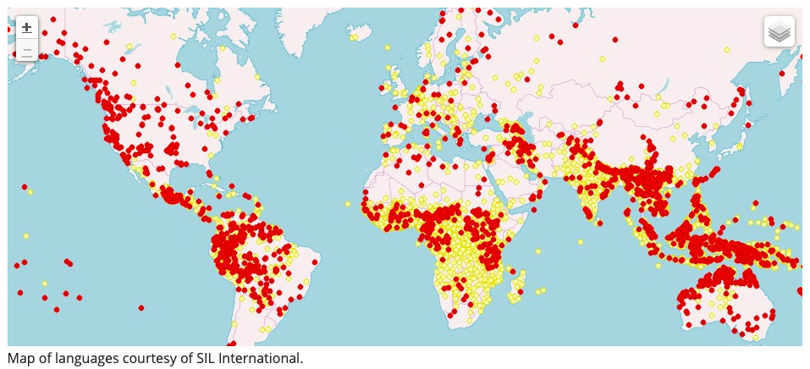
Source: https://www.sil.org/worldwide

There are three activities for you to do independently. Then, we will meet online to share our responses.

When we meet on Zoom please be prepared to discuss three questions:
- Should governments and international organizations be willing to spend money and time on language preservation efforts?
- What do endangered languages look like in your country?
- Do the last speakers of a language have a responsibility to preserve it?

A note on terminology: in this document the term Indigenous is used, as well as Native American, depending on context. For more information on appropriate vocabulary, please check out the vocabulary list on page 5.

PART I: Gain perspective on the issue by reading the following articles on both sides of the argument

Riehl, Anastasia. ‘Why are Languages Worth Preserving?’ SAPIENS, 8 November 2019, https://www.sapiens.org/language/endangered-languages/
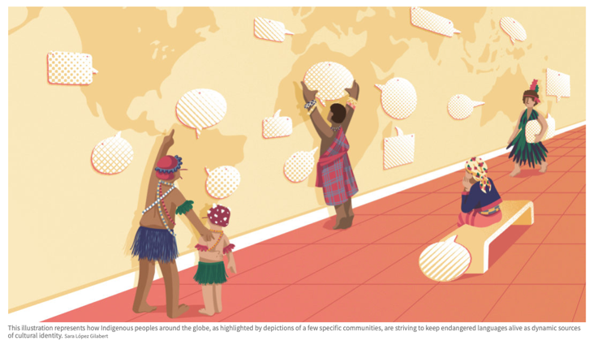
“I know that language loss is a critical and urgent problem—not only for the speakers who lose their languages, but for everyone. Languages are a vital source of culture and identity for individual communities, and for the global community, languages are an invaluable source of information about human cognition. A linguistically diverse world benefits us all.”

Harbeck, James. ‘Why do we fight so hard to preserve endangered languages?’ The Week, 2 March 2015, https://theweek.com/articles/541609/fight-hard-preserve-endangeredlanguages
(Access note: you need a subscription to read more than 4 articles from this site per month)

“In any event, if speakers no longer want to speak a language, who are we to tell them that they are wrong? It's their language, not ours, and it's paternalistic of us to expect them to do as we wish just to satisfy our need for authentic cultures to fill the pages of magazines.”

Discussion question: Should governments and international organizations be willing to spend money and time on language preservation efforts?

Optional extension: If you’re interested in reading more you may want to explore the following articles

Nuwer, Rachel. ‘Languages: why we must save dying tongues’, BBC News, 6 June 2014 http://www.bbc.com/future/story/20140606-why-we-must-save-dying-languages

Brice, Brandon, ‘Why English should be the official language of the United States’, Washington Times, 31 December 2014, https://www.washingtontimes.com/news/2014/dec/31/why-english-should-be- official-language-united-sta/

Newnum, Graham .‘Why Language Preservation Matters (According to Experts)’, Cyracom, 28 August 2018, http://blog.cyracom.com/why-language-preservation-matters-according-to-experts

PART II: Global endangered languages

Step One: Go to the UNESCO Atlas of the World's Languages in Danger www.unesco.org/languages-atlas/

Step Two: Select your country or a country of interest to you.
- How many endangered languages have been identified in that country?
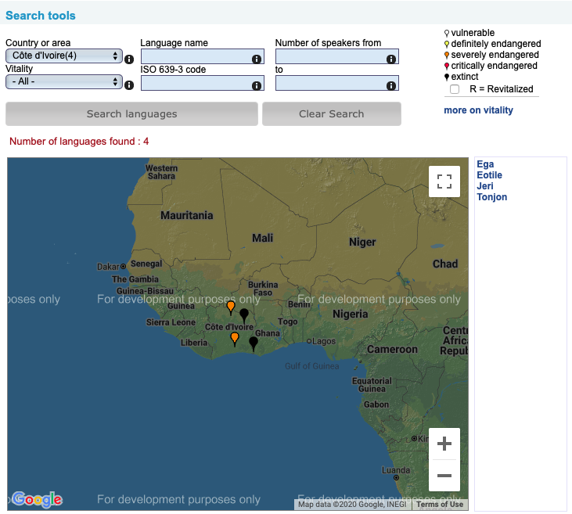
For example:

This key tells you how endangered the language is. For more information on these terms go to page 5.

You can click on the languages to find more details about them.

Step Three: Choose one of the endangered languages you found, and using Google*, collect 2-3 facts, including:
- What is the level of endangerment? How many speakers are left (if any)?
- Who speaks this language? Are they part of a marginalized group?
- Are there any efforts to preserve or resurrect the language?
We will be sharing this information during out break-out groups.

*It is worth being aware that your search may lead you to sites that collect data on certain linguistic populations in order to facilitate their conversion to Christianity. There is a long history of missionaries being both the agents for language preservation, as well as being responsible for language suppression. As always, when doing research on the Internet, be aware of your sources of information and any possible biases they may have.

Discussion question: What do endangered languages look like in your country (or another country that you chose)?

PART III: Native American language preservation
Did you know? Among the estimated 154 Indigenous languages still remaining in the United States, half are spoken by only a handful of elders over 70 and are not being taught to children.

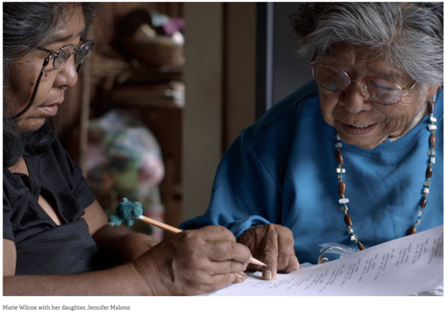
One of the ways to preserve an Indigenous language is to talk to the elders in a community who have memories of speaking that language. For this activity, we are going to watch a video about a Native American woman, Marie Wilcox, who is the last fluent speaker of Wukchumni (one of the languages of the Yokuts tribal groups who are native to Central California). For seven years, she created a dictionary in order to keep her language and culture alive.

Watch the video “Marie’s Dictionary” at https://bit.ly/2GVw47n (10 minutes).

Discussion question: Do the last speakers of a language have a responsibility to preserve it? Why or why not?

Optional extension: Identify the location of your virtual host family. Then, identify which Native American group(s) live in that area and the language(s) they speak at http://www.native-languages.org/states.htm . For more information regarding whether or not the language is endangered, you can check out www.endangeredlanguages.com/lang/country/USA
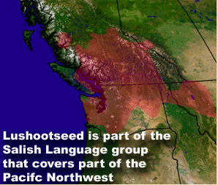
For example, I live in Edmonds, Washington. Lushootseed is the regional dialect of the Coast Salish people. Unfortunately, since colonization, many Indigenous peoples have either been punished for using their language or shamed into only using English. According to the Endangered Languages Project, there are only five native speakers of Lushootseed in the world, which means that Lushootseed is considered critically endangered. There are efforts to preserve Lushootseed by teaching classes at the local university and through informal conversation groups.

Vocabulary List:

Indigenous – peoples with pre-existing sovereignty who were living together as a community prior to contact with settler populations, most often, though not exclusively, Europeans. Indigenous is the most inclusive term, as there are Indigenous peoples on every continent throughout the world, such as the Sami in Sweden, the First Nations in Canada, Mayas in Mexico and Guatemala, and the Ainu in Japan, fighting to remain culturally intact on their land bases.

Indigenous Peoples – refers to a group of Indigenous peoples with a shared national identity, such as “Navajo” or “Sami,” and is the equivalent of saying “the American people.”

Native American – refers to peoples living within what is now the United States prior to European contact.

American Indian – used in specific legal contexts because there is a branch of law, Federal Indian Law, that uses this terminology.

*Whenever possible, it is best to use the name of an individual’s particular Indigenous community or nation of people; for example, “Tongva,” “Tataviam” and “Chumash” are the Indigenous Peoples of the Los Angeles area, and they are also “American Indian,” “Native American,” and “Indigenous”.

Source: https://equity.ucla.edu/know/resources-on-native-american-and-indigenous-affairs/native-american-and-indigenous-peoples-faqs/

Degree of endangerment |  | Intergenerational Language Transmission
 | safe | language is spoken by all generations; intergenerational transmission is uninterrupted
 | vulnerable | most children speak the language, but it may be restricted to certain domains (e.g., home)
 | definitely endangered | children no longer learn the language as mother tongue in the home
 | severely endangered | language is spoken by grandparents and older generations; while the parent generation may understand it, they do not speak it to children or among themselves
 | critically endangered | the youngest speakers are grandparents and older, and they speak the language partially and infrequently
 | extinct | there are no speakers left
Source: UNESCO’s Language Vitality and Endangerment framework

