- ______ Crée une légende pour expliquer pourquoi les chats et les chiens se détestent
- ______ Crée une légende inspirée pour ces trois mots: (1) une sirène, (2) la guerre, (3) un ours
- ______ Réponds à la question: Pourquoi est-ce que nous continuons à lire et discuter les légendes?
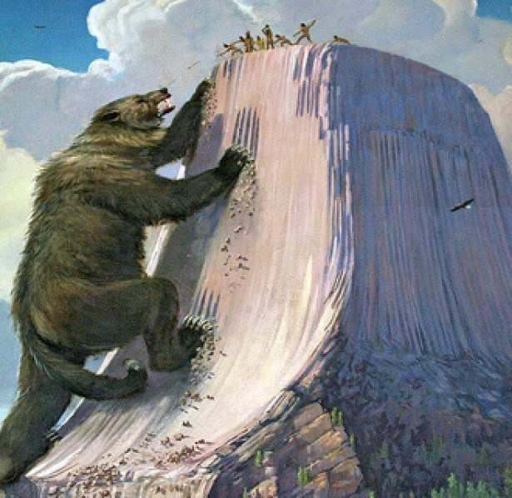
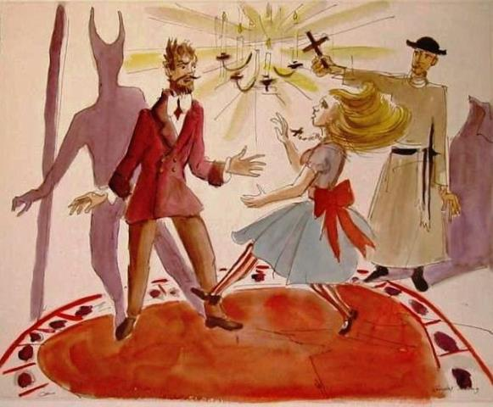
- ______ Réponds à la question: Comment est-ce que nous pouvons utiliser les légendes pour comprendre notre monde?
F. ______ Crée une légende inspirée par cette image (#2) :
- ______ Crée une légende
inspirée par cette image (#1) :

Not Yet Meeting Expectations (I) | Approaching Expectations (C) | Mostly Meeting Expectations (B) | Fully Meeting Expectations (A)
Doesn’t use sufficient vocabulary or transition words. Consistent use of literal translations. Simplistic sentence structures and tenses interfere with ideas. Unable to use verb tenses in appropriate context. Overall, a high number of errors are made that create great difficulty understanding. | Uses vocabulary and transition words that are basic and or repetitive. Literal translations are frequent. Simplistic sentence structures and tenses are used. Inconsistently uses verb tenses in appropriate context Overall, errors distract from meaning and create difficulty understanding. | Uses a narrow selection of vocabulary and transition words. Sophisticated sentence structures and tenses are attempted. Usually uses verb tenses in appropriate context. Overall, there are a few errors but they do not distract from meaning. | Uses a wide variety of vocabulary and transition words. Sophisticated sentences structures and tenses are used. Consistently uses verb tenses in appropriate context. Overall, errors are rare and do not distract from meaning.

