# Letter of Transmittal

Not required for the draft report – will be written for the final report

# **Feasibility Analysis of offering online computer science courses at the University of British Columbia**

for

Ian M. Mitchell

(Undergraduate) Associate Head of the Computer Science Faculty

University of British Columbia

Vancouver, British Columbia

by

Marissa Tamaki

English 301 Student

July 10, 2017

# Table of Contents

Abstract iii

Introduction 1

Data Section 2

Key Factors to Offering Online Computer Science Courses at UBC 2

**Administrative Factors** 2

**Tools and Resources** 2

**Student Interest** 3

**Examples of existing online courses** 4

**Advantages and Disadvantages of online courses.** 6

Conclusion 7

Summary of Findings 7

Interpretation of Findings 7

Recommendations 7

Appendix A: Interview Questions 8

Appendix B: Survey Questions 8

References 9

# List of Tables and Figures

Figure 1 Which Courses are Good Candidates for Online Courses 4

Figure 2 Student Interest for Online CPSC Courses 4

Figure 3 Uses for MIT OpenCourseWare 5

# Abstract

Not required for the draft report – will be written for the final report

# Introduction

Over the past couple of years, there have been many issues regarding course availability and section size in the Computer Science Department here at UBC. The main issue is that there is not enough seats in courses to handle the growing amount of students in the department. Waitlists usually have over 100 students on them at the beginning of each semester and students cannot register for all the courses they need.

There are several factors that have led to the current situation. Enrollment numbers have doubled since 2010, but the number of professors in the department have not increased in the same fashion (Ubyssey). This shortage is especially apparent when it comes to upper year level courses. For example, many popular courses like CPSC 410, CPSC 430 and CPSC 425 were not able to find professors for the 2017W semester. There is also a lack of students willing to become Teaching Assistants (TA). They are needed to facilitate labs and tutorials as well as mark materials and hold office hours. The last factor is the lack of lecture hall space. The largest lecture hall in the building where computer science lectures are held (Hugh Dempster Building) has a max capacity of 160 (Students UBC). There are larger lecture halls on campus, but those need to be shared with other faculties and are not as readily accessible. All of these factors combined have forced the department to limit the number of seats they have in many computer science courses and it also makes it very difficult to increase the number of sections.

The solution I am proposing is to make some of the courses into distance education courses. A majority of the lecture material is online already and students have a way of interacting with the professors and TAs through a website called Piazza. Many of the professors also use tools like Github, edX and Gradscope to manage the distribution of assignments and grades. The only part that cannot be found online would be the material that is taught in class. A possible solution to that issue would be to provide screencasts / recordings of the lectures or to use only written material. Providing online courses can help to alleviate the resource problem as it could open up the possibility of having more seats or sections in some courses.

The purpose of this report is to assess the feasibility of offering distance education computer science courses at UBC. It will analyze information gathered from faculty members in the computer science department as well as computer science students. It will also discuss examples of other online courses/programs and the possible tools that could be used to facilitate online courses. The report examines student interest, steps required to convert a lecture based course into an online course, pros and cons of online courses and effects that online courses could have on the resource shortage in the department.

# Data Section

## **Key Factors to Offering Online Computer Science Courses at UBC**

There are many factors that come to play when discussing the feasibility in offering distance education courses at a university. The data that is included in this section was gathered using secondary research, interview questions with UBC Computer Science Faculty (See Appendix A) and a survey addressed to UBC Computer Science Students (See Appendix B)

### **Administrative Factors**

*(Will be included once interviews with Computer Science Faculty are complete)*

### **Tools and Resources**

There is a wide variety of tools that can be used to facilitate online computer science courses. The ones discussed below are already being used in courses at UBC so it wouldn’t be difficult to incorporate them into an online version.

* **Gradescope (https://gradescope.com/)** This website aims to improve the grading process for both students and instructors. To hand in an assignment, students would upload a PDF version and indicate which question is on which page. When it comes time to mark, the instructor can grade the assignments completely online and provide written feedback. The instructor includes the grading rubric for each question so it is simple to assign marks and students can easily review what they did right or wrong. The website also provides statistics to the instructors allowing them to analyze the progress of the students.
* **GitHub Education (https://education.github.com/)** Github is one of the most important sites to a software developer. It ensures that you will never lose your work, helps you to stay organized and allows you to create a professional portfolio full of examples. The education version of GitHub does all of the above while also providing a way for instructors to distribute starter code, provide automated tests and collect assignments. Students are also able to directly communicate with instructors and since the instructors can readily see the students code, they are able to provide better quality assistance for their problems.
* **Piazza** (**https://piazza.com**) Piazza is one of the more common websites that instructors at UBC use to communicate with their students. It is used not only in the Computer Science department but also in the Math and Pharmacy departments. Students post questions and these are visible to everyone who is in the course, allowing others to learn from the questions being asked. Both instructors and peers are able to provide answers, encouraging discussion of course material. Instructors also use this site to post announcements or memos to the students and they have the option to post course materials if they choose to do so.
* **Cousera (https://www.coursera.org/) and edX** **(https://www.edx.org/).** Both of these websites provide hundreds of free complete online courses from some of the top universities in the world. They provide all the resources you need for a course in a single place and students are led by instructors who are there to guide you along. Professors can also create their own courses and upload their course material, which is what many of the professors at UBC are already doing. More information will be discussed in the *Examples of existing online programs section* below.

Each of these tools facilitate a different aspect of online computer science courses. Gradescope is for theory-based assignments, GitHub Education is for code-based assignments and Piazza is for overall communication. As online learning gets popular, more websites to support online courses are being created so there are many other options than the ones listed above.

### **Student Interest**

To assess student interest with respect to online computer science courses, a survey addressed to computer science students at UBC was distributed using Google Forms (See Appendix B). There was a total of 15 response and everyone was in Third year or higher (the survey included alumni). Over 80% of the respondents had already taken all of the required course for a computer science degree as well as some additional electives. Additionally, all 15 respondents have taken some form of distance education course at UBC. While there are not a lot of data points, most of the respondents have extensive experience with computer science courses as well as online learning, so the opinions gathered in this survey are quite valuable.

Figure 1 shows which computer science courses the respondents think would be good candidates for distance education. Over 50% chose CPSC 110, CPSC 210 and CPSC310 as good courses to take online. CPSC 210 and CPSC 310 in particular are the required software engineering courses that UBC offers and both are heavily based around a term project. Many respondents reasoned that since there is not a lot of in-lecture content and much of that information can be found online, the lower amount of in-class support is acceptable. On the other hand, theory based courses like CPSC 221, CPSC 313 and CPSC 320 have less than 25% of the respondents believing that these courses are good candidates to be offered online. The material in these courses are considerably more difficult and so being able to ask questions in lecture support is extremely valuable.

The results displayed in Figure 1 correlate with the responses found in Figure 2. Depending on the course, 60% of the respondents would register for a fully online course if UBC were to offer them. As there is such a difference between project and theory based courses, it is understandable that the type of course would affect one’s decision to take an online course. An interesting point to note is that none of the 15 respondents explicitly stated that they would not take an online computer science course.

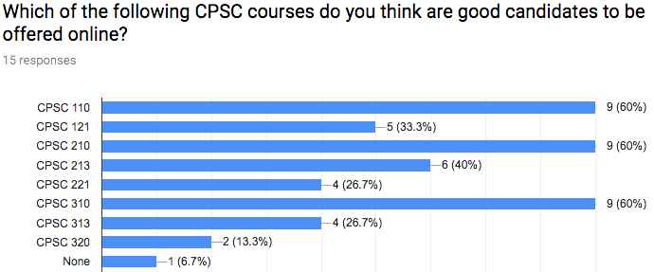

Figure 1 Which Courses are Good Candidates for Online Courses

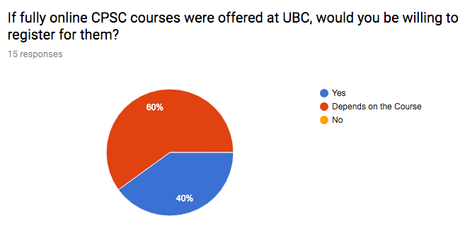

Figure 2 Student Interest for Online CPSC Courses

### **Examples of existing online courses**

Over the last couple years there has been an increase in the growth and development of online courses. One of the most popular subjects to be taught online is of course, computer science. There are dozens of courses available at any education level and many are offered by prestigious universities like Harvard, Stanford and most famously MIT. These courses are taught by the same instructors who teach them on campus, providing students with the same incredible experience (Computer Science Online)

MIT OpenCourseWare (OCW) is a web-based publication of all MIT course content (MIT OpenCourseWare)) and it hosts not only computer science courses, but also a large variety of courses and subjects. For a majority of the courses, you can find resources to the compete course like assignments, previous exams, study materials, video lectures and downloadable course material.

Figure 1 shows the wide range of purposes that MIT OpenCourseWare has been successfully used for. We can see that educators, students and self-learners all benefit greatly from having such extensive learning materials online.

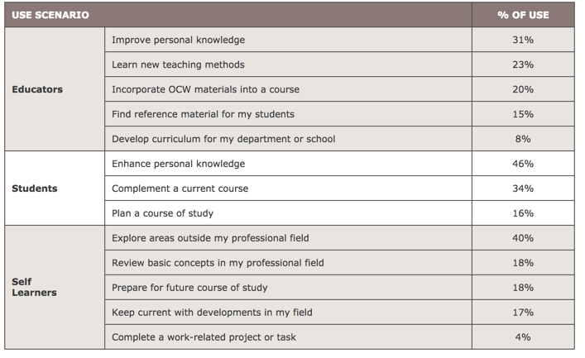

(Figure 3 Uses for MIT OpenCourseWare, from - https://ocw.mit.edu/about/site-statistics/)

However, the biggest downfall to providing course material in this manner is that there is no guidance by an instructor. Even though lecture videos are provided and you would get the same information as if you were sitting a lecture hall, there is no avenue to interact with the professor. Most of the material posted is from previous offerings of the course so there is no professor that could provide the students with feedback or help. This way of learning, where everything is provided for you, is best for students who are strong self-learners and do not require instructor interaction.

Another popular place to find online courses are websites like edX and Coursera. They are massive open online course providers and host university-level courses in a wide range of disciplines (edX Wikipedia). They feature courses from major universities around the world and the courses are available to anyone. Each of the courses provide extensive learning materials and you could complete the course using only one website. Some of the more extensive programs require payment but there plenty of free courses. The format of these online courses differ from MIT OpenCourseWare in that while some courses are self-paced, others have a more rigid scheme. For those courses, there are pre-determined start and end dates and there is an set schedule to follow. However, whether the course is self-paced or not, there is an instructor available for students to ask questions.

UBC has partnered with edX to add to the evolving ecosystem of learning technology platforms, tools and applications on campus. edX also supports the Edge platform which can be used for regular UBC courses and provides a blended experience for campus-based courses. edX Edge differs from the standard edX in that edX is the home for their open online courses and Edge is used by the university to provide material for their on-campus or other traditional students (Flexible Learning UBC). Courses like CPSC 110 already extensively use edX Edge to support in-lecture learning as it provides a way for instructors to upload assignments, lecture videos and other course materials.

The various sites listed above provide examples of successful online courses and each have their own pros and cons. If UBC were to offer distance-education computer science courses it could either borrow a platform like edX Edge or course material could be provided in a similar manner as MIT OpenCourseWare. Together with the tools and resources discussed in the previous section, a very cohesive online learning environment could be created.

### **Advantages and Disadvantages of online courses.**

One of the main advantages to online courses is flexibility and being able to learn at your own pace. With no lectures to attend and having all the material online, students are able to study whenever they want and at whatever speed is best for them. Many of the respondents to the survey cited similar advantages, another one being not having to commute to the campus. Online courses also provide more flexibility for classes sizes and scheduling as there is not as much of a physical restriction with regards to lecture space.

However, because there is more freedom with online courses, many students stated they had problems with discipline. With no lectures to go to, students were more likely to procrastinate and keeping on top of everything was significantly more difficult. Another major roadblock for online courses was the lack of in-person support. Depending on the type of learner a student is, some greatly value the lecture experience while others do not deem it such a necessity. With lessened in-person support there is definitely more emphasis on maintaining ways to communicate with instructors online. From the instructor / faculty perspective, converting the in-lecture material into online material could be a challenge. Recording screencasts or lecture videos are an option but is quite time consuming and resource heavy so it might not be the ideal solution.

# Conclusion

## **Summary of Findings**

To offer an online computer science course at UBC, it requires handling different administrative factors, deciding on a combination of resources to use, and making sure there is enough student interest. There needs to be a way for instructors to distribute learning material, communicate with the students and provide assessment. A number of options are available for instructors to use and each have their own strengths and weaknesses. There are many aspects that need to be considered when deciding to change the approach of a course so students can have the best possible learning experience.

## **Interpretation of Findings**

UBC has already taken steps towards offering more online learning as they have formed a partnership with edX. The Computer Science Department has begun to use edX more heavily and tools like Piazza and Github are already extensively used in many courses.

Since there are tools online to handle every aspect of the course and most of the material that is used in-lecture is already found online, having an distance education course does not seem unattainable.

Offering online courses could potentially have a positive effect on the resource shortage that the computer science faculty is facing. It would not have a significant effect on the lack of teaching faculty or teaching assistants but it will definitely help with regards to the lack of seats and sections. As the course would be held online, more sections could be opened up and class sizes would also not be restricted by the lecture hall space.

## **Recommendations**

Consider these suggestions when deciding if an online computer science course is feasible:

* It is important for student to be able to easily communicate with instructors online (professors and Teaching Assistants) while also having an option for in-person support. The communication options need to be carefully considered, whether this means utilizing Piazza along with office hours or using some other tool integrated into edX / Coursera.
* The type of material that is taught in a course needs to be considered when deciding if a course can be offered online. Project courses are the best candidates for online courses, as much of the work is done individually/partners and a majority of the learning is done online. Theory based courses are not as good of an option as they benefit more from the lecture experience. However, there are courses online that successfully teach theory-based topics so we cannot rule them out completely.
* As the course is based solely online, the method of material distribution is highly important. If more comprehensive sites like edX edge are used then the syllabus, course dates, assignments, lecture material, assessments, and feedback would all be in one place. However, if a combination of tools is used, then all of those aspects still need to be covered.

*(Note: Conclusions and Recommendations are incomplete as not all the data has been collected)*

# Appendix A: Interview Questions

Not required for the draft report – will be written for the final report

# Appendix B: Survey Questions

Not required for the draft report – will be written for the final report

# Works Cited

“About EdX Edge at UBC.” *Flexible Learning*, flexible.learning.ubc.ca/about-edx-edge/. Accessed 10 July 2017.

“About OCW.” *MIT OpenCourseWare, Massachusetts Institute of Technology*, ocw.mit.edu/about. Accessed 10 July 2017.

“DMP.” *Classrooms | Student Services*, students.ubc.ca/campus-life/organizing-campus-events/book-event-space/buildings-classrooms/DMP. Accessed 10 July 2017.

“EdX.” *Wikipedia,* Wikimedia Foundation, 1 July 2017, en.wikipedia.org/wiki/EdX. Accessed 10 July 2017.

Nguyen, Alex. “Too Many Students, Not Enough Seats in Computer Science.” *The Ubyssey,* www.ubyssey.ca/news/computer-science-program-frustrating-students/. Accessed 10 July 2017.

“Online CS Courses.” Computer Science, www.computerscienceonline.org/courses/. Accessed 10 July 2017.

 “Site Statistics.” MIT OpenCourseWare, *Massachusetts Institute of Technology,* ocw.mit.edu/about/site-statistics/. Accessed 10 July 2017.

Tamaki, Marissa “Interest in online CPSC courses at UBC”. Survey. https://docs.google.com/forms/d/e/1FAIpQLScomEp49VZVpTmOXQ8ltNNwxtpmu3IgNDjJqH0g93YMJSwwSw/viewform/. Accessed online. 10 July. 2017.