**Debenture Definitions**

**Introduction**

The purpose of this assignment is to demonstrate my knowledge when it comes to when definitions are necessary and how to cater these definitions to varying audiences. To complete this assignment, I will identify an audience and purpose and create three definitions: a parenthetical definition, a sentence definition, and an expanded definition. The expanded definition will utilize a variety of expansion strategies to maximize comprehension of the subject.

**Audience and Purpose**

I am looking to define *debenture* for a beginner investor who has had little to no education and experience with corporate finance and investing. In order to begin to build an investment plan for future retirement, a financial advisor could present several money allocation options in different asset classes. A potential option for investors seeking low-risk investments are debentures. The purpose of this definition is to provide insight as to how a beginner investor could use debentures to balance their retirement portfolio.

**Parenthetical Definition**

The debenture (loan issued by a corporation or government) is a relatively low-risk investment option.

**Sentence Definition**

Debentures are long-term loans issued by companies or governments, that are backed by general creditworthiness instead of specified assets. These kinds of loans are used to raise money and are also known as unsecured debt, because they depend on the reputation of the issuer instead of physical assets or collateral.

**Expanded Definition**

A debenture is a written acknowledgement of indebtedness by the company setting out the terms and conditions of the loan. This definition will explain their purpose, typical features, compare debentures to bonds, some pros and cons, and an example.

**Purpose**

There are two main purposes for debentures. For companies and governments, they are a means to raise capital or funds for many different purposes. For investors, debentures offer periodic interest payments called coupon payments. They are usually seen as a long-term, low risk assessment, especially if the issuer is a government.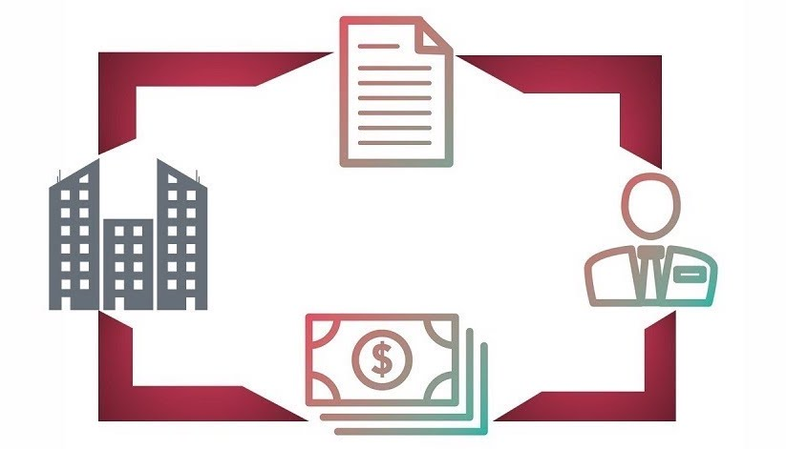

*Figure 1.* The process of a debenture starts with the corporation or government entity of the far left - and moves clockwise. The document is meant to show the written acknowledgement of indebtedness, the person is meant to show an individual investor. Finally, the money image is meant to show that the money is paid out to the individual investor when the debenture matures.

**Characteristics**

Interest Rate: The rate of interest that the company or government will pay the investor.

Credit Rating: Depending on the creditworthiness of the corporation or the government, investors will assess their risk. Credit ratings are provided by agencies that will essentially look through the company’s or governments’ track record of repaying their debt. If they have a history of not paying back their debts, they are deemed as riskier and more speculative investments.

Maturity Date: The maturity date dictates when the company must pay back the investors. This can be done in several ways; paid out in full at the end of the term, or in specific amounts each year. This is advantageous for investors as they know exactly when their money is paid to them.

**Debentures vs Bonds**

Both bonds and debentures are loans issued by companies and governments, and some investors may confuse them for one another. Outlined below are some key differences:

Bonds are backed by the assets of the issuer, while debentures are not secured by any physical assets or collateral.

The interest rate of bonds is generally lower than debentures. Because bonds are secured loans, they are inherently lower risk; the lower interest rate depicts the lower risk factor. While debentures give you a higher interest rate, they are unsecured in nature, hence the risk factors is increased.

**Pros and Cons**

**Pros**

A debenture pays a regular interest rate to investors. This is predictable and can help investors manage cash flow for they retirement portfolios. Riskier investments like equity in a company depend on company performance, and the value of your money will fluctuate depending on volatility of share prices.

**Cons**

Debentures do carry some risk. If the company is not secure or struggle financially, investors are at risk of losing their money.

**Example**

An example of a debenture would be a U.S. Treasury bond. They are used to finance projects and fund governmental operations. While they face the risk of inflation, most investors have faith in the U.S. government and don't think they will go bankrupt (this unlikely event would devalue the debentures).

**Sources**

“What is a debenture.” BDC.ca. https://www.bdc.ca/en/articles-tools/entrepreneur-toolkit/templates-business-guides/glossary/pages/debenture.aspx.

Chen, James. “Debenture.” Investopedia, Feb 25th, 2020. <https://www.investopedia.com/terms/d/debenture.asp>.

“What is a debenture?” IG.com. https://www.ig.com/en-ch/glossary-trading-terms/debentures-definition