ENGL 301

Assignment 1.3: Three Definitions

*Introduction:*

The primary object of this assignment is to first choose a relatively complex term, then define it using the three forms of definition (paranthetical, sentence, and expanded) for an audience that likely does not already understand the technical definition of the term. These definitions, ranging in precision and length, will act as a lesson for both myself and the reader in different methods of this important form of technical communication. Specifically, the varied but equally important purposes these different forms of definition serve will be addressed. My term for this exercise will be chosen from my respective discipline, geology, as I am familiar with the technicalities and complexities of the discipline that the reader may not already be.

*Term:* Boudinage

**A: PARANTHETICAL DEFINITION**

The rock had been strongly *boudinaged* (pulled into sausage-like structures by extension).

**B: SENTENCE DEFINITION**

Boudinage is a geological concept broadly describing the process by which a competent layer of rock is pulled apart into sausage-like structures by a stress acting on that rock. There are many different processes by which this occurs and concurrently many different forms of boudinage.

**C: EXPANDED DEFINITION**

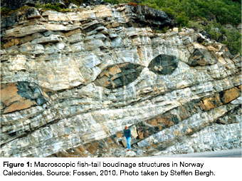

The term “boudin”, unsurprising to French-speakers, refers to a sausage, and was first applied in geological terms by Max Lohest in 1908 in describing “sausage-like” structures observed in rocks in Bagstone, Belgium (Fossen, 2010). *Boudins,* in a geological sense, represent these physical structures, whereas *boudinage* represents the process that forms these discontinuities from originally continuous geological layers. Figure 1 is an excellent example of a large scale boudinaged structure, which will be further discussed and defined below.

*i) How does it form?*

Boudins can form at all scales and in all terranes of rock from the *microscale* (invisible to the eye) to the *macroscale* (tens of kilometers in size), and can be resultant of a large range of different stresses on the rock. At minimum, the process of formation requires a *competency contrast* (difference in hardness) between two pre-existing layers of rock, with a harder “competent” rock sandwiched between two layers of much softer “incompetent” rock. This sandwiching allows the softer rock matrix, when put under either *extensional stress* (force pulling the rock apart) or alternatively *shear stress* (force pushing the rock together), to flow around the harder boudins as they pull and break apart.

*iii) Types of boudinage*

As has been alluded above, there are many different types of boudinage, defined by a number of characteristics including whether the stress acting upon the rock has been extensional or shear, what type of rock is being deformed, the amount of competency contrast between the different layers, and how much stress has been put on the rock.

The specific affect that these conditions have on the boudinage process are complex, but form a number of different end-member types including: symmetric vs. asymmetric boudins, foliation boudins, barrel-shaped vs. fish-mouthed boudins, drawn vs. torn boudins, and domino vs. gash boudins. The figure below, created by Goscombe et. al. in an attempt to systematically classify boudins into five classes, summarizes these categories. 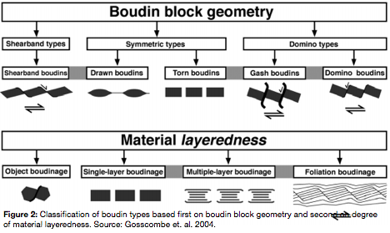

*iv) Geologic importance?*

Boudinage is a very important process to be noted by a field geologist, as it can indicate many features of the geological condition of the rock. Most practically, the amount, direction, and scale of deformation of rock can be determined, allowing the geologist to predict how this may have influenced the surrounding rock and what other important features may be found in the area (Rowland et. al., 2007).

*References:*

Fossen, H. (2010). *Structural Geology.* New York, USA: Cambridge University Press.

Goscombe, B. D., Passchier, C. W., Hand, M. (2004). Boudinage classiication: end member boudin types

and modified boudin structures. *Journal of Structural Geology, 26.* 739-763.

Rowland, S. M., Duebendorfer, E. M, and Sciefelbein, I. M. (2007). *Structural Analysis and Synthesis: A*

*Laboratory Course in Structural Geology, third edition.* Oxford, UK: Blackwell Publishing Ltd.