**Definition of Phylogeny**

Introduction:

The objective of this assignment is to practice writing definitions for a relatively complex term, targeting readers without background knowledge in the given topic. The audience could be comprised of, for example, high school science students who have some basic knowledge of evolutionary biology, or peers who do not have a background in science. The chosen term for this practice, phylogeny, will be defined using three methods: parenthetical, sentence, and expanded definitions. The various definitions should provide readers with a clear understanding and application of the given term.

Parenthetical Definition:  
The phylogeny (tree of life) shows the evolutionary history, or change, in different species from a common ancestor through time.

Sentence Definition:

A phylogeny is a visual representation of a proposed evolutionary history of populations, genes, or species that is derived by analyzing data from several characteristics and/or genetic materials. The phylogeny of life implies that different species arise from previous forms via descent, thus giving the shape of a tree. It also suggests that that all organisms share a common ancestor from a lineage of the phylogeny, or a branch on the tree.

Expanded Definition:

*What is phylogeny?*

Phylogeny is the study of the relationship between populations, genes, or species. It is depicted as a complex network of a branching system, also known as a phylogenetic tree, because it suggests that all descents are forms of a common ancestor.

*What determines the phylogeny?*

Scientists often analyze large amounts of data on various characteristics, such as the way an organism looks or the physical and structural features an organism possesses, before reconstructing a phylogeny. For example, specific bone structures, protein production, and DNA sequences are common markers for phylogenetic analysis.

*How accurate is a proposed phylogeny?*

One of the common misconceptions is that phylogeny provides the absolute relationship between species; however, this is not true. The degree of accuracy of a proposed phylogeny depends on the quality and the completeness of the collected data. Furthermore, different markers used in the data will also affect the results of the reconstruction. It is important to recognize that the currently accepted phylogenetic tree is based on the evidence available to us at the time of data collection (Figure 1.0). The phylogeny is thus subject to change as scientists discover more evidence, such as fossils.

Figure 1.0: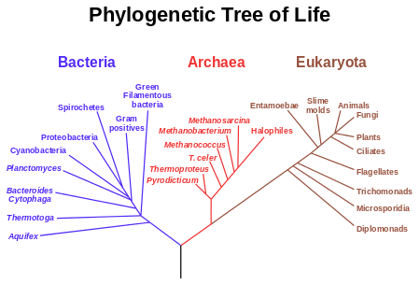 Example of the Phylogenetic Tree of Life

Source: "Phylogenetics." *Wikipedia*. Wikimedia Foundation, n.d. Web. 27 Sept. 2015. <https://en.wikipedia.org/wiki/Phylogenetics>.

*What are some applications of phylogeny?*

A reconstructed phylogenetic tree may guide us in search of an adjacent species for our target group. This is exceptionally useful in the field of medicinal research, where preliminary trials are performed using nonessential animals, yet closely related enough that both species would have the same biochemical mechanism to the drug being administered. For example, many medicines are developed using mice at the preliminary stage, then proceed to human trials at the final stage. Furthermore, phylogeny informs microbiologists of the genetic correlations between species; this may allow various pharmaceutical companies to make propitious predictions from the database of gene families and apply the information to the development of vaccines and antimicrobials. Other fields that benefit from phylogenetic research include, but are not limited to, conservation ecology, biochemical weapon development, and historical linguistics.

Sources:

"Learning with the ToL." *Tree of Life: What Is Phylogeny*. N.p., n.d. Web. 27 Sept. 2015.

"Utilizing Phylogenetic Information." *CIPRES | Outreach*. Cyberinfrastructure for   
 Phylogenetic Research, n.d. Web. 27 Sept. 2015.

Zimmer, Carl, and Douglas John Emlen. *Evolution: Making Sense of Life*. 1st Ed.   
 Greenwood Village, CO: Roberts, 2013. Print.