## **Examination Protocol for MFRE Exams**

## All students are expected to adhere to the following protocol when taking exams.

1. Cell phones must be taken out of bags/jackets and placed on the desk/table (or at the front desk) prior to starting the exam
2. Jackets and bags should be placed at the front or back of the room, NOT under desks or chairs.
3. No watches allowed (smart watches or plain). Invigilators should check and remind students.
4. No caps allowed during exams.
5. Students may not leave the exam room in the final 15 minutes of the exam.
6. When time is called, all students must stop writing immediately or face a penalty.
7. Students should not have anything on their desks besides calculators and permitted writing instruments (pens, pencils, markers).
8. The invigilator(s) will assign seats to the examination candidates.
9. The examination candidates must leave all their belongings in a designated area and take only the material to their seats that they will require for the examination (pen, pencil, ruler, calculator, marker, NO pencil cases). Scrap paper will be provided at the discretion of the invigilator.
10. Before the examination starts, the invigilator(s) will read the following to the examination candidates:
11. Only one examination candidate at the time will be allowed to leave the room to use the washroom. Cell phones must be left with the Invigilator when the student leaves the room to use the washroom.
12. When the examination time is over, ALL examination candidates must put their pencil/pen down. Examination candidates that do not stop writing when indicated will be penalized at the discretion of the instructor.
13. As soon as one examination candidate has completed the exam and left the room, the other examination candidates are not allowed to use the washroom.
14. Students may not leave the room in the last fifteen minutes of the exam.
15. The invigilator(s) will regularly inform candidates about the remaining time during the examination.
16. The invigilator(s) has the freedom to ask any examination candidate to change seats at any point.

## **UBC Student Conduct During Examinations**

1. Each examination candidate must be prepared to produce his or her UBC card for identification, upon the request of the invigilator or examiner.
2. Examination candidates are not permitted to ask questions of the examiners or invigilators, except in cases of supposed errors or ambiguities in examination questions, illegible or missing material, or the like.
3. No examination candidate shall be permitted to enter the examination room after 30 minutes from the scheduled starting time, or to leave during the first 30 minutes of the examination. Should the examination run 45 minutes or less, no examination candidate shall be permitted to enter the examination room once the examination has begun.
4. Students may not leave the room in the last fifteen minutes of the exam time.
5. Examination candidates must conduct themselves honestly and in accordance with established rules for a given examination, which will be articulated by the examiner or invigilator prior to the examination commencing. Should dishonest behavior be observed by the examiner(s) or invigilator(s), pleas of accident or forgetfulness shall not be received.
6. Examination candidates suspected of any of the following, or any other similar practices, may be immediately dismissed from the examination by the examiner/invigilator, and may be subject to disciplinary action:  
        i. speaking or communicating with other examination candidates, unless otherwise authorized;  
        ii. purposely exposing written papers to the view of other examination candidates or imaging devices;  
        iii. purposely viewing the written papers of other examination candidates;  
        iv. using or having visible at the place of writing any books, papers, or other memory aid devices other than those authorized by the examiner(s); and,  
        v. using or operating electronic devices, including but not limited to, telephones, calculators, computers, or similar devices other than those authorized by the examiner(s)—(electronic devices other than those authorized by the examiner(s) must be completely powered down if present at the place of writing).
7. Examination candidates must not destroy or damage any examination material, must hand in all examination papers, and must not take any examination material from the examination room without the permission of the examiner or invigilator.
8. Notwithstanding the above, for any mode of examination that does not fall into the traditional paper-based method, examination candidates shall adhere to any additional rules for conduct as established and articulated by the examiner.
9. Examination candidates must follow any additional examination rules or directions communicated by the examiner(s) or invigilator(s).

If you are unable to write an examination, you must have a verifiable doctor’s note and must contact the course instructor and the MFRE Program Coordinator before the scheduled date/time. Documentation must be provided to explain your absence. If the documentation is considered legitimate, the instructor will let you know how to proceed.

**MFRE Two devices remote Exam Process**

In circumstances where you have mobility issues or are sick but would like to conduct an exam. The program requests the students to follow the following exam plan:

* Exam will be given using Canvas in a secure mode
* Students will require their laptop to take their exam and the 2nd device with a camera (laptop, tablet. Smartphones for zoom proctoring
* Zoom Proctoring may (may not) be recorded. It is the discretion of the instructor to request the zoom proctoring

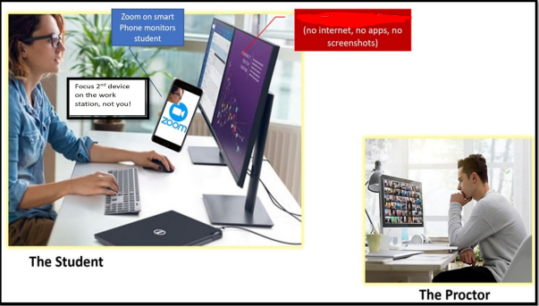

Day(s) before the exam:

* Students should test their 2nd device to ensure zoom functions and that they are comfortable sending chats and messages using that device.
* Students should set up their space so that they have good access to power, wifi, and plug-in devices
* Exam invigilator will send instructions and zoom link to the students which will open on the 2nd device. Note: there will be an alternative host in the event that zoom connections are lost.

Note: you will be exempted to conduct an online exam if your condition is examined and approved by UBC [access and Diversity](https://students.ubc.ca/about-student-services/centre-for-accessibility)