Recommendation Report

for Possible Improvements

of UBC Rooftop Weather Forecasts

(DRAFT)

for

Dr. Rosie Howard

Weather Forecast Research Team Researcher

University of British Columbia

Vancouver, British Columbia

by

Matthew Y.S Fung

English 301 Student

July 10, 2017

Table of Contents

Introduction 3

Data Section 4

Usage of Forecasts 4

Preferred Access Platforms 4

*Figure 1. Preferred Platforms for Forecasts Figure 2. Preferred Durations for Accessing Forecasts* 5

Preferred Duration of Each Access 6

Content and Representation of Forecasts 6

Relevancy of Different Meteorological Variables 6

Communication of Uncertainty 8

Value of Historical Data 9

Conclusion 10

Summary of Findings 10

Recommendations 10

### Introduction

The UBC Weather Forecast Research Team (WFRT) is a research group in the department of Earth, Ocean, Atmospheric sciences that studies the improvements and applications of weather models. While research is a priority, the team also participates in providing forecasts to clients.

One method of summarizing and communicating forecast is through the use of weather graphics, or meteograms. While some forecasts are private based on confidential agreements, the research group publishes public forecast graphics for UBC Point Grey Campus and Vancouver International Airport. Although the layout of the weather forecasts relays technical information effectively, the meteograms are not well-suited for daily use. Most prominently, the graphics tend to be too detailed, and the layout is not mobile friendly. This is reflected by the poor viewer-ship of the forecast page.

Based on online survey and literature reviews, this report aims to provide recommendations regarding the content of the graphics, the layout and platform of the forecast.

In order to investigate the needs of users not in the field of Atmospheric Sciences, this report seeks to answer three main questions: what kind of information do people need from forecasts, how much detail is required by users, what is the preferred platform for users. Moreover, the study will also look into the benefits and interests of the three mentioned features.

### Data Section

#### Usage of Forecasts

The focus of the first section is to investigate how people utilize weather forecasts. User behaviour describes the preferences users have regarding the form of a product, and the habits the users have when using the product. This section seeks to look into what users prefer with regards the form of product, be it in print or digital, how frequent users access products, and the duration.

##### Preferred Access Platforms

Access platform refers to the medium where a certain product is distributed, and consumed. In the context of weather forecasts, such platforms include news print, television, websites, and mobile applications. Understanding the preferred platform of users allows the research team to best focus resources in order to provide the best user experience possible.

The following is a summary of the results based on figure 1 shown below:

* Mobile devices and computers are equally popular at 40%
* 20% of voters equally prefer mobile and computers
* Print, Radio and Television received zero votes as the most preferred platform

It is interesting that the conventional methods for obtaining weather forecasts received no votes as most preferred platform. This is most likely due to the fact that neither television nor print have the portability and accessibility that web and mobile sources offer.

As well, the results suggest that there is an equal preference for consuming forecasts using mobile and computer. While mobile devices are more portable, they have lesser screen space and is more suitable for short summary of weather phenomena. In contrast, the larger displays of a computer makes it easier to access various information, and is better suited for examining the causes of incoming weather in depth. While the current UBC forecast is designed for computers, its support for mobile devices could be improved. This is an area that needs to be addressed as the preference for mobile forecast support will likely continue to rise as mobile technology improves.

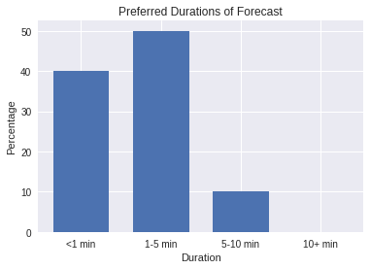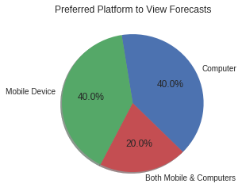

*Figure 1. Preferred Platforms for Forecasts Figure 2. Preferred Durations for Accessing Forecasts*

##### Preferred Duration of Each Access

Understanding the attention spans of users allow providers to present products in the desired amount of detail in the most concise manner possible. A simple method is to gauge the duration of each forecast access. Below are the results shown in figure 2.

* 40% of the participants prefer to use under one minute to check forecasts
* Half the participants prefer to check forecasts for 1-5 minutes

An important consideration for forecast developers is what content should occupy the most important areas of the presentation. Based on the above findings, users expect to be able to understand the upcoming forecasts in under a minute. That said, a good portion tend to briefly look more into the details as long as it is not overtly lengthy.

#### Content and Representation of Forecasts

While adequate forecast format and brevity allows users to get the amount of detail they require, considerations regarding content of the forecast is also important in making sure the detail is relevant to the users' needs. In the following section, the study will discuss user preferences regarding (i) the kinds of weather information needed, (ii) how uncertainty should be communicated, and (iii) the value of historical data.

##### Relevancy of Different Meteorological Variables

The atmosphere is a complex environment that can be described in many ways. Meteorological variables are qualities of the atmosphere that can be quantified (AMS Glossary 1). Such variables can include variables that can be easily perceived such as precipitation or cloud cover as well as more subtle ones such as humidity and pressure. Acknowledging the most important variables will provide guidance for designers on how to prioritize the positioning of graphs.

In the survey, participants are asked what variables are accessed the last time he or she read a forecast. The results are used as an approximation of how often such forecast variables are accessed. The options include temperature, precipitation, wind speed and direction, solar radiation (cloud cover, UV ratings), and pressure.

Results (in figure 3) indicate that as expected, staple variables, temperature and precipitation are checked by every user. Furthermore, wind variables are the next most frequently read at 75% of the time. Lastly, solar radiation and atmospheric pressure are the least accessed at 25% of the time. This is particularly interesting as currently, the meteograms have pressure on the first page while having wind information in a less significant loca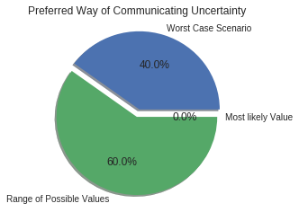tion.

##### 

*Figure 3. Frequency of Access for Variables Figure 4. Preference for Communication of Uncertainty*

##### Communication of Uncertainty

Weather forecasts are informed predictions of the future. Unavoidably, there will be uncertainty in the information presented. That said, the degree of certainty can be communicated to assist interpretations. Most notably, this can be achieved by indicating the worst case value, providing the range of possible values, or showing percentages such as percentage of precipitation (POP). However, one trade off with communicating uncertainty is that it requires more complicated graphics, which needs to be used in moderation. Articulating uncertainty by using more detail than needed will lead to unnecessarily convoluted and confusing forecasts.

Participants are asked to pick the most preferred way of presenting uncertainty given the following three options: by showing the worst case scenario, by referencing a range of possible values, and by indicating the most likely value.

The summary of results (shown in figure 4) are as follows:

* A majority of participants prefer to see the range of possible values.
* A good portion of users would like to know about the worst case scenario
* None indicated that the most likely value is their first preference.

Comparing between range of values and most likely value, the latter is a more condensed and simplified way of representing uncertainty while the former is more descriptive. The participants' preference to the more descriptive is consistent with the previous finding where users prefer acceptable amounts of detail in their forecast as opposed to very simplified formats.

##### Value of Historical Data

Historical Data of Climatological Data describes the range of values that are considered normal over some area for a certain period of time (AMS Glossary 1). It is useful when evaluating whether the conditions on a given day are normal, or whether it is a record breaking value. One resource that the UBC research team possess is an archive of daily high and low temperature values for the past decade.

In order to gauge the interest of the following graphic, participants are inquired to evaluate their interest for this feature.

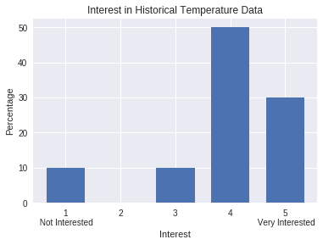

*Figure 5. Interest in Historical Temperature Data*

As indicated by the results, a majority of the users are interested or very interested in climatological information. A possible reason for this is whether the weather is normal is a relevant topic today given the awareness over climate change, and that the graph provides a simple illustration of the norm.

### Conclusion

#### Summary of Findings

* People equally prefer accessing forecasts using mobile devices, and computers
* 90% of users tend to use under 5 minutes to read forecasts, 40% of them accesses in under 1 minute
* Temperature and Precipitation are the most relevant to users, followed by Wind information, then solar and pressure
* Participants prefer interpreting uncertainty through seeing a range of possible values
* 80% of participants indicated that they are interested, or very interested on historical temperature data

#### Recommendations

Based on the following studies, please consider the following recommendations regarding the format and content of the UBC Rooftop Forecast.

* Implement mobile friendly interface for presenting forecasts that limits scrolling and resizing pages.
* Provide short weather summaries that can be read in under five minutes.
* Place wind speed in a location of greater priority after Temperature and Precipitation
* Maintain and build upon climatological records