ENGL 301

Unit 1.3 Definitions

Last Updated: Aug 10, 2017

The ability to explain technical terms to a general audience is an important skill for professionals. The following assignment provides an opportunity to practice three different methods of defining terms. The assignment will be marked using peer review format. The work will be marked based on clarity of work, whether the explanations aptly address the needs of the audience, and whether the level of detail is appropriate.

Parenthetical Definition

Hurricanes and typhoons are represented on weather maps as zones of high vorticity (measure of rotational motion).

Sentence Definition

Vorticity is a value given to an air mass that measures the amount of shear due to turning motion present in the area.

Expanded Definition

*Etymology*

The term "vorticity" describes the vortex-like properties of a fluid. The word "vortex" originates from the Latin word "vertex" meaning whirlpool or eddy.

*Compare and Contrast*

Compared to other atmospheric variables such as temperature, relative humidity, or pressure, vorticity is not a quality that is physically measurable by weather instruments. Instead, it is a way of summarizing the flow of fluids (in this case, the atmosphere) in such a way that highlights important rotational features like cyclones.

*History*

The idea of vorticity is first used by physicists and engineers studying fluid dynamics. In particular, the equations that describe vorticity is derived from a set of equations that describe how temperature, pressure, and density of fluids relate called Navier-Stokes equations. The equations are formulated in the early twentieth century and is still not fully understood today. The underlying mathematics behind weather forecast forecast models is based on these equations.

*Example of Uses*  
One of the foundational tools used by weather forecasters is satellite imagery. Such resource provides near real-time description of the state of the atmosphere. However, since the satellite observes from above, important weather producing features such as cyclones (rain, strong wind) can sometimes be obscured and hidden. Take for example the first figure of a satellite composite. The only feature present is the mid-latitude cyclone represented by the comma-shaped cloud pattern on the top left of the figure near Greenland. However, with the help of vorticity analysis, one discovers that there are also two smaller circulations approaching Spain in the middle-bottom part of the second figure. By looking at the vorticity signatures of satellite images, weather forecasters can narrow down and better focus on the key weather systems in the atmosphere.

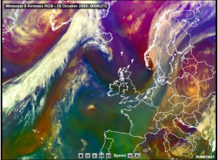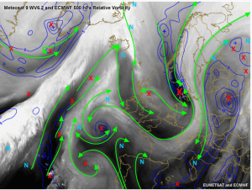

(Top: Plain satellite composite, weather features difficult to spot out. Bottom: Vorticity analysis, aside from main cyclone on top left, there are embedded systems on the bottom center.)

Citations

American Meteorological Society glossary of meteorology. American Meteorological Society, 2014, http://glossary.ametsoc.org/wiki/Vorticity. Accessed 30 May 2017.

Recognition and Impact of Vorticity Maxima and Minima in Satellite Imagery. University Corporation for Atmospheric Research, 2009, http://www.goes-r.gov/users/comet/EUMETSAT/vorticity/index.htm. Accessed 30 May 2017

Stull, Roland. Practical Meteorology: An Algebra-based Survey of Atmospheric Science. Univ. of British Columbia, 2015, pp. 362-63