Assignment 1.3- How ‘Montage’ Can Be Defined
The Importance of a Good Definition
As we continue learning how to write professionally in different contexts, we have learned the importance of a good definition. As John Lannon and Laura Gurak explain, “definitions explain terms or concepts that are specialized and may be unfamiliar to people who lack expertise in a particular field” (394). An effective definition adapts to its audience through writing based on the reader’s background. It also indicates the purpose of the item, process or concept by explaining what makes it unique. The final element to an excellent definition is, as Dr. Paterson noted, ‘differentiat[ing] between the levels of details in definition and then ‘select[ing] the right level of detail according to the situation’. This can be done by selecting either a parenthetical, sentence or expanded definition based on the audience and purpose.
For my chosen definition, the audience is an ‘unknowing’ reader who has little to no previous knowledge of the term. The definition has a dual purpose. Firstly, it illustrates that ‘montage’ is a unique film editing technique because it allows the filmmaker to produce one idea through the juxtaposition of multiple shots. Secondly, it allows for the summary of many events which take place over a long period of time.
Parenthetical Definition:
To convey an idea or to compress time, filmmakers often use montage (a series of combined film shots).
Sentence Definition:
Montage is a film technique in which film shots of different activities are edited together to illustrate a particular idea.
Expanded Definition:
The term “montage” is a French word meaning “editing”. First created between 1920-25, it is derived from the Old French “monter”, which means “to mount” or “to assemble” (Online Etymology Dictionary). The use of the word has not changed during this time, given that “montage” is still an assemblage of film shots.
Historically, “montage” was first used in the 1920s, notably in Soviet Russia. Montage is used prominently in Dziga Vertov’s film “The Man with a Movie Camera”. It must be noted that in Soviet Russia, montage was used to create new language for film in order to distance it from theatre and literature. In theatre, for instance, the location of the acting is called the stage, while in film it is called the set. Vertov also wanted to move away from the ‘acted’ film present in Hollywood. To do this, he shows the camera and cameraman in the film to demonstrate the work involved in creating a film (Barrance).
Ironically, contemporary Hollywood films use montage, but for a different purpose. Today’s films use montage to summarize events which happen over a large time scale. We need only look at Disney and Pixar’s “Up” and Chartoff-Winkler’s “Rocky I” as examples of this. In Disney’s “Up”, montage is used to portray Carl and Ellie’s married life which happens before the storyline begins. Using shots from different stages of the life cycle like their marriage and travelling together, their long relationship is summed up in a matter of minutes (see Figure 1a and 1b).
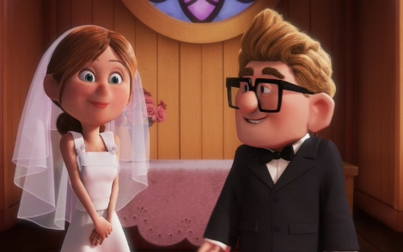

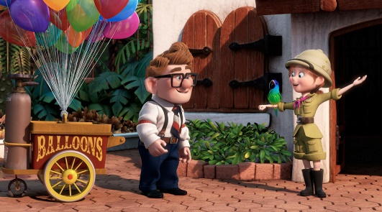

Figures 1a) and 1b)- images from a montage in Disney Pixar’s “UP”
Sources: 1a) Siden, Hannah E; “10 Things Carl And Ellie’s Marriage Taught Us”; Theodysseyonline.com, 21 Sept. 2017, https://www.theodysseyonline.com/10-things-carl-and-ellies-marriage-taught-us
1b) “Ellie And Carl's Wedding”; Youtube.com; 20 Sept. 2017, https://www.youtube.com/watch?v=M5oB3l1pFF0.
Similarly, “Rocky I” uses montage to display Rocky Balboa’s training to become a professional boxer. Using film shots of Rocky doing a variety of activities in different environments indicates that his training is a progression over time (Figure 2a and 2b).
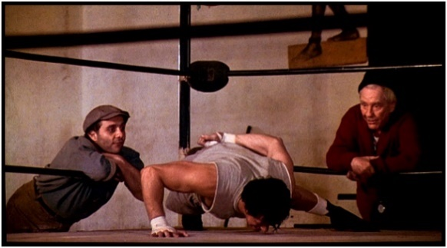
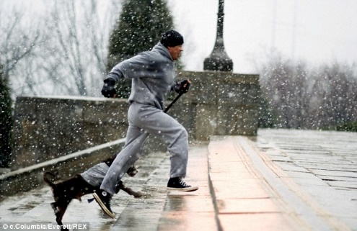

Figure 2a and 2b- A montage of images visualizing Rocky’s training process
Sources: 2a) “Action Star Workout: Train Like Rocky And Achieve A World-Class Physique!” Bodybuilding.com, 20 Sept. 2017, https://www.bodybuilding.com/fun/rocky_workout.htm
2b) “Better than the Real Thing: Training Montages”; Modestmovie.wordpress.com, 20 Sept. 2017, https://modestmovie.wordpress.com/tag/rocky/
A ‘jump cut’ is similar to montage in that it creates the effect of advancing time in the film. However, jump cuts are not to be confused with montage. Jump cuts involve moving the subject slightly and taking another shot. This results in a more abrupt movement through time rather than the large time scale seen in montage. ‘Cross-cutting’, which is when cameras cut away from one action to another, is also distinct from montage. This creates the appearance of an action occurring at the same time, whilst montage creates the effect of events happening over a long duration.
Thus, montage has historically been used differently than it is used today and there are a variety of film editing techniques to visualize time. Montage has evolved into an effective tool for filmmakers to present an idea in the contemporary cinematic world.

Works Cited
Barrance, Tom. "Soviet Montage: How The Russian Revolution Changed Film - Learn About Film." Learn about film. N.p., 2017. Web. 17 Sept. 2017.
Lannon, John M, and Laura J Gurak. Technical Communication. 14th ed. Essex: Pearson Education Limited, 2016. Print.
"Montage | Origin And History Of Montage By Online Etymology Dictionary." Etymonline.com. N.p., 2017. Web. 20 Sept. 2017.

