For Elizabeth Peterson
curator@vancouverpolicemuseum.ca

A Strategy to Increase Vancouver Police Museum Volunteers: A Causal Report

Table of Contents
Introduction 2
Methods 2
Results 3
Location of Past Volunteers’ Education 3
Volunteers’ Field of Study 5
Volunteers’ Degree Type 6
Results from Informational Interviews 7
Conclusions and Recommendations 8
Location of Past Volunteers’ Education 8
Volunteers’ Field of Study 9
Volunteers’ Degree Type 9
Results from Informational Interviews 9

Introduction
This report recommends strategies to increase numbers of qualified volunteers at the Vancouver Police Museum. Employing a causal analysis, the report answers three questions. Firstly, “what are past volunteers’ educational backgrounds and number of weeks logged?”. Secondly, “why do current volunteers continue at the museum?”. Finally, “what are the potential and actual reasons to leave the volunteer role?” The answers to these questions will help provide you with new marketing ideas to attract long-term volunteers. The data on past volunteers’ backgrounds will highlight where you can best advertise positions in the future. The push and pull factors of both current and past volunteers will reveal the best points to use in attracting long-term volunteers.
After speaking with you, the ideal characteristics of a volunteer came to light. Desirable volunteers are university-educated in museum studies, criminology or a related field. They are committed, respectful and responsible. They must agree to six to eight months of volunteering. This report will provide strategies to secure higher numbers of volunteers who meet these requirements. The Vancouver Police Museum needs more than the three current volunteers to manage the workload. As such, the report is a timely resource.
Methods
Informational interviews, volunteer applications, and exit interviews are the report’s three data sources. Common trends in the data along with pertinent individual responses were recorded in each. These trends and anomalies contributed to the recommendations for the future marketing strategy.
Three current volunteers at the Vancouver Police Museum participated in informational interviews to determine their educational backgrounds, reasons for continuing and potentially leaving the museum, and suggestions for future marketing techniques. The interviews comprised of the same six questions for each volunteer. Each interview also had specific follow-up questions, which are indicated as such in the results section of this report. Informational interviews are the best form of primary data collection for this study. The data provided is qualitative and individual to each volunteer. As such, a survey or focus group is less well suited to this research.
The initial volunteer applications and their time logs were used to collect data on volunteers’ educational experiences and amount of time spent volunteering. The data included the institution, the type of degree(s), and the field of study. Volunteers educated outside of Canada were excluded for the feasibility of attracting future volunteers. Past volunteers’ educational backgrounds are useful in knowing who and where to target future marketing of the roles. The length of time is important to learn when to check in during current and future volunteers’ experiences. Checking in may entice volunteers to continue at the museum.
Past volunteers completed exit interviews reflecting on their volunteer experience. The interviews were analysed to learn why the volunteers left, how the experience could be improved, and ways to enhance volunteer management. This data is particularly valuable as the volunteers had recently stopped volunteering at the museum. The questions asked are useful in this report because they request improvements for the future. One question, for example, is “if you could change your volunteering role what would you have wanted to change?”. Conclusions and recommendations in the report benefitted from reflective answers to the above type of question.
Results
Location of Past Volunteers’ Education
Out of the twenty volunteers who kept time logs, fourteen went to university or college in Canada. The current volunteers’ educational backgrounds are also included in the analysis. Figure 1 demonstrates how the institutions are distributed across Canada. The clear majority of the schools are located within British Columbia. Ontario is the second most common school for volunteers to attend. Figure 2 displays the schools within British Columbia alone, which has nine out of the thirteen schools volunteers attended. Although the University of Victoria is located on Vancouver Island, it should remain part of the analysis. Two out of three current volunteers and two out of the twenty past volunteers attended the University of Victoria. The fact that the two current volunteers are in the Cultural Resource Management program at the University of Victoria is significant.
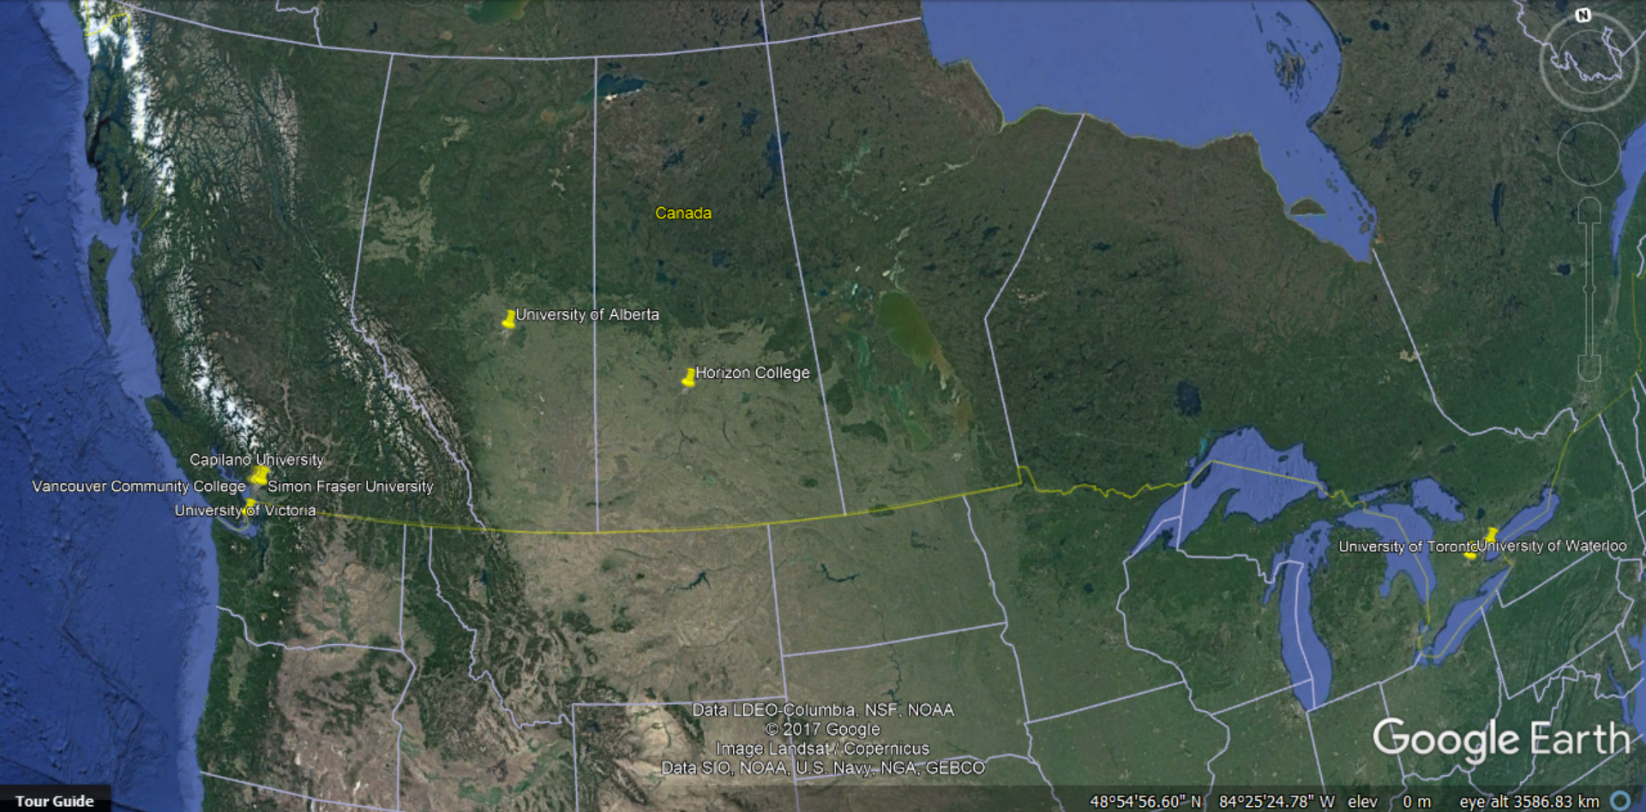
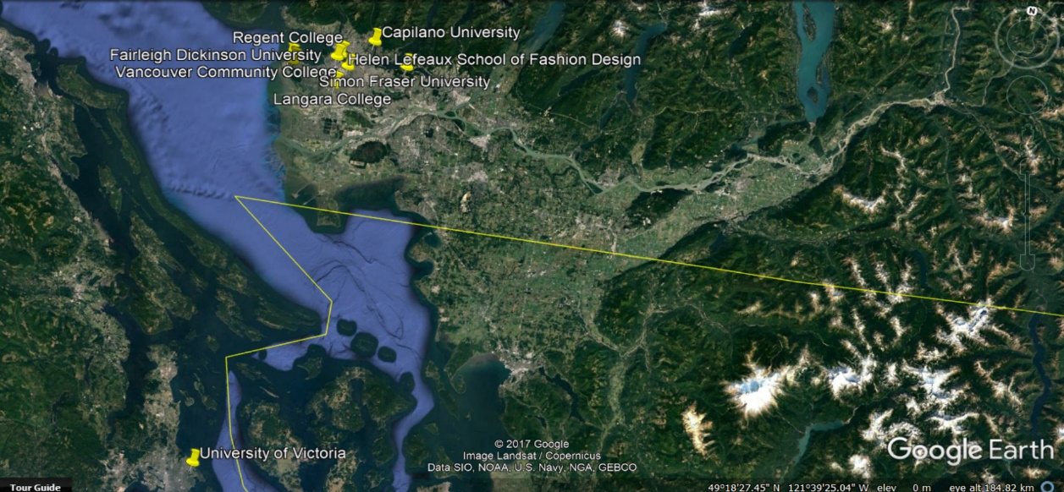
Figure 1 – A satellite image of the location of volunteer’s education within Canada
Figure 2 – A satellite image of the location of volunteer’s education within British Columbia
Volunteers’ Field of Study
Figure 3 indicates that the vast majority of current and past volunteers studied History at their university or college. Three volunteers studied either Law or Science. Two volunteers are currently studying Cultural Resource Management. Library and Information Science, Business Administration, Education and Psychology are other common degrees. Only one volunteer studied Computer Science, French, or Political Science. The fields of study which only one volunteer pursued are not worthy of future marketing efforts to attract volunteers.

Figure 3 - A Radar Diagram of the Volunteer’s Field of Study
Volunteers’ Degree Type
33% of the volunteers possess a Bachelor of Arts degree (BA). This is a large portion of the total numbers of volunteers. 11% have a Master of Arts degree (MA), while another 11% obtained a diploma. Other popular degree types include a Bachelor of Science degree and an Honours Bachelor of Arts degree. Considering that History is the most common field of study and it is typically a Bachelor of Arts degree, this result is not surprising. Less commonly held degrees are certificates, a Bachelor of Education degree or an Associate of Arts degree.

Figure 4 – A Pie Diagram of the Volunteers’ Degree Type
Results from Informational Interviews
The first of the six questions asked of the current volunteers is “what is your educational background?”. Two out of the three volunteers are currently pursuing their diploma in Cultural Resource Management at the University of Victoria. The other volunteer is pursuing his Honours Bachelors degree in Criminology at Simon Fraser University. The second question asked, “do you think there is demand in your university program or professional field for volunteer positions such as yours?”. The two volunteers in the Cultural Resource Management program stated that volunteer experience is highly encouraged within the program. The respondents cited this as the reason for searching for volunteer opportunities, and applying to the Vancouver Police Museum.
The next question was to determine how volunteers found out about the volunteer position. Significantly, two out of three volunteers learned of the museum through the Experience Vancouver Passport program. The other volunteer found the position on the Alliance for Arts website, an online resource for arts-related events and job postings. She also used Google to search for available volunteer positions.
The question of “what factors have influenced your decision to continue volunteering at the museum?” yielded common results among two volunteers. Two out of three volunteers cited working with the collections and learning new things as their main reasons to continue. The small nature of the museum allowed one volunteer to increase her responsibilities quickly, a factor she praised heavily. She also gave the Better Impact website as an example of an easy, organized way to apply for volunteer jobs.
The time commitment, moving, or getting a full-time job are all reasons why current volunteers would stop working at the museum. One volunteer noted that she is using this role as experience in order to land a full-time position in the museum field. The volunteers may only work during the museum’s open hours. Not being available during this time period due to getting a full-time job, for example, was cited as a potential obstacle.
There was no consensus in answering the question “do you have any suggestions for better publicizing this volunteer position?”. One volunteer suggested detailed postings on the museum’s website so prospective volunteers know about the positions from the start. Another volunteer recommended schools as a target audience. She added that if she had seen postings on her university department’s bulletin boards, she would have applied as an undergraduate. The other volunteer proffered the idea of a free coupon to the museum or a special lab tour to motivate students to volunteer.
Conclusions and Recommendations
Location of Volunteers’ Education
The majority of past volunteers went to university or college in British Columbia. These universities should be prioritized when advertising volunteer positions in the future. Since seven of the twenty volunteers went to UBC, this university in particular should be targeted. The University of Victoria’s Cultural Resource Program is another important avenue for future advertising given that two current volunteers are in the program, and museum experience is recommended by the program’s professors.
Volunteers’ Field of Study
The History Departments at different universities and colleges are an ideal place to advertise this position, given its popularity amongst past volunteers. After reaching out to the History Department at UBC, it is clear that they allow for postings to be published on their bulletin board on their floor of the building. Law and Science faculties are other good places to send the positions to. There are some fields of study which previous and current volunteers were not a part of, but are still viable options for advertising the positions. Examples include the Anthropology and Sociology Departments at UBC. Both of these departments are willing to distribute the volunteer position to their students using their e-mail lists.
Volunteers’ Degree Type
The Faculty of Arts is a good resource to contact for posting the volunteer opportunities. This is because such a large proportion of past and current volunteers have either a Bachelor of Arts or Masters of Arts degree. The high numbers of volunteers who have a diploma means the diploma programs at universities and colleges should not be ignored. With 6% of all the volunteers having either a Master of Science or Bachelor of Science, this faculty would be another good resource to get into contact with to distribute this position.
Results from Informational Interviews
One volunteer found the position through the Alliance for Arts website. This is a good resource to continue advertising the volunteer positions on. The Better Impact website, which is for Surrey and Burnaby museums, was also cited as a tool used by current volunteers to search for positions. Looking at postings on the Better Impact website would be beneficial to learn tips for posting the Vancouver Police Museum’s positions. It is worth it to continue as a stop for the Experience Vancouver Passport program, as it increases awareness of the museum in young people. Since those on the Passport program are young and interested in museums already, this could be a good opportunity to advertise the available positions as well.
The Google search made by one of the volunteers did not result in her learning about the Vancouver Police Museum. The Museum could receive more digital traffic through completing a search engine optimization. This way, the museum would appear much more frequently as a top result on the public’s search engines.
The three concerns the volunteers mentioned are the time commitment, moving, or getting a full-time job. Addressing these concerns right away with new volunteers is one way to ameliorate these issues. An alternative way to advertise the positions may be to frame them as a “stepping stone” to future positions. This may limit the secondary goal of this new volunteer strategy, however, which is to ensure more volunteers stay for a long duration.
Two volunteers noted that the things they liked most about volunteering at the museum are working with the collections and learning new things. These are two points which should certainly form part of future volunteer job postings. Other tools to entice prospective volunteers may be a free coupon to the museum or a special lab tour. Since the museum houses the old City Analyst’s lab on the ground floor, but it is not open to the public. Giving university students an opportunity to see what it looks like and what equipment was used may attract them to work as volunteers in the future.

