Improving Nightlife, Event, and Party Culture Practices on
UBC’s Vancouver Point Grey Campus

for

The Board of Governors
The University of British Columbia
Vancouver, British Columbia

and

The Executives of the Alma Mater Society (AMS) of UBC
The University of British Columbia
Vancouver, British Columbia

by

Michaela Basciano
ENGL 301 Student,
Internal Director of The Calendar,
Student Consultant & Volunteer at SVPRO

August 1st, 2020

Table of Contents

Abstract 3
Introduction 4
Methods 6
Data Section 7
Demographics of attendee survey 7
Demographics of host survey 7
Data limitations 7
Events 7
Event Safety 8
Positive Practices 8
Table 1 8
Table 2 9
Areas for Improvement 10
Host input on future training. 11
Conclusion 12
Summary of Findings 12
Interpretation of Findings 12
Recommendations 12
Figures 13
References 21

Abstract

Introduction

The University of British Columbia is one of the largest universities in the country and is home to the largest student enrollment in western Canada. Established in 1908, it is the province’s oldest university and has established a respectable global reputation. With students hailing from all corners of the world, the university attempts to hold a place for everyone with over 350+ student clubs within the Alma Mater Society (AMS) and many other established student groups across campus. A rather popular activity that occurs amongst many of these groups, or students in general, are parties, or nightlife events. Some of the larger, more notable groups on campus that host these events include, but are not limited to, The Calendar, AMS Events, The Plug, the Greek system (more notably the fraternities), and The Black Student Union (UBC BSU). The most popular locations on campus for nightlife events are Koerner’s Pub, a bar scene located on West Mall, The Pit Pub, a nightclub type scene located in the AMS Student Nest, and the Great Hall, located in the AMS Student Nest. Something to consider when analyzing these experiences is that one of the most prominent dangers within the nightlife sector is the potential of experiencing sexual harassment and/or violence, as bars and nightclubs are just a couple of the places where sexual harassment most often takes place in Canada (Cotter & Savage).

Sexual violence is not unique to nightlife environments; it is prevalent and can occur across all areas of our campus and society. A 1993 Canadian study analyzing a large sample of undergraduate students reports that “28% of [the women studied] had experienced some form of sexual assault … and 45% of [the] women had experienced some form of sexual assault since entering college” (DeKeseredy & Kelly 140). And sexual violence is not just an act seen against women; anybody can be a victim of sexual violence. For men, “the prevalence of sexual assault in British Columbia (11%) is higher than the [country’s] provincial average (8%)” (Cotter & Savage). However, there are unique risks and scenarios for potential perpetration in nightlife and party environments, and therefore, a more tailored approach is needed. The university’s Board of Governors and AMS currently pose a strong focus on creating a “consent culture” on campus and providing mandatory training to university staff and faculty on supporting survivors and how to receive disclosures (5). Although this is great and extremely important in setting a survivor centric approach to the issue, they have rarely addressed what can be done in terms of prevention in the past. Practices pertaining to sexual violence response should expand beyond support and the handling of disclosures after the fact.

Nightlife practices carried out by campus groups have the capacity to improve immensely by providing the students within them the appropriate training and giving them access to the applicable resources. Each year, campus groups should be required to attend training on relevant topics, such as the ones that have been discussed thus far, in order to host events on campus. In addition, groups on campus should be encouraged to work with university offices (e.g. Sexual Violence Prevention & Response Office (SVPRO)) to form their own code of conduct and sexual violence policy that reflects that of the university’s. These, amongst other things, will not only educate and assist numerous students, but will also contribute to the university’s efforts in creating a consent culture and creating safe and inclusive spaces for all that attend events at UBC.

By analyzing various surveys and documents, this report will outline where groups are excelling at creating safe spaces, where there is room for improvement, what students want to see improve within nightlife atmospheres, and demonstrate that there are students at UBC who want to do more and are willing to learn how they can contribute in a positive way to everyone’s enjoyment and safety within party atmospheres.

Methods

To generate a diverse collection of data, two surveys were created specifically for this report. The first was created for the general student population – those who attend the events on campus. This survey was distributed over social media to various Facebook Groups and personal friends who were willing to assist in collecting data. This survey asked questions about demographics, safety and inclusion, event preferences and experiences, and asked for suggestions pertaining to the improvement of nightlife events on campus.

The second survey was created for the students within the host groups (e.g. The Calendar, AMS Events, etc.). The students were required to respond to the survey as individuals and not on behalf of their entire team. This survey was distributed to colleagues and sent out to other groups over email. This survey asked questions about demographics, event details, beliefs about their affiliated group, current education efforts, areas for improvement, their thoughts on mandatory training, and whether their group currently has, or is working on, a sexual assault policy.

Both of these surveys were entirely voluntary and anonymous other than the respondents noted group affiliation.

To provide additional insight to this report, various documents were virtually collected from the AMS Vice President Academic & University Affairs, Georgia Yee, some of which include data from the 2020 Academic Experience Survey. All student responses provided for this survey are anonymous and the official survey report is made available to the public yearly. One of the many topics on this survey is sexual assault and other misconduct, making it prevalent to this report.

Data Section

Demographics of attendee survey. After distribution, the sample size resulted in 35 people giving responses. Of the 35 respondents, 26 of them (74.3%) identified as female, with the other 9 identifying as male. This similarly reflects the gender distribution breakdown of students on campus as a whole, with female identifying students encompassing almost 60% of students on campus (PAIR). A majority of the respondents (37.1%) are going into their fourth year at UBC, with incoming third years being the second largest majority (25.7%).

Demographics of host survey. After distribution to colleagues, 17 nightlife host team members responded to the survey from across nine different groups. The majority of responses came from The Calendar (35.3%), with other responses coming from AMS Events (11.8%), The Plug (5.9%), the UBC BSU (11.8%), the Greek system (11.8%), Generocksity (5.9%), the Residence Hall Association (5.9%), and a member from varsity athletics (5.9%). One other respondent (5.9%) chose not to select one of the distinct groups but noted that they are a part of the UBC BSU, AMS Events, and the Greek System elsewhere in the survey. Eleven (64.7%) of the participants identified as female, with the other six identifying as male. All participants who affiliated with the Greek system in this survey also identified as male, signalling that they belong to one of UBC’s many fraternities. All the participants noted that they are either going into their third (23.5%), fourth (41.2%), or fifth (29.5%) year at UBC, with one respondent having just graduated.

Data limitations. The UBC Residence Hall Association (RHA) is an organization of elected students that represent all students residing in UBC Student Housing. The organization is funded by Student Housing and Community Services (SHCS) through the payments of its residents and is therefore governed and advised by university staff. As a result, the RHA follows university and housing policies strictly and receives yearly training on specific topics similar to that of Residence Life staff. However, there are still times during the academic year where the RHA is allowed to host events with the presence of alcohol for their residents of age. Concurrently, the RHA does not receive yearly training on topics such as alcohol safety and bystander intervention, even though they are present in situations where these practices could be of need. Therefore, the RHA’s data is permitted and relevant in this study despite them not being a nightlife group.

In addition, as previously stated, none of the participants of this study who affiliated with the Greek system also identified as female, meaning that none of the Greek system participants belong to a sorority. For this reason, UBC sororities are not to be cognitively encompassed in “the Greek system” when mentioned in this report.

Events. The Calendar tends to be the preferred event host from an extensive list provided to the sample (Figure 1). However, the sample has attended AMS Events’ events more often than those hosted by The Calendar (Figure 2). One potential reason for this is that AMS Events hosts “Pit Wednesdays” on a weekly basis, whereas the Calendar does not do regularly scheduled open events. This is supported by Figure 3, demonstrating where events have been attended.

Events that have party and nightlife atmospheres are the preferred event theme by the respondents (Figure 4). A student is likely to attend these events 1-3 times per month, with some respondents noting only once or twice per semester (Figure 5). A vast majority of these events, as stated by the host respondents, have the presence of alcohol (Figure 6) and more than half of the time have 200+ attendees (Figure 7).

Event Safety. Feeling safe is one of the largest determinants of whether a student decides to go somewhere for an event. If a student feels that there is potential to experience any sort of harm, they are likely to not attend. Overall, students typically feel safe attending events on campus (Figure 8). However, there are gender differences to this claim, as female identifying students tend to feel less safe than male identifying students, especially if or when they are attending an event alone (Figures 9, 10).

An overwhelming majority of 74.3% attendee respondents stated that they feel welcome when attending events on campus. This statistic is similar to that of the host survey response, with 94.1% of the hosts stating that they believe students feel welcome at their events. In addition, 88.2% of host respondents believe that students feel safe while attending their event with the other 11.8% feeling “neutral” toward the question.

Positive Practices. Currently, some of the best equipped resources on campus available for nightlife host groups to learn and gain support are the AMS Sexual Assault Support Centre (SASC), SVPRO, the UBC Wellness Centre, and the Independent Investigations Office (IIO). The choice of which service a group may use may depend on their affiliation with the university. For example, AMS Events is directly affiliated with the AMS of UBC, and is therefore likely to choose the SASC as its main outlet, whereas The Calendar has established a relationship with the SVPRO, as they are not affiliated with the university or the AMS.

The following table outlines which triainings each of the respondent groups receive on a yearly basis, on average:

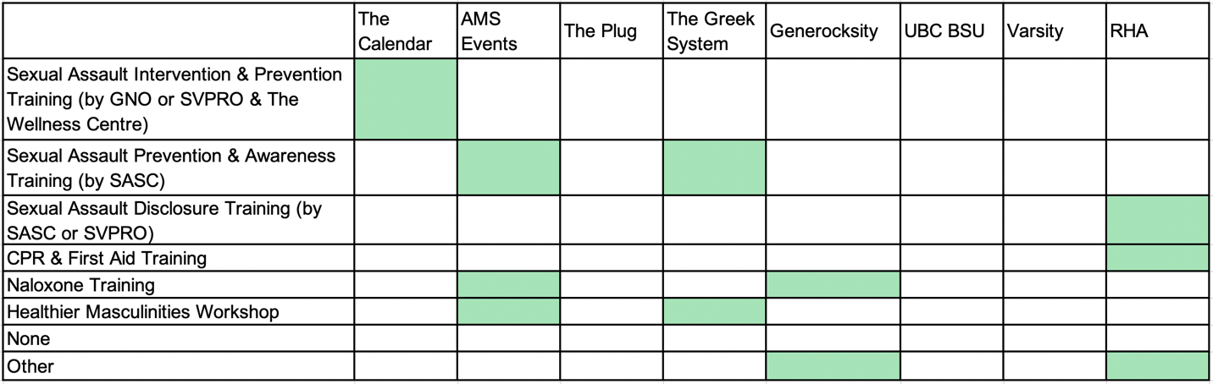
Table 1 – Yearly education received by groups on avergage stated by host survey respondants. If the group (top row) recieves the training (left column), their intersecting square will be green.

In order for a square to be green, the training had to show up in each respondent’s answer within that affiliated group. For example, within The Calendar, a respondent stated that CPR & First Aid training is received while other respondents did not. In addition, some groups mentioned that they have received the top-most listed training by GNO or SVPRO and the Wellness Centre. However, this training has only been given to a handful of groups on campus so far, with The Calendar being the only sole nightlife event group to receive it as a part of SVPRO’s trial/pilot program. It is important to note that three of the responding groups have not received any of the listed trainings, or provided any “Other” responses.

It seems that regardless of the lack of training, however, all the groups have stated that during their time at UBC they have learned about a variety of important topics in some sort of capacity, whether it be from training or in conversation (Figure 11). If asked to explain the topic(s) to others, the respondents feel confident they would be able to do so on a comprehensive level (Figure 12).

When hosting nightlife events, there are many practices and strategies that groups can execute to ensure the safety and enjoyment for all attending. The follwing chart demonstrates the practices each of the respondent groups carry out at their events:

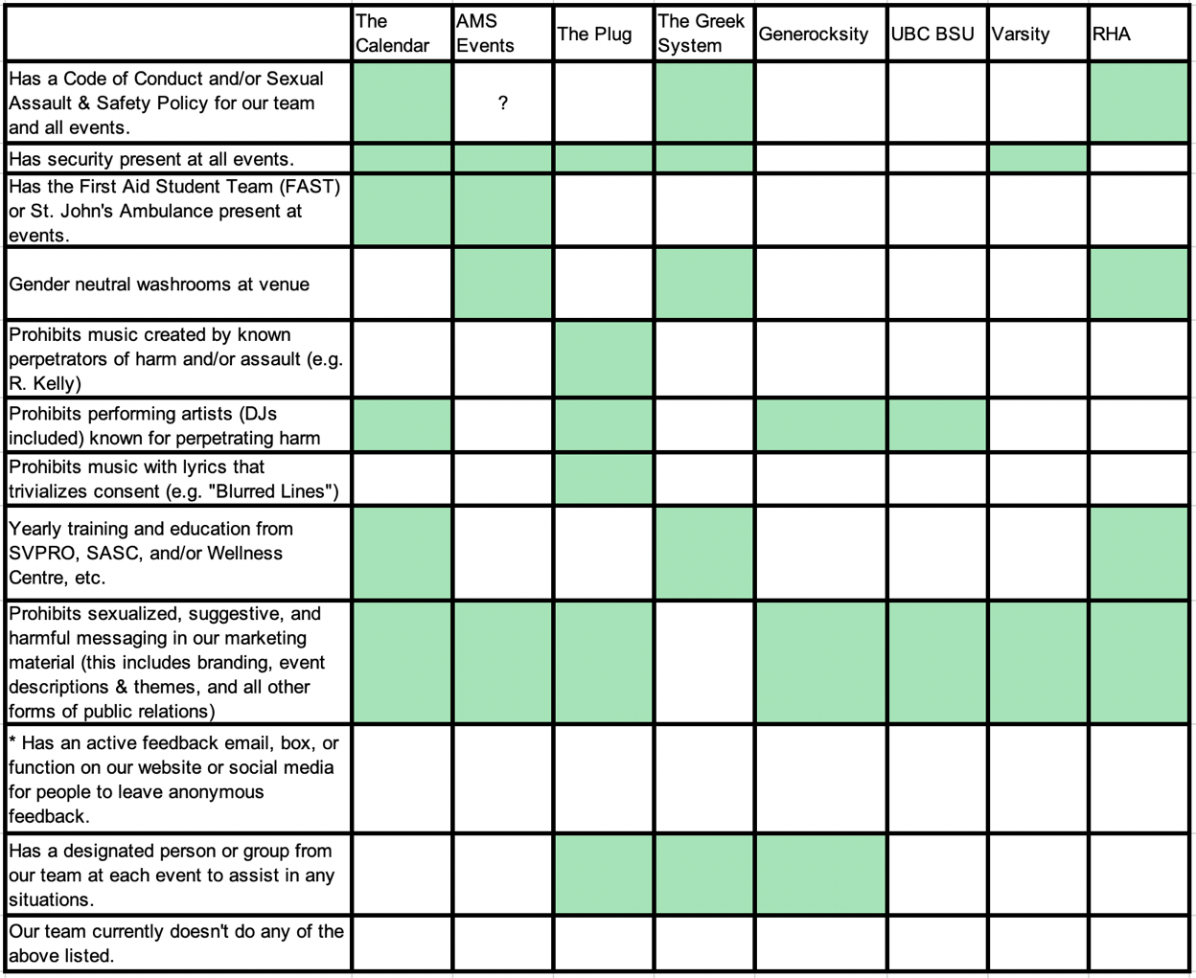
Table 2 – Positive practices currently carried out by host respondent groups. If the group (top row) practices the strategy (left column), their intersecting square will be green.
*Some respondents did state that they have an active feedback feature for anonymous feedback, but this information was back-checked and found to be false.
? – Left unclear based on responses.

In an ideal world of practicing sexual violence prevention and promoting a consent culture and inclusivity, all the squares with the exception of the bottom row would be green. However, it is enlightening to see some rows and columns almost completely there. Again, there are some discrepencies between respondents within the same affiliated group which demonstrates the inconsistencies in some of these practices as well as the potential for false information. A box is only highlighted if information was found in all responses from that group and not proven false through background varifiication of information (e.g. anonymous feedback option).

Areas for Improvement. In the suggestions portion of the attendee survery, students proposed a variety of things groups on campus could to to boost feelings of safety, inclusivity, and their events overall. Many of the suggestions overlap and include the following:
- Implementing a larger variety of themes making events more diverse and appealing to more demographics of students,
- Creating an extension of events without the presence of alochol,
- Ensuring organizers have the proper training to deal with incidents of sexual violence, including the receiving of disclosures,
- Ensuring that groups across campus have to meet the same specifications of safety within their events,
- Ensuring that groups across campus receive the same level and amount education in order to host events,
- Asking event organizers to stay sober in order to facilitate the event properly and assist in a incident of harm if needed,
- Creating a “chill zone” at events, where attendees can take a break and relax if they’re been dancing too much, have lost their friends, or need a mental reset from everything occuring at the event,
- Inviting first aid personnel to events, and
- Making event spaces accessible to everyone (ranging from having wheelchair access to changing the ticket price set up arrangement for those who do not have the financial means to attend an event).

Some suggestions also included proposals for the AMS of UBC and the university, such as extending Salf Walk hours on peak event nights, adding more blue emergency poles around campus, and adding more lighted walkways on paths home from popular event locations.

When asked where respondents thought their team could benefit from more education on various topics, a strong emphasis was put on substance use safety, safe and inclusive spaces, bystander intervention, and tools and strategies for safe events (Figure 13). Hosts would also like to see their respective groups practice more of the previously discussed prevention practices to execute a safer event (Figure 14).

Host input on future training. When asked what their thoughts are on implementing mandatory training on sexual violence prevention in order to host events on campus, hosts are in favour (Figure 15). In addition, all respondents except for one believe that if their team is to undergo the training, you must attend the training to be a part of the group. However, when it comes to receiving and paying for the training, over 50% of the host respondents feel very strongly about training being provided to them for free, or at a reduced cost (Figure 16). This can imply that groups have not recieved certain trainings due to their inability to afford it; unlike AMS Events, many groups, including The Calendar and The Plug, do not receive yearly funding meaning that their earned assests from events carry over to the next year leaving budgeting tight.

Conclusion

Summary of Findings

Sexual violence is one of the main threats of attendee safety within nightlife. Although the university has made great strides within the past decade on expanding its services and focussing on training staff and faculty, there are areas that deserve more attention. The university has some amazing resources which should be put to use on a wider scale and have an impact on more people. An ideal consent culture cannot exist on campus without it being supported and carried out by the university’s largest population of people – its students.

Interpretation of Findings

Nightlife groups on campus are already making positive efforts in practicing sexual violence prevention strategies, but there are many areas where student groups can improve and need to work on implementing action. Event attendees also believe there is room for improvement and are not satisfied with the lack of certain practices by some of these groups. Students on campus want to do more to achieve a consent culture and a safe, inclusive nightlife experience but they are in need of guidance, and it is clear that it needs to begin with regular education and training. Sexual violence prevention strategies and safe party planning tools is an excellent place to start.

Recommendations:

If you are able and wanting to improve how UBC is promoting and creating a consent culture and practicing the strategies of sexual violence prevention, consider these suggestions:

- Creating working relationships between university offices and external groups (e.g. Good Night Out Vancouver) in order to create the best tailored educational programs for student nightlife groups.
- Emphasizing the need of providing students with education, stressing importance on the topics of alcohol safety and safe event planning tools, including sexual violence prevention strategies (e.g. bystander intervention).
- Implementing a yearly education plan and schedule for on-campus nightlife groups, including the staff at university establishements (e.g. bartenders).
- Requiring all nightlife campus groups to implement a Code of Conduct or Sexual Violence Policy which mimics that of the university’s.
- Requiring the presence of the First Aid Student Team (FAST) at all on-campus nightlife events or parties, and ensuring they receive the matching training as the host groups.
- Adding more physical safety measures around campus, such as emergency poles and walkway lighting.
- Extending the student safety services, such as Safe Walk.
- Promoting the importance and benefits of getting educated to UBC students.

Figures

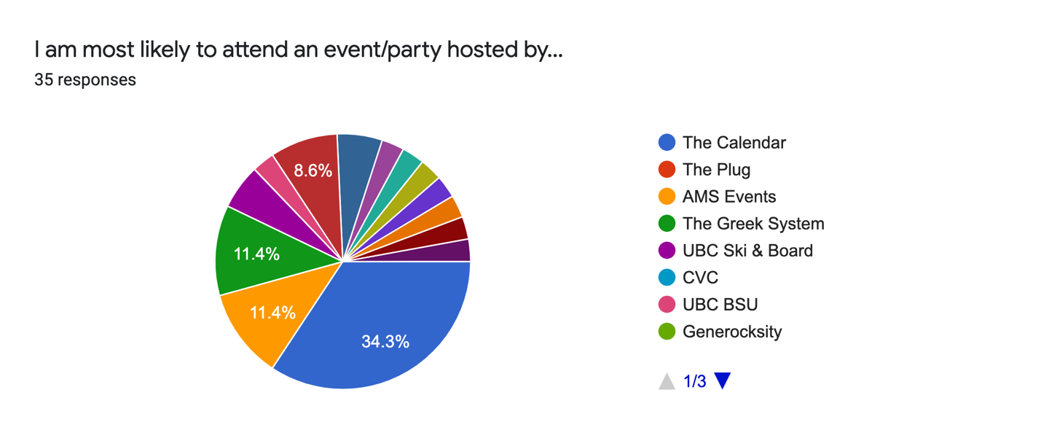
Figure 1 – Attendee survey respondents are most likely to attend an event hosted by The Calendar.

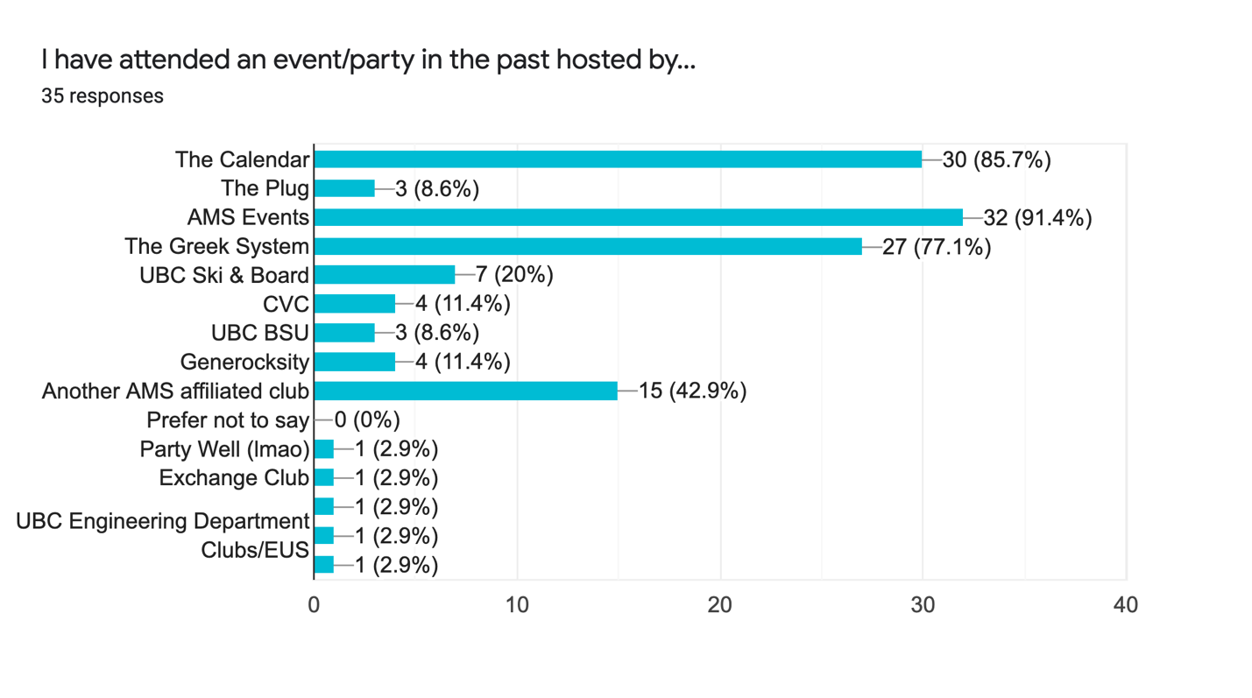
Figure 2 – Almost all attendee survey respondents have attended an event held by AMS Events, with The Calendar and the Greek System also being popular hosts.

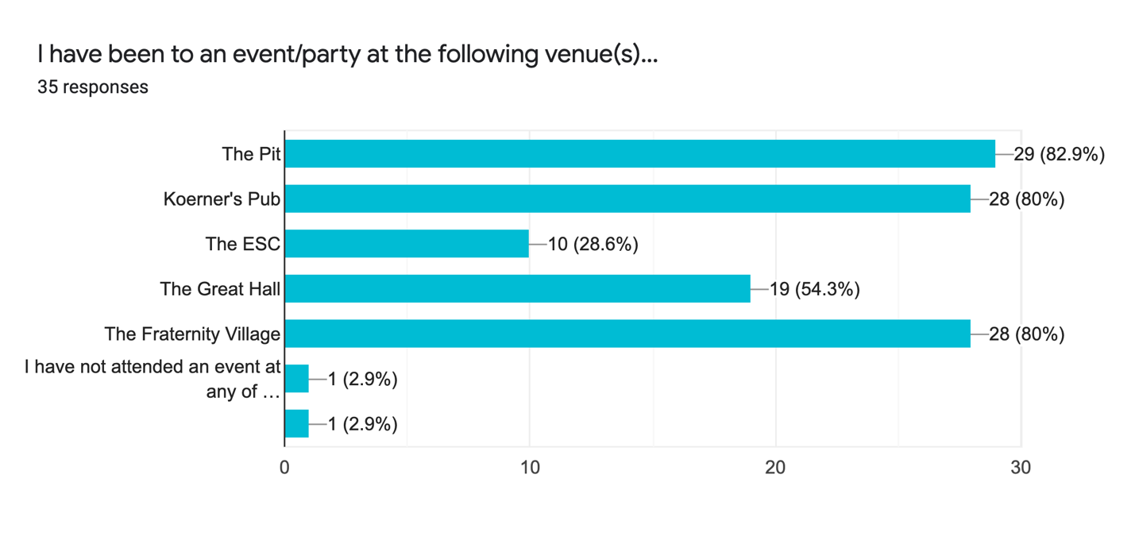Figure 3 – The most popular events on campus are most frequently held and attended at The Pit, Koerner’s Pub, and the Fraternity Village.

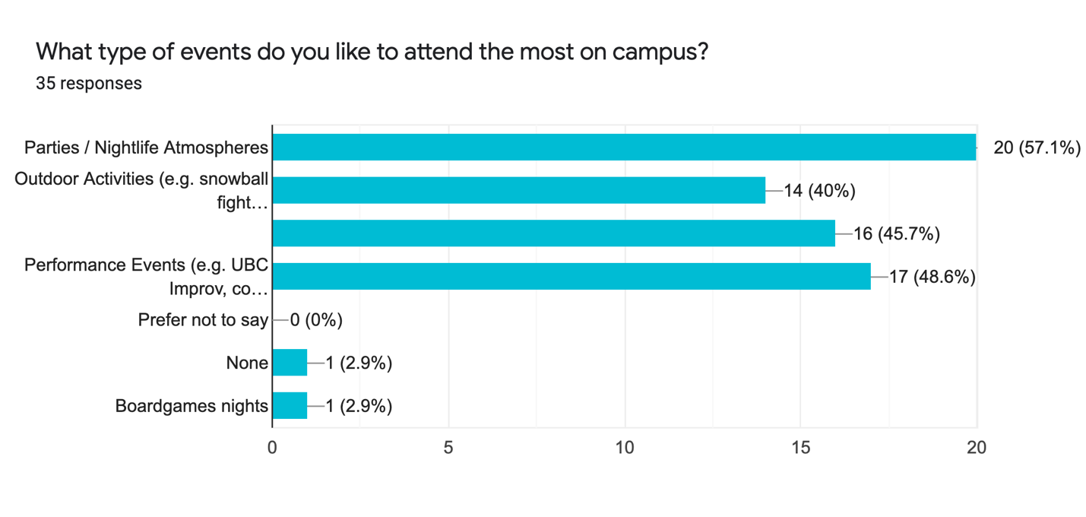
Figure 4 – Parties are the most favoured types of events on campus voted by attendee survey respondents.

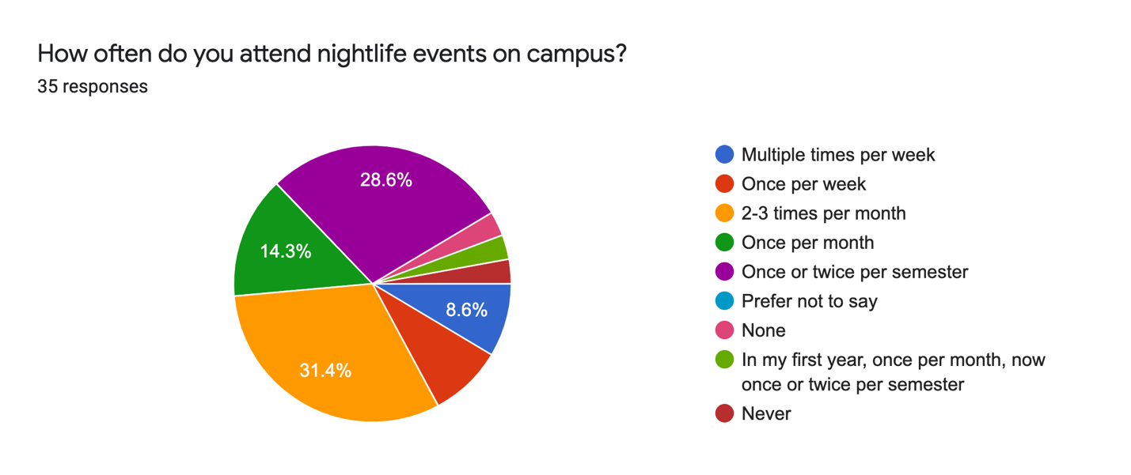
Figure 5 – Students tend to attend nightlife events one to three times per month, with a large population of the sample also only attending once or twice per semester.

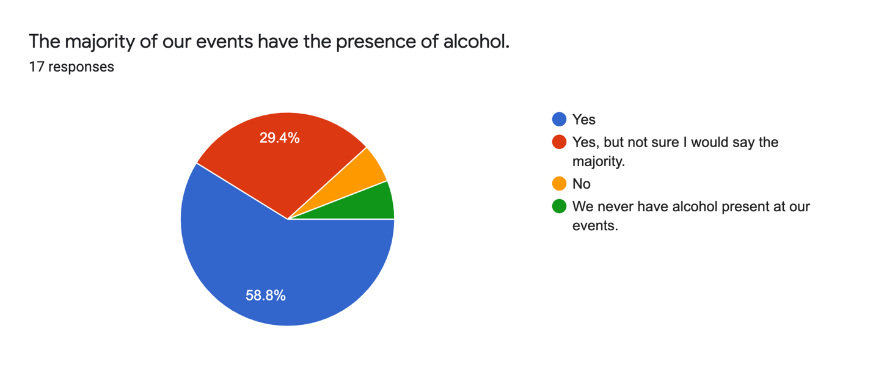
Figure 6 – Host survey respondents claim that their events are most likely to have the presence of alcohol.

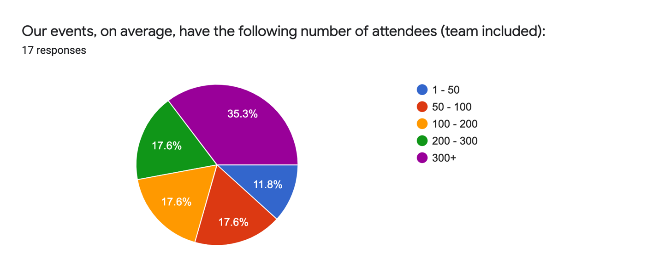
Figure 7 – Nightlife events are expected to gather 200+ students over 50% of the time, according to hosts.

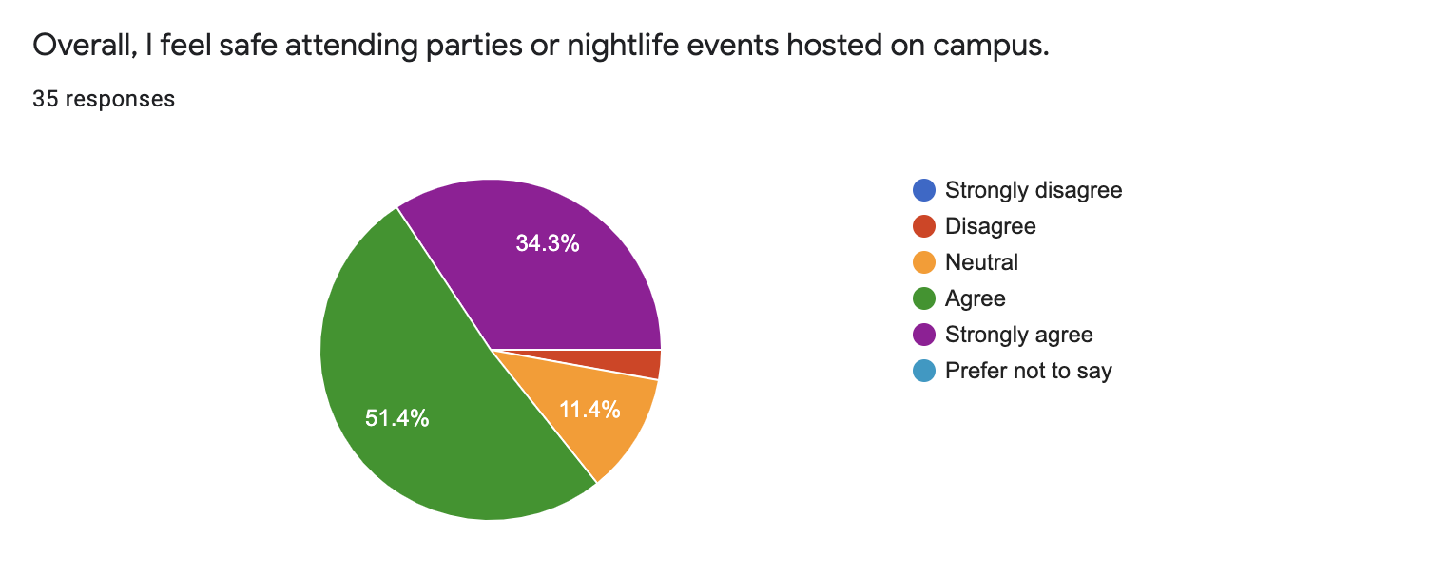
Figure 8 – Respondents tend to agree that overall, they feel safe attending events on campus.

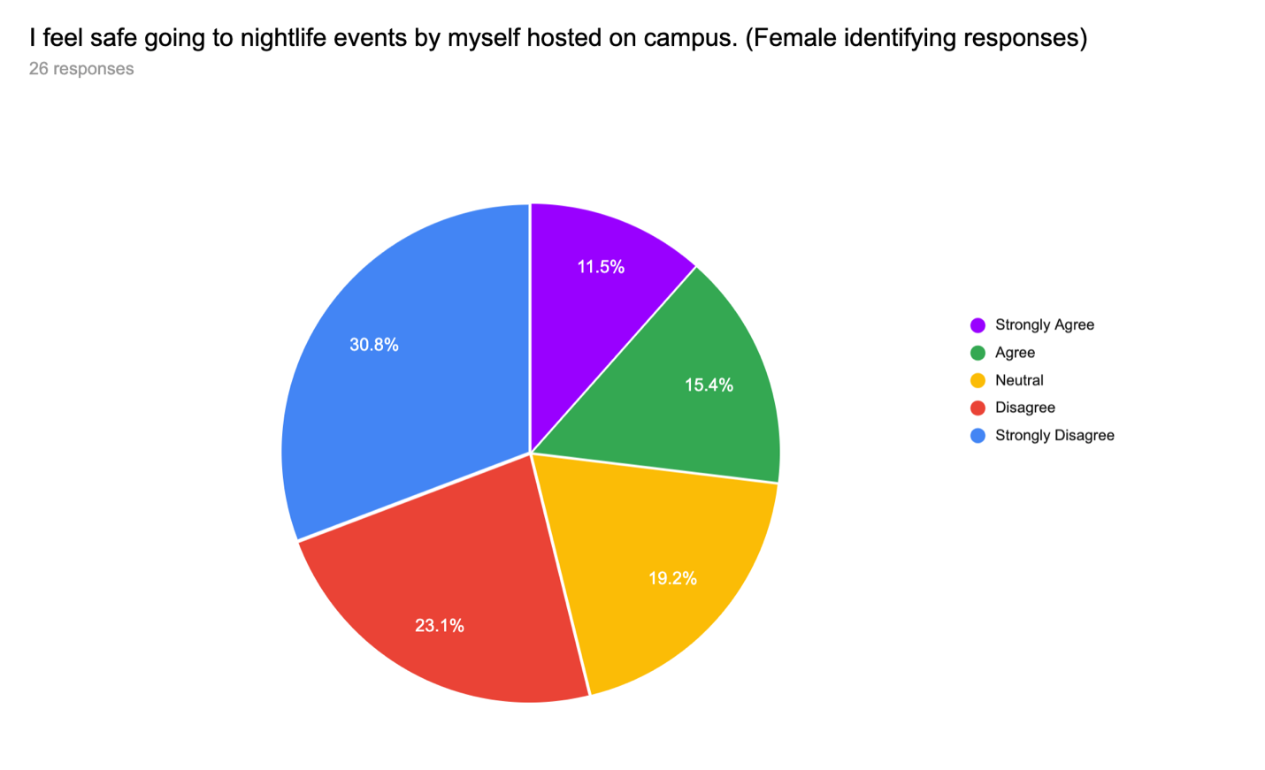
Figure 9 – Female identifying attendee survey respondents strongly disagree towards the notion of feeling safe if they were to attend an event on campus alone.

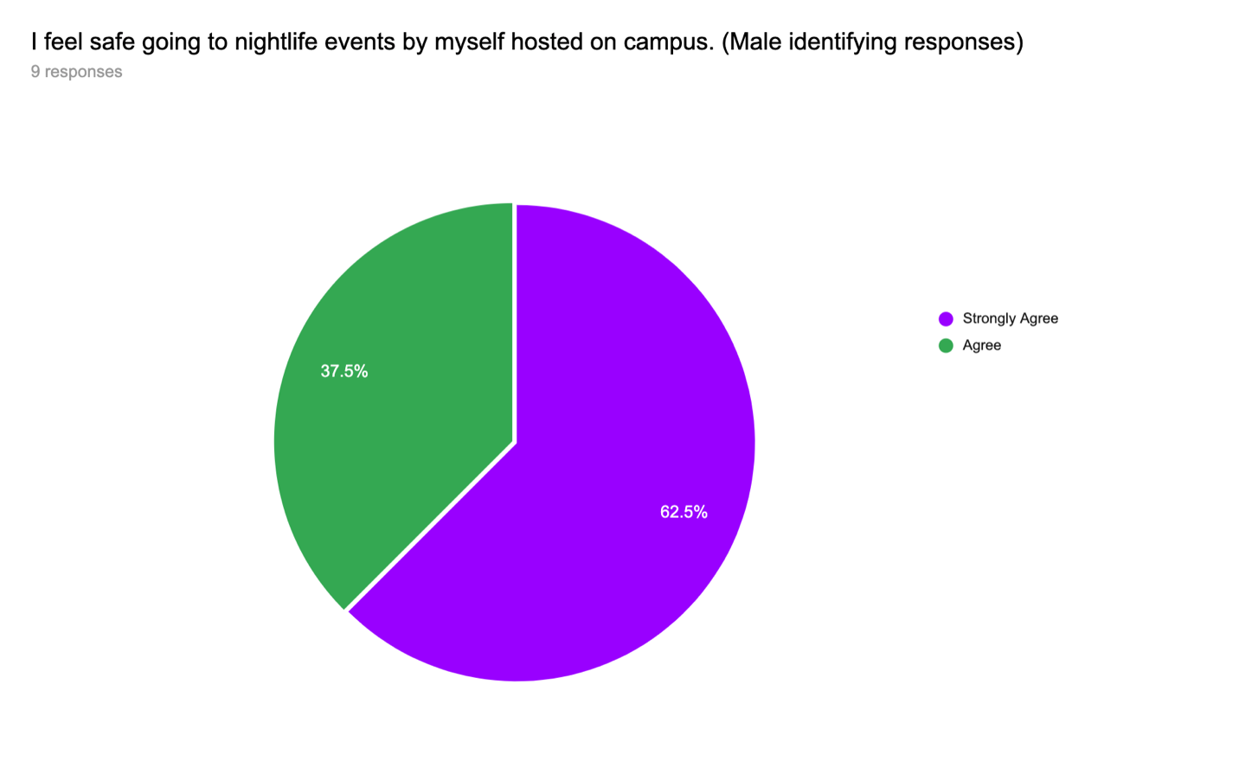
Figure 10 – None of the male-identifying attendee survey respondents stated that they felt unsafe or “neutral” attending an event on campus alone.

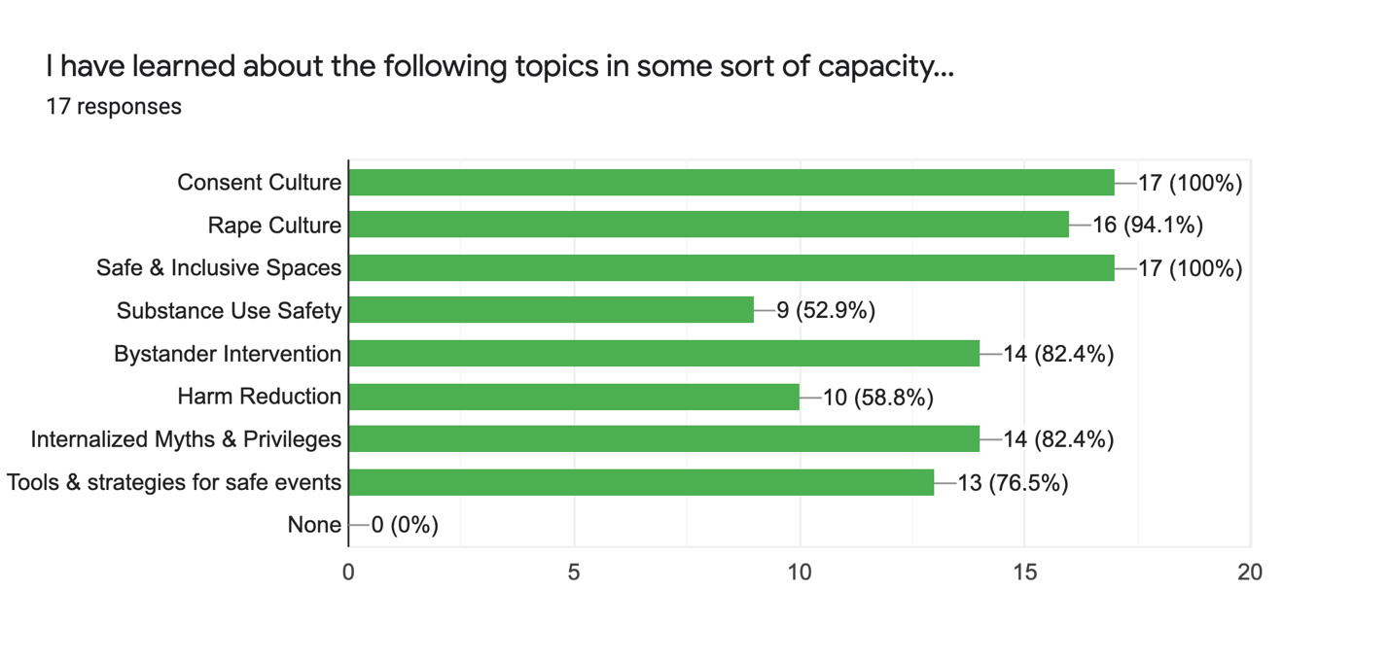
Figure 11 – Host respondents state that throughout their time at UBC, they have learned about the listed topics in some sort of capacity, regardless of their amount of formal education.

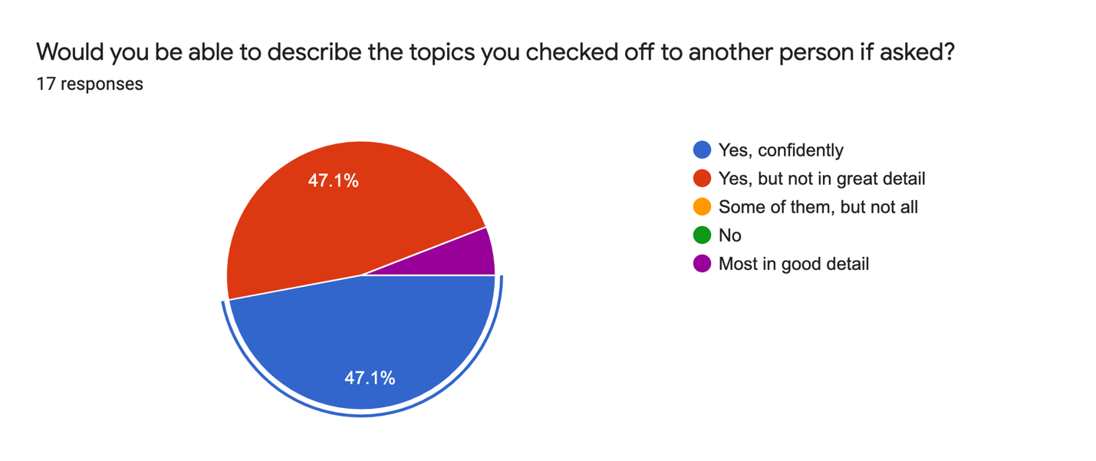
Figure 12 – Host respondents feel confident that they would be able to explain the topics in Figure 11 to another person, even if not in perfect detail.

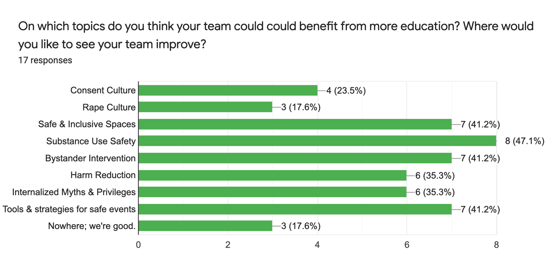Figure 13 – Host respondents would like their team to receive more education on the provided topics with primary emphasis on substance use and alcohol safety. The three responses stating “Nowhere; we’re good” came from members of The Greek System and AMS Events.

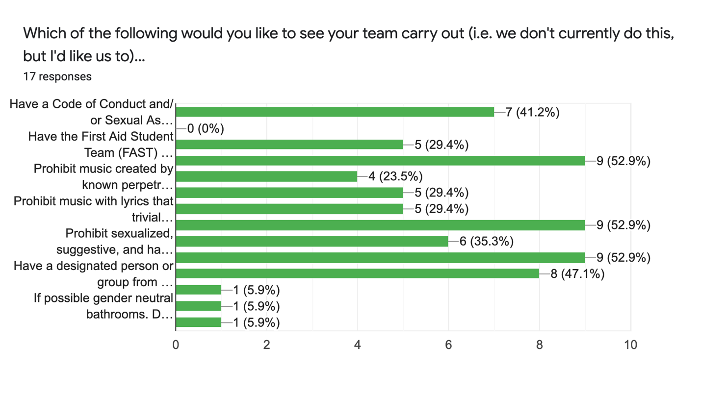
Figure 14 – Host respondents would like to see their team execute more safe practices, most notably, have gender neutral washrooms at the venue (52.9%), clean up their marketing (52.9%), and have an active, anonymous feedback location for their attendees to use (52.9%).

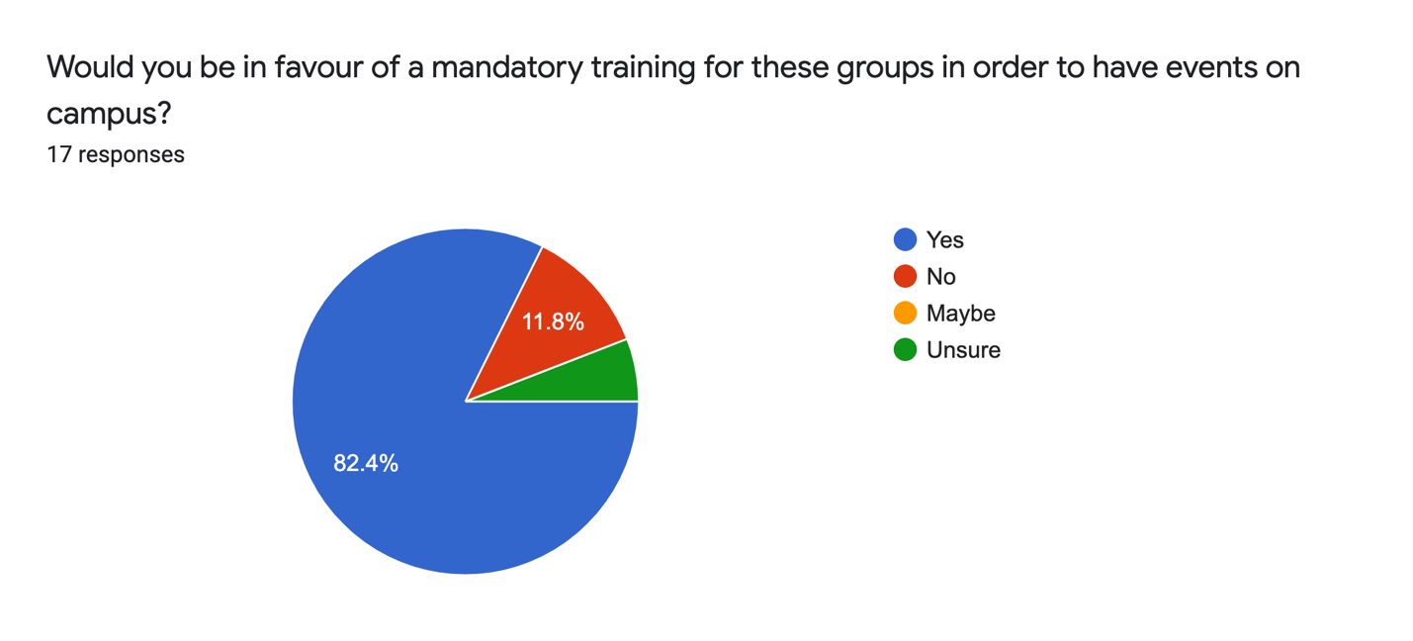Figure 15 – Host respondents agree that they should have to receive training in order to host events on campus in order to provide safer events for all.

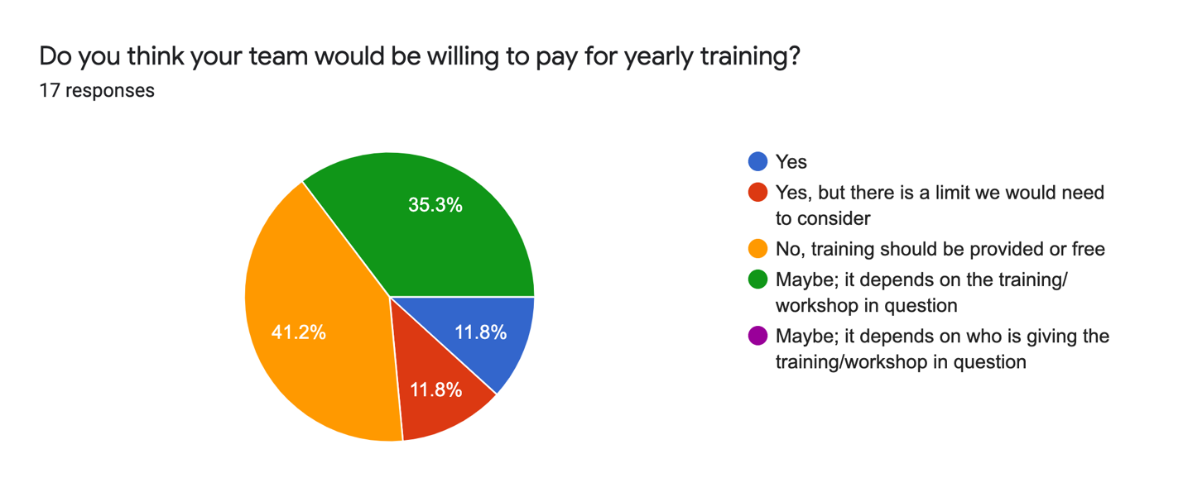
Figure 16 – Host respondents believe that training should be provided for free or at a reduced cost but would be willing to pay for training in full depending on the topic, presenter, and their budget.

References

Alma Mater Society of the University of British Columbia. “Submission to the UBC Board of Governors People, Community & International Committee Regarding the Implementation of Board Policy SC17: Sexual Assault and Other Misconduct”. UBC Board of Governors, June 2020, https://bog3.sites.olt.ubc.ca/files/2020/05/14a_2020.06_Correspondence-from-AMS.pdf

Cotter, Adam, and Laura Savage. “Gender-Based Violence and Unwanted Sexual Behaviour in Canada, 2018: Initial Findings from the Survey of Safety in Public and Private Spaces.” Government of Canada, Statistics Canada, Government of Canada, Statistics Canada, 5 Dec. 2019, www150.statcan.gc.ca/n1/pub/85-002-x/2019001/article/00017-eng.htm.

DeKeseredy, Walter, and Katharine Kelly. “The Incidence and Prevalence of Woman Abuse in Canadian University and College Dating Relationships.” The Canadian Journal of Sociology / Cahiers Canadiens De Sociologie, vol. 18, no. 2, 1993, pp. 137–159. JSTOR, www.jstor.org/stable/3341255. Accessed 22 July 2020.

“Good Night Out. Safer Events for All.” Good Night Out Vancouver, www.goodnightoutvancouver.com/.

Planning and Institutional Research (PAIR). “Fact Sheet Winter 2019.” University of British Columbia, 1 Nov. 2019.

