Feasibility Analysis
of Employee Engagement Programs

for
John Lo
Manager
Mitchell Island Terminals Ltd

by
MinZhang Si
English 301 Student

read by
Kenny Colosie
Member of the Commas

March 16, 2022

Table of Contents
Letter of Transmission …………………………………………………………………………... 3
Abstract …………………………………………………………………………………………. 4
I. Introduction …………………………………………………………………………………… 5
A. Definition of job satisfaction ………………………………………………………………… 5
B. Background on employee engagement programs …………………………………………… 5
C. Statement of the problem ……………………………………………………………………. 6
D. Purpose of this report ………………………………………………………………………... 6
E. Brief description of primary and secondary data sources …………………………………… 7
F. Scope of this inquiry ………………………………………………………………………... 7
II. Data Section …………………………………………………………………………………. 8
A. Surveys Completed by Coworkers …………………………………………………… 8
B. Observations During Lunch Hours …………………………………………………. 16
C. Academic Research on Employee Engagement Programs …………………………. 17
III. Conclusion ……………………………………………………………………………….… 19
Summary and Interpretation of Findings ………………………………………………………. 19
Recommendations ……………………………………………………………………………… 19
Works Cited ……………………………………………………………………………………. 20

Figures
Figure 1: Hobbies and Interests ……………………………………………………………….. 8
Figure 2: Social Events of Interest …………………………………………………………….. 10
Figure 3: Willingness to Participate in Social Gatherings at Work …………………………… 12
Figure 4: Number of Hours on Weekly Work Social Events ………………………………….. 13
Figure 5: Level of Interest in Social Gatherings at Work ……………………………………… 14
Figure 6: Frequency of Social Gatherings …………………………………………………...… 15

Letter of Transmission
1234 Cloudy Street
Raincouver, BC V3B 6M8

March 16, 2022

John Lo
Manager
Mitchell Island Terminals Ltd
13280 Mitchell Rd, Richmond, BC V6V 1M8

Dear Mr. Lo:

Here is the report, Feasibility Analysis of Employee Engagement Programs. Thank you for giving permission to investigate employee engagement programs for Mitchell Island Terminals Ltd.

In the report I describe what employee engagement programs are in detail before stating the problem and purpose. I discuss primary and secondary data, drawing my conclusion from the conducted surveys distributed to 30 staff members and from scholarly research.

I appreciate your approval of this project and would be glad to answer any questions. Please call at 604-321-1111 or email at msa176@students.cs.ubc.ca if you would like to discuss the report anytime.

Sincerely,

MinZhang Si

Abstract

This report determines the feasibility of employee engagement programs for Mitchell Island Terminals Ltd.

Employee engagement programs can improve social ties and employees’ performance and productivity. This report discusses findings from a survey distributed to 30 employees at Mitchell and from scholarly studies.

This report has three recommendations:
- establishing an employee-led engagement committee that runs a Social Club and a Sports Club
- running a monthly social event, a biweekly event and other pop-up events,
- and ensuring all social gatherings at work are optional, voluntary, varied, flexible, partially to fully subsidized.

I. Introduction

A. Definition of job satisfaction
According to Sara Soldo, Professor of School of Business at the University of Mostar, job satisfaction refers to how employees feel about their jobs and various aspects of their jobs and the degree to which they like or dislike their jobs (196). Soldo explains that job satisfaction is of paramount importance to organizations because “the humanitarian perspective is that people deserve to be treated fairly and with respect” (196) and job satisfaction is to some extent “a reflection of good treatment” (196).

B. Background on employee engagement programs
Researchers Schaufeli et al. define engagement as “a positive, fulfilling, work-related state of mind that is characterized by vigour, dedication, and absorption” (74). While vigor refers to “high levels of energy and mental resilience while working” (74), dedication describes “a sense of significance, enthusiasm, inspiration, pride, and challenge” (74) and absorption emphasizes “being fully concentrated and deeply engrossed in one’s work” (75).

Schaufeli et al. also stress the non-monetary, emotional, and mental qualities of engagement:
Rather than a momentary and specific state, engagement refers to a more persistent and pervasive affective-cognitive state that is not focused on any particular object, event, individual, or behaviour (74).
Employee engagement programs therefore are connected to employees’ emotional and mental health.
Paul Turner, author of Employee Engagement in Contemporary Organizations, explains that employee engagement is a crucial part of human resource management and within the organizational context because it is associated with improved employee performance and increased productivity (27). As Turner states,
An engaged employee achieves above average levels of productivity and contributes significantly to team effectiveness; an engaged team is a source of unit or departmental efficiency; but an engaged workforce is a potential source of organisation wide competitiveness and strategic advantage (1).
Together, Schaufeli et al. and Turner point to the importance of an engaged organization that implements an employee engagement strategy.

C. Statement of the problem
Mitchell Island Terminals Ltd currently does not have any employee engagement programs. Some employees have voiced concerns over lack of social life in the workplace and felt distanced from their coworkers and their organization. There are two major implications of this problem. First, employees of different departments do not interact with one another as well as they can, which leads to less efficient communication in the company. Second, employees have low morale and feel less motivated to work, let alone communicate or support their colleagues.

D. Purpose of this report
One possible solution to the problem is to run several employee engagement programs, such as a Social Club and a Sports Club. This solution will provide employees different ways to engage with others, get to know those they work with, and create a motivating work environment. The objective is to increase employees’ job satisfaction so they can be more committed to their work tasks and to Mitchell Island Terminals Ltd.

E. Brief description of primary and secondary data sources
My primary data sources include a survey with the five questions above. I circulate the survey to 5 employees from each department. Also, as informal observations, I talk to coworkers and get their opinions on employee engagement programs, gathering information on what they prefer, when they most want to participate in social life at work, and how much they are willing to spend on social activities.

Secondary sources include academic studies on employee engagement strategies. These will be evidence showing the effectiveness of employee engagement programs.

F. Scope of this inquiry
To assess the feasibility of running several employee engagement programs, I focus on five areas of inquiry:
- What are employees’ interests and hobbies?
- What social events do employees want the most?
- How many employees regularly do some form of sports?
- What sports programs do employees like?
- Which period would employees most likely want to participate in a weekly, biweekly, or monthly social event?

II. Data Section

A. Surveys Completed by Coworkers
To determine the extent to which employee engagement programs are feasible, I send out a six-question survey consisting of 2 short answers, 2 multiple-choice questions, and 2 linear scale questions. I use social networking sites, emails, and text messages to send the survey link to coworkers.

In total, there are 30 responses highlighting 6 themes: 1. Hobbies and Interests, 2. Social Events of interests, 3. Willingness to Participate in Social Gatherings at Work, 4. Number of Hours on Weekly Work Social Events, 5. Level of Interest in Social Gatherings at Work, and 6. Frequency of Social Gatherings.

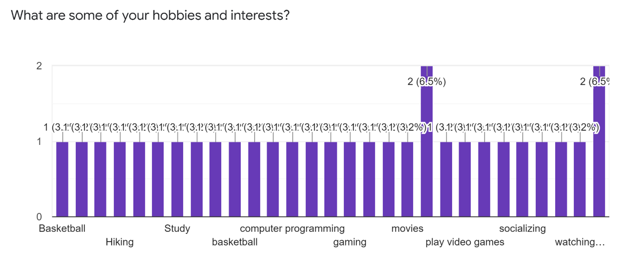
Figure 1: Hobbies and Interests

1. Hobbies and Interests
Figure 1 illustrates respondents’ answers to the question about their hobbies and interests. The answer that appears three times are gaming/video games while the answers that appear twice are workout and music, and the rest of the answers appear only once. Some respondents have 2+ hobbies and interests so the number of responses here exceeds 30. Four sub-themes are observable in the responses:
Sports and Outdoor Activities. Many respondents (10) lead an active lifestyle. Their answers include the following: workout (2), hiking, basketball, running, exercise, skydiving, football, hockey, and badminton.
Their interest in sports and outdoor activities suggest a Sports Club or an Active Club that organizes sports events is an option for employee engagement.
Drinks. Some responses (4) show that employees enjoy making new connections and having a good time with others over a drink. These answers include drinking, socializing, meeting new people, and clubbing.
Their response points to the possibility of a Social Club in charge of planning regular hangouts and drinks that allow employees to relax and expand their social networks.
Games, Technologies, and Media. Some responses (7) indicate that employees like gaming and other tech-related activities: video games (3), music (2), computer programming, and movie.
This sub-theme shows tech-based social activities at work will appeal to some employees, and employee engagement programs can take place virtually, like through Zoom movie nights or online game nights.
Others. Several responses (6) from the survey may be more niche, including pets, nothing, books, studies, poker, and LEGO.
The responses that fall under this category imply that successful employee engagement programs would be more flexible and diverse so that more employees can participate, pick up new hobbies, and try new activities.

2. Social Events of Interest
Figure 2 illustrates the variety of social events that respondents are interested in. It is an important figure that points to three sub-themes:

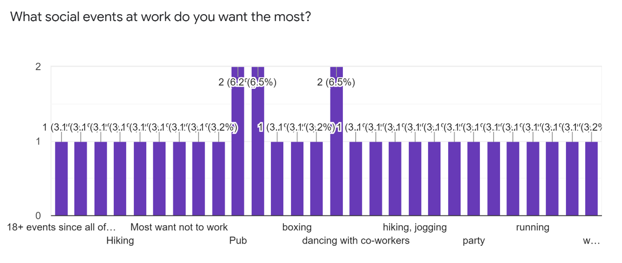
Figure 2: Social Events of Interest
Variety of Interests. Respondents together mention many different types of social events they would like to take part in, including pub (3), clubbing (2), parties (2) sports (2), dancing, hiking, track and field, boxing, running, workout, jogging, swimming, movie nights, card games, deep talking, meals, Netflix, library, and pet events.
The responses are varied and suggest that employees would enjoy a mix of social gatherings at work. An effective employee engagement program will need to offer employees different choices of social activities.
Alignment of Personal Interests and Social Events. The answers illustrated in Figure 2 are aligned with those in Figure 1, suggesting that respondents likely want to see their personal interests represented or advocated for in social events at work. For example, pub/parties/drinking and sports/workout are both employees’ top personal interests and social interests. In other words, employees interested in sports themselves will promote and join sports events at work.
This alignment between personal interests and social events suggest that employee engagement programs need to represent what employees like to do at the work social events.
Lack of Motivation for Social Events. A few responses (5) underscore some level of indifference toward social events at work: go home, most want not to work, not sure, better not have, not a lot of social events at work and would only participate in the ones on holidays like Christmas.
These five responses are important because they reveal that not all employees are passionate about social events and that some would like to go home and attend to other personal or family matters. Their responses suggest that employee engagement programs will be best optional instead of mandatory.

3. Willingness to Participate in Social Gatherings at Work
Figure 3 illustrates respondents’ level of willingness to take part in social gathering at work. Of the 30 respondents, 8 or 25.8% of them indicate 10 (most likely), 6 or 19.4% choose 9, and 4 or 12.9% opt for 8. There are 3 or 9.7% each for 6 and 7, and 1 or 3.2% each for 3, 4, and 5. Four or 12.9% of the respondents choose 1 (least likely). The data here reveal the following two sub-themes:
High Level of Willingness. Given most of their responses are situated at scale 6+, it is clear majority of the respondents lean towards being willing to participate in a social gathering at work. Therefore, setting up a committee or taskforce responsible for employee engagement programs is a possible intervention that can improve social ties and cross-departmental communication at work.
Voluntary Participation. The few respondents who select scale 1-5 are important clues that some employees have little to no interest in group activities or social events at work. As mentioned in Figure 2, in the interest of respondents who do not like social gatherings or who have other obligations, participation in employee engagement programs will be preferably voluntary.

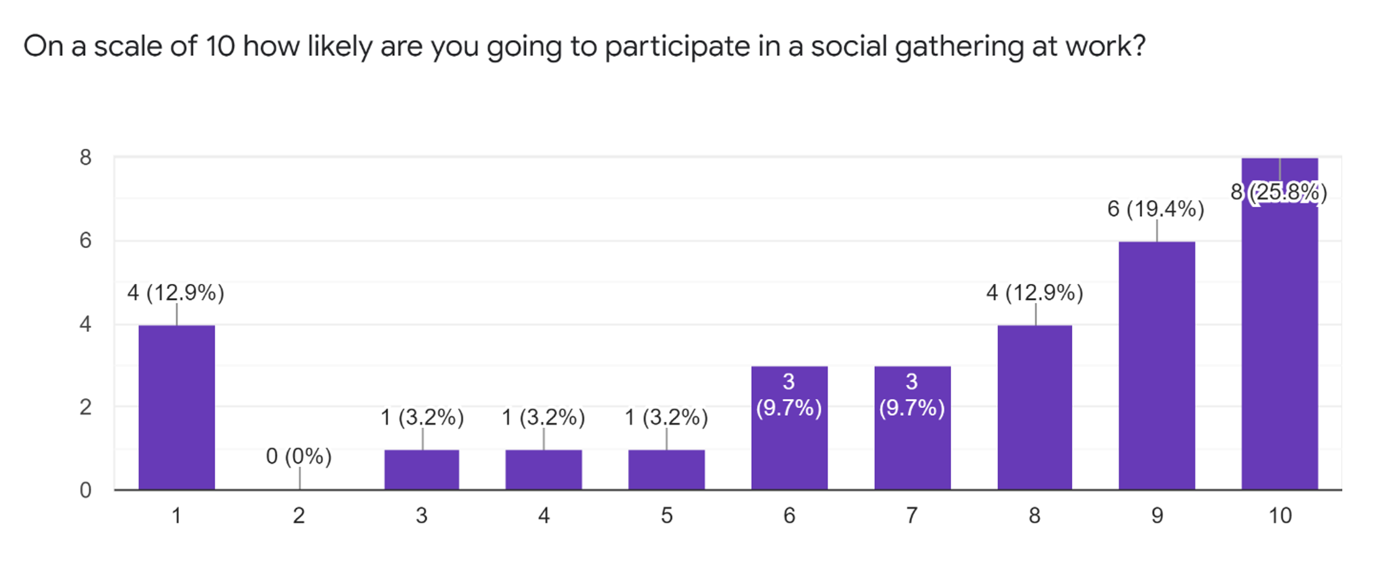
Figure 3: Willingness to Participate in Social Gatherings at Work

4. Number of Hours on Weekly Work Social Events
Figure 4 illustrates the number of hours employees are ready to spend on a work social event each week. The responses are fairly divided as respondents seem to have different opinions on how much time they will use to socialize at work. About 26.7% of the respondents are willing to spend half an hour on one social gathering each week, followed by 23.3% each for 1 hour and 3+ hours and 20% for 2 hours. There is a small portion willing to spend 3 hours. The one sub-theme the responses highlights is as follows:
A Social Event with Flexibility. Since respondents are quite split about how much time they are ready for a social event at work, organizers of employee engagement programs need to design social events that are flexible. Events can run from 30 minutes to 3+ hours, and employees are encouraged to come and leave at their own time. This flexibility will attract more employees to attend a work social event, especially for those who have time constraints, additional work duties, or personal engagements.

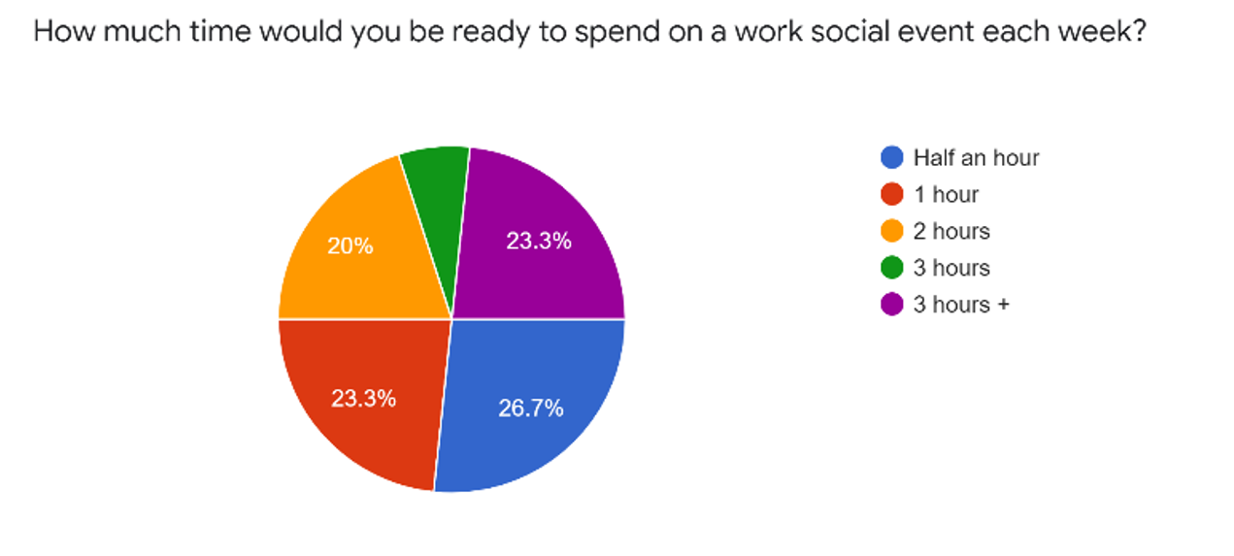
Figure 4: Number of Hours on Weekly Work Social Events
5. Level of Interest in Social Gatherings at Work
Figure 5 illustrates respondents’ scale of interest in social gatherings at work and this figure reinforces the responses and sub-themes illustrated in Figure 3. Notably, responses to this question about interest in work social gatherings are mostly the same as Figure 3, e.g., 8 or 25.8% of the responses for scale 10 (most likely) and 4 or 12.9% for scale 4 (least likely). Together with Figure 3, Figure 5 points to the following two sub-themes:
An Outgoing Workspace. As most of the responses fall under the 5+ scale, employees are thus already relatively outgoing and sociable. Although they will have individual differences in terms of how personable they are or how much they enjoy socializing, most would welcome some interpersonal communication and social interaction through an employee engagement program.
Employee Choice. As emphasized above in Figure 2 and Figure 3, some employees may have personal tasks and goals to fulfill and may be less inclined to take part in socializing. Employee engagement programs need to be open to all employees, whether they are outgoing or not, and they have the choice to decide whether to and how much or how often to join a social event.
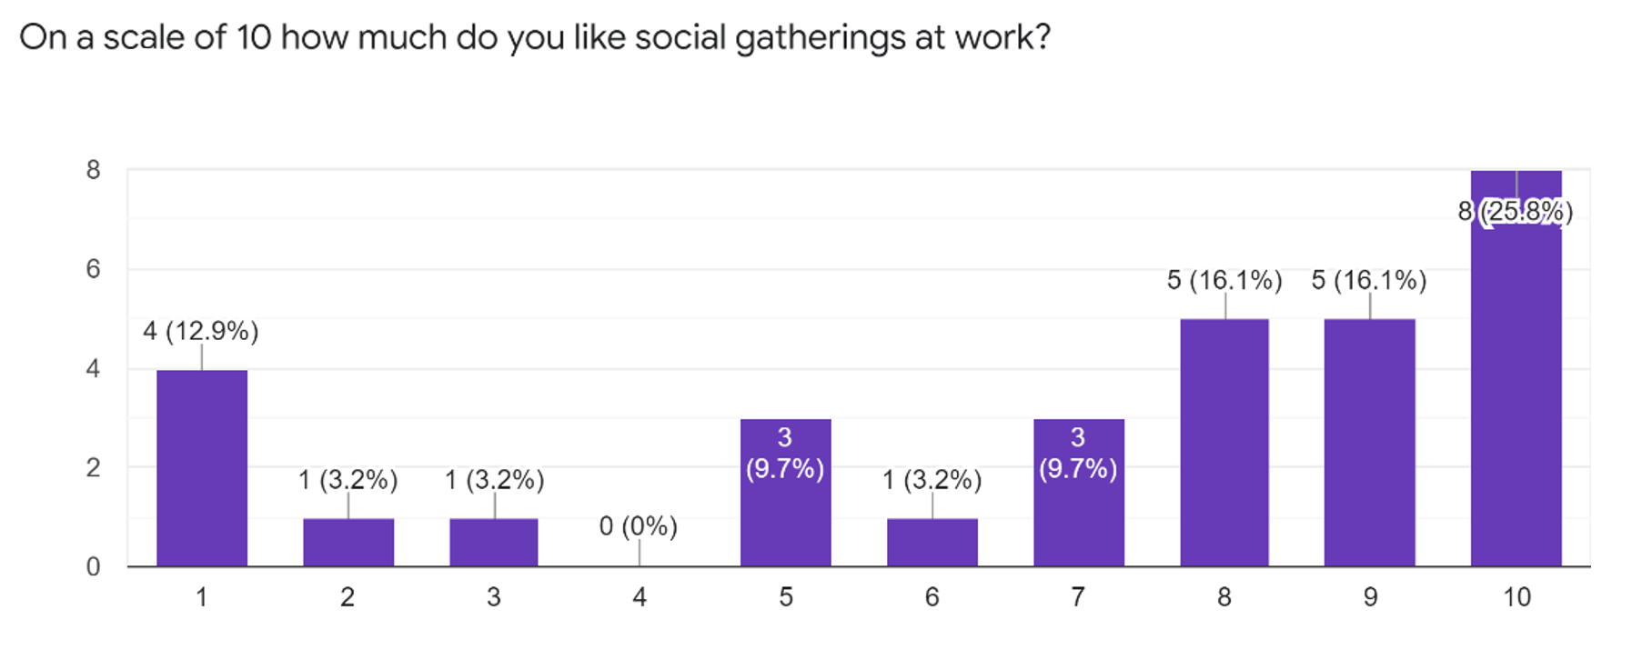
Figure 5: Level of Interest in Social Gatherings at Work
6. Frequency of Social Gatherings
Figure 6 illustrates respondents’ thoughts on the frequency of social gatherings at work. Close to half (48.4%) of the respondents indicate a monthly social gathering event is preferable. The second highest percentage (25.8%) goes to a biweekly social gathering, followed by 12.9% for a weekly social gathering. Other responses, though a small number, show that two employees want a social gathering once a year, another wants an event approximately half a year, and one expresses a focused interest in work during work hours. The sub-theme that emerges from these responses are below:
Regular and Pop-Up Events. To cater to employees who want monthly social events, some ongoing monthly events, sports or drinks, could be arranged. At the same time, there could be another regular set of biweekly events to meet the needs of the second largest group of employees. In addition, employees or organizers who are part of an employee engagement committee can coordinate pop-up events so that employees with different preferences can join if those non-regular events fit into their schedules.

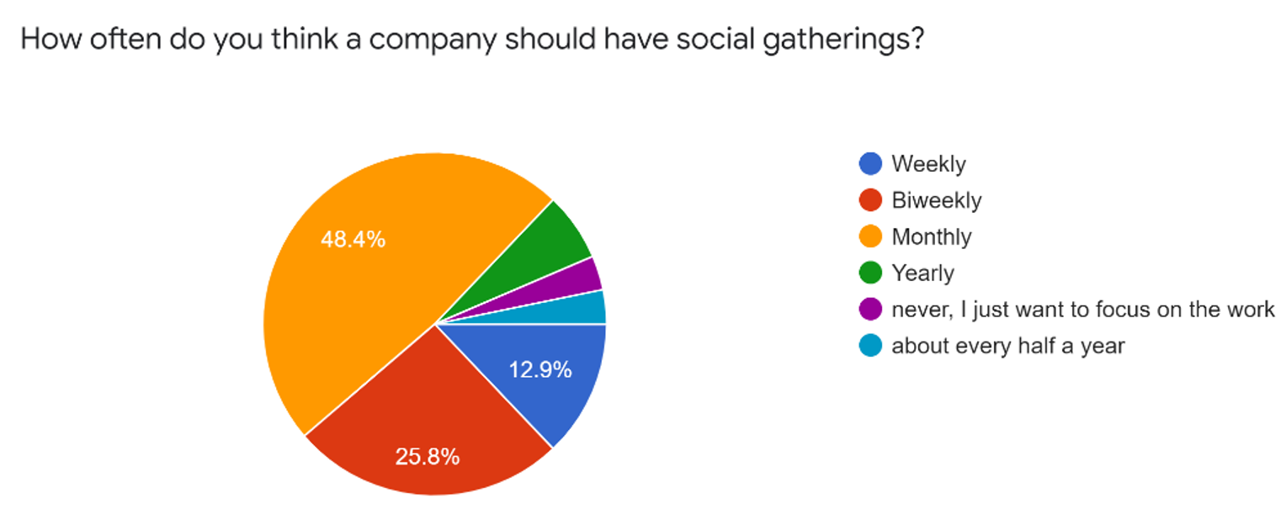
Figure 6: Frequency of Social Gatherings
B. Observations During Lunch Hours
To collect additional information on employees’ interest in social gatherings and the feasibility of employee engagement programs, I conducted an informal lunch-hour observation at the pantry between February 28, 2022 and March 11, 2022 for a total of 10 work days. I listened to coworkers’ conversations and participated if possible. Each day, there are about 3-4 employees, including myself, who are at the pantry, except for 2 days on March 3, 2022 and March 10, 2022 when there are 6 employees. On March 11, 2022, there are only 2 employees because the others work from home. These informal observations reflect three sub-themes:
Fun and Playful Workspace. The observations indicate that most employees are friendly and enjoy play at work. While most check on their phones during lunch hours, some have a chat over their lunch and go for a walk together around outdoors. This working atmosphere suggests employees do socialize to decompress and loosen up before picking up work again.
Employee-Led Initiatives. Already employees hang out after work occasionally for a drink. There have been previous attempts by some coworkers to organize social events, like after-work dinners and drinks and badminton nights. These attempts suggest that some employees will take the initiative to form a preliminary employee engagement committee and test-run several regular and non-regular social events.
Company-Funded, Employee-Paid and Free Events. Although employees do not directly express a wish for company-funded events or how much they would spend on a work social event, some employees show appreciation of company-supported events. Depending on company budget, an employee engagement committee can work to provide some amount of subsidy or incentive, like a free pizza, a free drink, small prizes, or discounted gym class, to encourage employee participation in social events.
Moreover, some free or low-cost events are available, like running, card games, walks, hikes, and movie nights, and employees can self-organize through an employee engagement committee.

C. Academic Research on Employee Engagement Programs
Scholarship on employee engagement programs highlight three sub-themes:
Employee’s Preferred Self. According to Alan M. Saks, a Professor of Human Resources Management at the University of Toronto, employee engagement strategy is linked to the concept of the “preferred self” (77) and engagement refers to the “simultaneous employment and expression of a person’s ‘preferred self’ in task behaviors that promote connections to work and to others, personal presence (physical, cognitive, and emotional), and active, full role performance” (77-78). Employee engagement programs can thus benefit employees physically, cognitive, socially, and emotionally and bring out the best of their selves for different work tasks.
Lowered Healthcare Cost and Increased Savings. In their study involving 92,486 employees at seven organizations, Goetzel et al. find that attention to and implementation of worksite wellness programs like exercises and meditation sessions can lower the cost of healthcare spending on employees and help companies increase their savings (2474).
Other Benefits. Paul Turner offers many reasons for employee engagement strategy:
- improving operational income revenue and profits
- ensuring shareholders’ returns
- adding to employees’ and organizations’ degree of creativity and innovation
- creating a workspace more committed to customer satisfaction
- retaining employees
- adjusting turnover
- controlling performance
- taking care of employees’ well-being (vii)
The various advantages shown in literature on employee engagement strategy suggest such strategically planned social gatherings can be beneficial to organizations.

III. Conclusion

A. Summary and Interpretation of Findings
Most employees can benefit from employee engagement programs personally, socially, emotionally, mentally, and physically, and most would enjoy social gatherings at work. Although some employees would like to focus on work and personal life, most employees will gain from optional, voluntary, varied, flexible, partially to fully subsidized social gatherings at Mitchell Island Terminals Ltd.

B. Recommendations
Based on the findings, this report has the following suggestions:
- Establishing an employee-led engagement committee that runs a Social Club and a Sports Club;
- Running a monthly social event, a biweekly event and other pop-up events;
- Ensuring all social gatherings at work are optional, voluntary, varied, flexible, partially to fully subsidized.

C. Works Cited
Goetzel, R. Z., et al. “Ten Modifiable Health Risk Factors Are Linked to More Than One-Fifth
of Employer-Employee Health Care Spending.” Health Affairs Web Exclusive, vol. 31, no. 11, 2012, pp. 2474–84, https://doi.org/10.1377/hlthaff.2011.0819.
Saks, A. M. “Translating Employee Engagement Research into Practice.” Organizational
Dynamics, vol. 46, no. 2, Elsevier Inc, 2017, pp. 76–86, https://doi.org/10.1016/j.orgdyn.2017.04.003.
Schaufeli, W. B., et al. “The Measurement of Engagement and Burnout: A Two Sample
Confirmatory Factor Analytic Approach.” Journal of Happiness Studies, vol. 3, no. 1, Kluwer Academic Publishers, 2002, pp. 71–92, https://doi.org/10.1023/A:1015630930326.
Soldo, S. “Definitions and Measures of Workplace Learning and Job Satisfaction in the
Context of Industry 4.0.” DIEM (Dubrovnik International Economic Meeting), vol. 6, no. 1, University of Dubrovnik, 2021, pp. 191–203, https://doi.org/10.17818/DIEM/2021/1.20.
Turner, P. Employee Engagement in Contemporary Organizations. Springer International
Publishing AG, 2019, https://doi.org/10.1007/978-3-030-36387-1.

