**Office Protocol Regarding the Periodontal Patient at Spencer Dentistry**

For

Gurbaz Sandhu DDS

Dentist/Owner of Spencer Dentistry

1240 Commissioners Rd W

London ON

N6K 1C7

By

Miranda Hoang

English 301 Student

July 14, 2021

**Table of Contents**

**Introduction**……………………………………………………………………………………...1

Description and background information…………………………………………………………1

Current problem…………………………………………………………………………………...1

Purpose and intended audience……………………………………………………………………2

Method of inquiry…………………………………………………………………………………3

Scope of inquiry…………………………………………………………………………………...3

Limitations of the study………………………………………………………………………...…3

**Collected Data/Body**……………………………………………………………………………..4

**Conclusion**………………………………………………………………………………………..9

Summary of findings………………………………………………………………………………9

Interpretation of findings………………………………………………………………………….9

Recommendations for Spencer Dentistry………………………………………………………..10

**Figures**

Figure 1: Survey response re: frequency of periodontal probing…………………………….4

Figure 2: Periodontal Probing and the importance of knowing the way …………………….4

Figure 3: Survey response re: AAP periodontal classification course……………………….5

Figure 4: Periodontitis Staging and Grading………………………………………………………….7

Office protocol regarding the Periodontal patient at Spencer Dentistry

**I. Introduction**

A. Description and Background Information

Currently there is no one size fits all approach to periodontal care. Depending on the clinician’s education, knowledge and sability the approach for diagnosis and specialist referral can vary. Knowledge of the recently updated AAP (American Academy of Periodontology) periodontal classifications is crucial as new research and information has emerged which has led to revisions. The redesigned disease classifications framework guides comprehensive treatment planning and allows for a personalized approach to care. The new guidelines highlight assessment of risk factors and systemic conditions to thus create consistency in diagnosis. Early diagnosis is paramount to reduce and stabilized periodontal disease. This can avoid surgical therapy and increase the prevalence of tooth survival. Currently there is minimal evidence regarding the frequency that a dental office should perform periodontal probing on their patients. However, collecting periodontal data to establish a diagnosis, treatment plan and implement care, is considered the “standard of care” with many regulatory bodies.(S. [Low](https://www.oralhealthgroup.com/features/effective-periodontal-charting-leads-to-effective-periodontal-care/))

B. Identify the Current Problem

Dentistry may be failing to address issues of the timely diagnosis of periodontal disease, appropriate treatment, and/or timely referral for treatment. (Park et al.) Spencer Dentistry falls withing these parameters as we lack an explicit standardized step by step approach to assessing a patient’s need for periodontal referral. The office has yet to produce a guide that can be followed to determine when it is time to refer patients. Currently clinicians are performing periodontal probing once every 36 months, and sometimes less frequent. This results in delayed diagnosis, and potential risk for tooth loss. A comprehensive full-mouth periodontal examination and charting is acknowledged as the most desirable means of evaluation and documentation, and should be carried out, whenever possible. (“*Dental Record Keeping Guidelines”)* Furthermore, there appears to be an inconsistency in the diagnosis of periodontal disease using the new AAP periodontal classifications, creating a conflicting referral process. Periodontal disease is a major chronic inflammatory disease that results in tooth loss and has a direct impact on the systemic health of dental patients.*10* The detection of periodontal disease using periodontal probing will ensure proper diagnosis, and appropriate periodontal management. Potential improvements in the procedure of periodontal charting, will increase accuracy and encourage frequency of this “standard of care” and optimize patient oral health (S. Low). Lastly, there is no existing documentation protocol established for informed consent to treatment, as well as informed refusal of referral. The client’s chart serves as a legal document of services rendered and/or recommended, and failure to have the correct documentations can place the clinic and the clinician vulnerable to speculation of negligence. Without a guideline for the treating dental hygienist to follow, Spencer Dentistry could be prolonging effective care which may lead to tooth loss. A timely and appropriate referral to a periodontal practice is an important determinant of periodontal health and is vital to the viability of the periodontal practice. A professional working relationship between GPs and periodontists should exist and function to provide an optimal long-term outcome for patients (Park et al.)

C. Identify the purpose of the report and the intended audience:

*Primary Audience*: Dr Gurbaz Sandhu, Dentist/Owner of Spencer Dentistry.

*Secondary Audience*: Dentists and Dental Hygienists employed by Spencer Dentistry.

*Relationship with Audience*: Employee, Colleague

*Purpose:* During the 2017 world workshop, a collaboration between the AAP and the EFP (European Federation of Periodontology) culminated a new classification system for diagnosing periodontal disease based on the most current evidence and includes a staging and grading system for periodontitis accounting for lifetime disease experience and considering the patient’s overall health status. (Fritz et al.) This new classification system proves to be more complicated and requires clinicians to take an education session focusing on the rational for the updated diagnosing system, as well as the changes adapted by the AAP as they relate to the diagnosis of periodontitis and gingivitis, and key strategies for utilization for the updated diagnostic system for improved patient care (“Exploring the new AAP Periodontal Disease Classification”) I propose that Spencer Dentistry develops a detailed step-by-step approach based on the abovementioned classifications for the dentists and dental hygienists to follow when presented with a patient who has periodontal disease. This will create consistency among the clinicians when it comes to the referral process. Furthermore, I propose we implement protocol for proper documentation regarding informed consent to treatment as well as refusal of treatment. This would include a guideline for the clinician to follow when creating their chart notes as well as a ‘Refusal of Referral’ form and ‘Refusal of Treatment’ form that can be signed and scanned into the patient charts.

D. Method of Inquiry:

The method of inquiry was based on a review of key research as well as a survey that was distributed to twenty dental hygienists practicing in Ontario.

*Primary Sources:*  Email survey questions to 20 hygienists practicing in Ontario to determine scope of inquiry.

*Secondary Sources:* Literature review regarding recommendations for periodontal diagnosis and referral as published by: AAP, CDHO, RCDSO, CDHA, ODA

E. Scope of the Inquiry:

In order to determine a solution to the abovementioned problem, my scope of inquiry included reviewing the guidelines being utilized by other dental offices within Ontario when it comes to the diagnosis and referral process. Also, determining if staff members within these offices have taken a course on the new AAP Periodontal classifications, and lastly what documentation practices regarding the referral process were being utilized.

F. Limitations of the Study:

The limitations of this study include possible selection bias as I personally know the hygienists completing the survey. As well as possible response bias again, because I personally know the respondents which may affect the way in which they answer.

**II. Collected Data/Body**

1. According to the survey responses, there is room for improvement within Spencer Dentistry regarding to the periodontal diagnosis and referral process. Currently our clinicians are performing periodontal probing once every 36 months or less which can potentially leave periodontal disease undiagnosed. Figure 1 shows that among survey respondents 52.63% are performing periodontal probing yearly and 31.58% are performing periodontal probing as needed which could indicate multiple measurements are taken yearly.

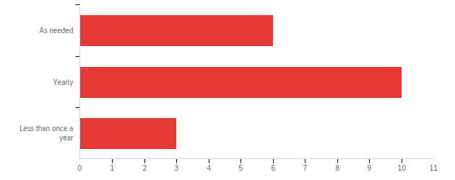

Figure 1: How often is periodontal probing completing on patients within your practice?

Calibration of clinicians performing periodontal charting can vary as to both validity and reliability. Both qualities are essential for consistency in performing an accurate examination to assist in a diagnosis. One way to assist in calibration is to ensure all clinicians are measuring periodontal pockets using the same type of probe. Figure 2 shows examples of the different types of periodontal probes that are available.

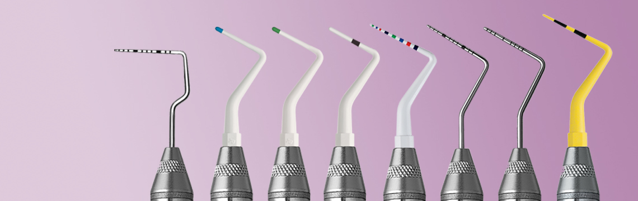

Figure 2: Periodontal Probing and the importance of knowing the way (Goldstein)

1. By incorporating the new AAP model of classification into the diagnosis of periodontitis allows for a more individualized diagnosis for each patient. This model takes into account the severity, extent, and distribution of the destruction of the periodontal tissues and the rate of progression of disease. Spencer Dentistry clinicians have not been formally trained in understanding these guidelines which can lead to misdiagnosis and a lack of calibration in the referral process. Figure 3 shows that 78.95% of survey respondents have taken a course or lesson on the new AAP periodontal classifications. The sources of education range from in office lectures, online webinars, guest speakers and professional readings. I propose we set up a continuing education day at Spencer Dentistry with guest speaker Dr Harinder Sandhu *DDS, Ph.D., Cert. Periodontist.* This will allow all clinicians to access their information from the same source to ensure calibration and allow time for questions and answers to clear up any miscommunication.

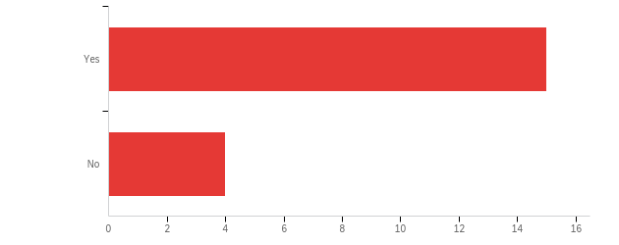

Figure 3: Have you and the staff within your practice taken a course or lesson on the new AAP Periodontal classifications?

1. Once clinicians at Spencer Dentistry have attended the continuing education day with Dr Harinder Sandhu *DDS, Ph.D., Cert. Periodontist*, we will be able to begin implementing a standardized step-by-step approach to addressing the periodontally involved patient, as well as implement a consistent referral process. Figure 4 demonstrates three steps that can help assist clinicians in the diagnosis process. The AAP released a statement to assist all members of the dental team who provide periodontal care and should be considered in its entirety (“Comprehensive Periodontal Therapy: A statement made by AAP”). A comprehensive assessment of a patient’s current health status including taking vital signs at every appointment, history of disease, and risk factors is essential to a proper diagnosis and prognosis of the dentition. Patients of Spencer Dentistry should receive a comprehensive periodontal evaluation and their risk factors should be identified on an annual basis at minimum. (“Comprehensive Periodontal Therapy: A statement made by AAP”)

**This** **protocol should include:**

1. Intra/extraoral examination
2. Measurement of probing depths, width of keratinized tissue, gingival recession, attachment level, bleeding on probing, furcation involvement, as well as detection of periodontal lesions
3. Assessment of the presence, degree and/or distribution of plaque/calculus/ and gingival inflammation
4. An occlusal examination including degree of mobility and fremitus
5. Interpretation of current and comprehensive diagnostic quality radiographs to visualize each tooth in its entirety to assess quality/quantity of bone loss patterns
6. Evaluation of systemic interrelationships
7. Determination and assessment of patient risk factors

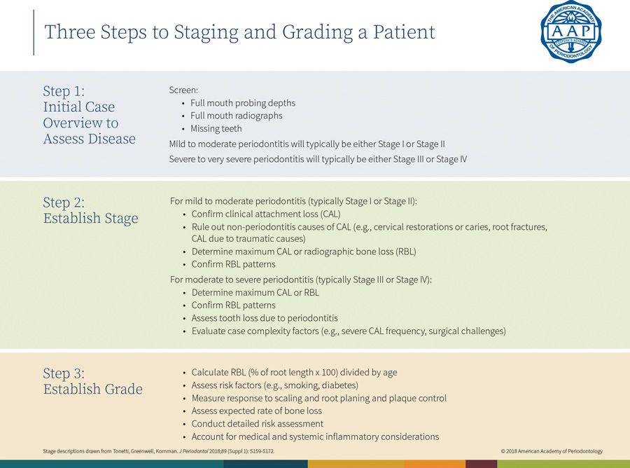

Figure 4: Periodontitis Staging and Grading (Ryerse)

1. When establishing a diagnosis, prognosis, and treatment plan clinical findings as well as assessment of risk factors should be used to develop a logical plan of treatment to alleviate the signs of periodontal disease. The treatment plan should be used to establish the appropriate periodontal therapy and may include non-surgical in office treatment of the patient or referring the patient for surgical therapy. (“Comprehensive Periodontal Therapy: A statement made by AAP”)

**The plan should include:**

1. Establishing a proper diagnosis that both the dentist and dental hygienist agree upon
2. Consideration of risk factors including, but not limited to, diabetes and smoking, which play a role in development, progression, and management of periodontal diseases.
3. Medical and dental consultation or referral for treatment when appropriately determined after following office protocol
4. Move towards surgical and non-surgical therapies as indicated
5. Provisions for ongoing reevaluations
6. Part of the proposed protocol would include implementing an office charting system that can be systematically followed to ensure proper documentation regarding informed consent and refusal of treatment. The college of dental hygienists of Ontario clarifies the importance of obtaining informed consent. Obtaining informed consent is a process that involves the meeting of minds. Informed consent rests on the principle that clients should make their own treatment decisions and the role of the practitioner is to provide all necessary information and recommendations that will enable the patient to make informed choices (“CDHO Registrants Handbook”). Informed consent should be obtained prior to the commencement of therapy. Complete records of the periodontal examination, diagnosis, treatment, and recommended follow-up and/or referral are essential and must be maintained according to law. (“Comprehensive Periodontal Therapy: A statement made by AAP”)

**Information given to the patient should include:**

1. The diagnosis, etiology and proposed therapy
2. Recommendations for treatment including referrals
3. Foreseeable risks and complications
4. Need for re-evaluation and periodontal maintenance

Once the patient has been given all the information and is able to make an informed decision, part of protocol should include ‘Consent to Treatment’ or ‘Refusal of Treatment/Referral’ forms that the patient must review and sign acknowledging they have been explained all the benefits/risks and understands the implications of their decisions.

**III. CONCLUSION**

These proposed standards of care are not static, meaning they change with new technologies, new materials, and new rules and regulations. Therefore, Dentists and dental hygienists must stay up to date with the accepted standards in their profession.

1. Summary of Findings: Studies indicate that there is a trend toward more severe periodontal disease being noted at the time of referral. Despite significant advancement in scientific knowledge of periodontal diseases the findings exhibit an increase in numbers of missing teeth, severity of bone loss and the need to extract teeth (Park et al.) A comprehensive assessment of a patient’s current health status, history of disease and risk factors is essential to the timely diagnosis and referral of the periodontally involved patient (“Comprehensive Periodontal Therapy: A statement made by AAP”). Once periodontal disease is identified, the general dentist must decide whether to treat or refer the patient. A professional working relationship between the general dentist, the hygienist and the specialists should exist and function to provide an optimal long-term outcome for patients (Park et al.)
2. Overall Interpretation of Findings Upon review of key research as well as the survey results, it is clear that a thorough comprehensive oral health examination must include a periodontal assessment as needed (once a year at least). The parameters for the periodontal examination include periodontal probing, oral health and medical health history, radiographs, and any additional components that will lead to a proper diagnosis and treatment plan. The American Academy of Periodontology suggests the following procedures should be included in a comprehensive periodontal evaluation (S. Low)

* Pocket depth
* Attachment level designation
* Furcation involvement
* Mobility
* Bleeding on probing
* Suppuration
* Recession
* Mucogingival

1. Recommendations for Spencer Dentistry

Considering the current turnover at Spencer Dentistry as we welcome the addition of new staff, some of which are newly graduated, the office would benefit from a streamlined approach to determine the need for specialist intervention. Such protocol would optimize patient care, improve treatment outcome, as well as calibrate the assessment among practitioners. Ensuring proper documentation of all recommended referrals and refusal of treatment forms as needed is a legal necessity and will protect Spencer Dentistry from possible accusations of failure to inform the patient.

1. Provide a continuing education day for all staff with Dr Harinder Sandhu, to review all necessary information regarding the new AAP Periodontal classifications
2. Create office protocol to be utilized by all dentists and hygienists that ensures a comprehensive assessment including probing is done yearly, and more frequently if needed
3. Ensure staff are calibrated when completing assessments of the patients, including utilizing the same probe when obtaining periodontal pocket readings
4. Create office protocol regarding when to refer the periodontally involved patient so there is no confusion and referrals are made in a timely manner
5. Create a systematic approach to documentation, including having the patient sign informed consent, refusal of treatment, and refusal of referral forms

**WORKS CITED**

<https://www.oralhealthgroup.com/features/effective-periodontal-charting-leads-to-effective-periodontal-care/>

<https://aap.onlinelibrary.wiley.com/doi/full/10.1902/jop.2011.100270?saml_referrer>

<https://az184419.vo.msecnd.net/rcdso/pdf/guidelines/RCDSO_Guidelines_Dental_Recordkeeping.pdf>

<https://www.oralhealthgroup.com/features/the-new-global-classification-system-for-periodontal-and-peri-implant-diseases-an-executive-summary-for-the-busy-dental-professional/>)

<https://www.cdha.ca/cdha/Education/webinars/CDHA/Education/Webinars/AAP_Perio_Webinar_Part1.aspx>

<https://www.hufriedygroup.com/blog/labor-day-road-trips-periodontal-probing>

https://aap.onlinelibrary.wiley.com/doi/full/10.1902/jop.2011.117001