**Introduction**

The criteria is to choose a jargon in our field of study and write three definitions, a parenthetical, a sentence and an expanded definition. I chose browser cookies because it shows up often when browsing the web. The purpose of this assignment is to learn different methods of explaining a complex term to people who do not have the same background.

**Situation**

My friend who is studying biology is doing some online shopping. Suddenly a window pops up and says the website uses cookies and asks him to enable cookies for a better shopping experience. He sends me a text asking what cookies are.

**Parenthetical Definition**

Youtube uses cookies (text files that stores data about your interaction with the website) to decide what videos to recommend you.

**Sentence Definition**

A cookie is text file created by a website’s server which is stored on a user’s computer and used by a website to remember user specific data.

**Expanded Definition**

History

There are several speculations of the origin of a browser cookie. One belief is cookies originated from the fairy tale Hansel and Gretel where they left cookie crumbs on their trail so they could remember their way back. This is similar to a cookie because it contains user specific details which a browser can use to remember a user.

Example

An example of how cookies are used is during online shopping. When a user adds items into their cart, a cookie is created with a unique ID that is linked to the items in the cart. When the user visits the site again, the website can retrieve the user’s information through the unique ID stored in the cookie. The site can analyze the items the user added to their cart on their previous visit and suggest them similar products. The shopping experience becomes more personalized for the user. If the user did not buy the items in the cart during their previous visit, the site could show the user the items in their cart.

Figure 1 shows an example of a cookie with a unique ID being created (number 1, 2, 3 in the visual) and retrieved (number 4, 5 in the visual).

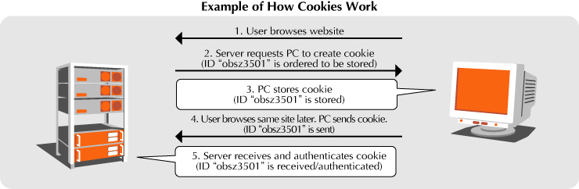

Figure 1: Example of how cookies work

Types

There are two types of cookies depending on how long they are stored on the user’s computer: session and persistent. A session cookie is destroyed when the user closes the browser, whereas a persistent cookie does not get destroyed until either the user deletes it or it is deleted automatically if there is an expiry date set when it was first created.

How It Works/Visual

Figure 2 shows browsing without cookies. Usually this occurs when the user goes to a website for the first time. When the url is entered, the website’s server will try to find cookies previously stored. If no cookies are stored, then a new cookie is created and saved on the user’s computer.

Figure 3 shows browsing with cookies. When a user enters a url, the website’s server will retrieve the cookies that are saved and customizes the site according to the information in the cookies such as preferences that were set by the user before.

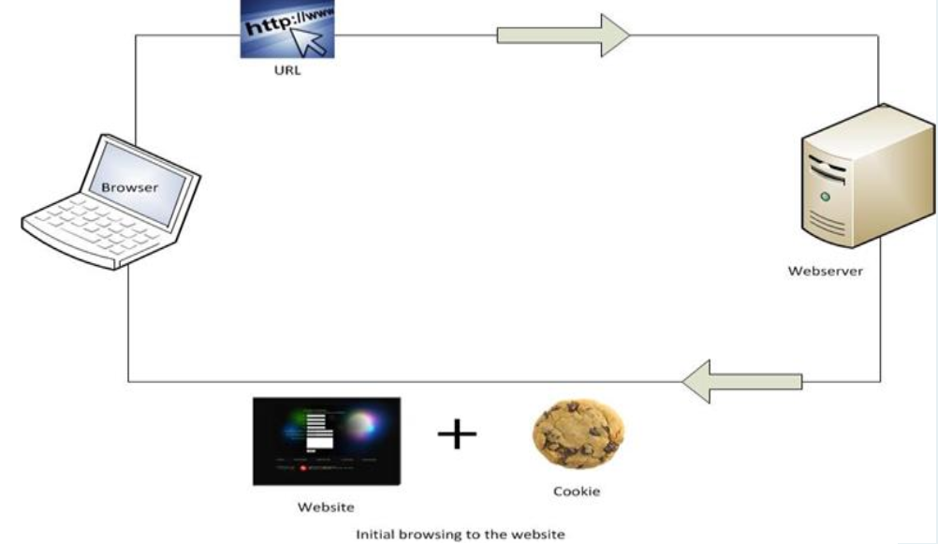

Figure 2: Browsing without cookies

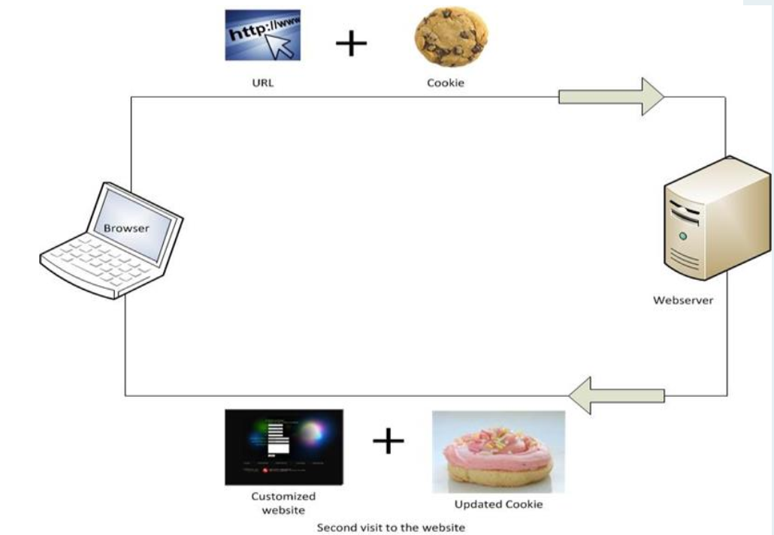

Figure 3: Browsing with cookies

**Sources**

Browser Cookies – Why are they called Cookies. (n.d.). Retrieved from <http://cookiecontroller.com/internet-cookies/browser-cookies/>

Cookie-Definition of cookie. (n.d.). Retrieved from <http://www.merriam-webster.com/dictionary/cookie>

Cookies and Web Beacons. (n.d.). Retrieved from <http://www.ntt.com/aboutus_e/hp/webbeacon.html>

Privacy and Cookies. (n.d.). Retrieved from <http://www.bbc.com/privacy/cookies/about>

Risk Associated with Cookies – InfoSec Resources. (2013, November 15). Retrieved from <http://resources.infosecinstitute.com/risk-associated-cookies/>