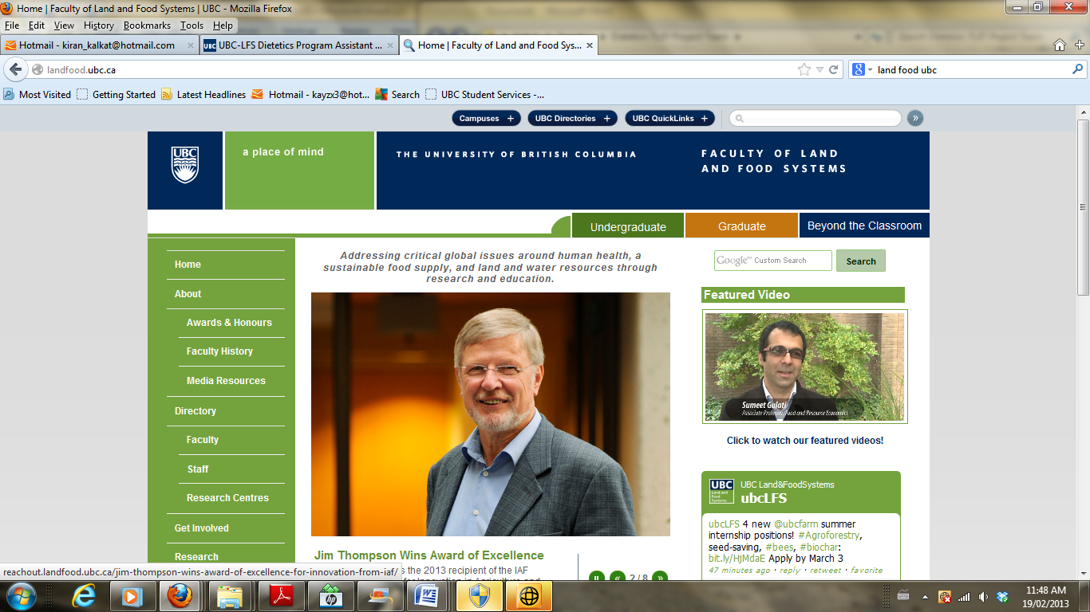

**UBC Dietetics Major**

**FNH 380 Professional Dietetic Practice I**

**Site Visit Report**

**Fall 2016**

|  |  |
| --- | --- |
| **REQUIRED INFORMATION** | **PROVIDE DETAILS BELOW  (point form is suitable; make sure writing is clear and report is edited for spelling and grammar)** |
| **Visit Details** | |
| **Report date:** | Oct. 18, 2016 |
| **Date of visit:** | Sep. 21, 2016 |
| **Length of visit:** | 2 hrs |
| **Names of student team members:** | Violet Liao, Mitra Nowroozi, Grace Tan, Ya Wen |
| **Facility name:** | Vancouver General Hospital |
| **Type of facility (acute care or residential care):** | Acute care |
| **Name and position title(s) of site host(s):** | Jennifer Yan, dietitian |
| **Summary of information Gathered** | |
| 1. **Brief facility description (number and type of patients / residents, other key features)** | * Sub-acute orthopedics Unit: 9 patients (mostly elderly patients with hip fractures) * Sub-acute Medicine Unit: 29-33 patients (reasons for admission include, for example, congestive heart failure, kidney disease, pneumonia, failure to thrive, fractures etc.) * Generally a trend of more elderly patients present |
| 1. **Summary of common types of patient/resident diets in use at this facility** | * Regular diet * Dysphagia diet   + puree   + mince   + fluid consistency adjusted, generally thickened (honey or nectar) * NPO if patients are awaiting surgery or if medical team is unsure of the problem * No added salt and fluid restriction as well, for some patients * Also modified texture diets for patients with chewing problems (e.g. dental soft or minced) |
| 1. **Who determines what diet patients/residents should be on?** | * Speech language pathologist does the swallow assessment using food such as minced sandwiches, canned fruits and fluids * In the sub-acute Medicine ward, the Occupational Therapist does the swallow assessment, unless the the patient has a neurological disorder, then the speech language pathologist will conduct the swallowing assessment. * Doctor decides whether the patient can be on a regular diet or not. * For later days, other professionals such as nurses and dietitians are able to change the diet if necessary |
| 1. **How is information about patient / resident diet type communicated to food services? What people and communication systems are used?** | * Diet fax forms are used between the dietitians and diet technicians, then the diet technicians manually enter the special requests and plan for the next meal. It is the main form of communication * Computrition is used to check diets, how much patients are consuming, and to confirm if dietitian requests are inputted correctly. Sometimes dietitians call/page to clarify notes on computrition but cannot adjust information on the system * Unit clerk can fax the tube feed that’s signed by the doctor down to the kitchen office, but sometimes, dietitians do it themselves as well to start the tube feed immediately. |
| 1. **When and where are patient/resident meals prepared?** | * 3 meals a day: Breakfast, Lunch and Dinner, with two snacks in between * Meals are prepared in the main kitchen located in the Centennial Pavilion and transported to various wards around the hospital |
| 1. **Describe patient/resident meal delivery system (e.g., centrally assembled trays or other system):** | * All meals for over 1000 patients are prepared and assembled in the main kitchen * Tray tickets are attached to each meal, indicating the patient’s name, room number, and bed number * Trays move down a conveyor belt with a ticket informing the food service workers which foods go on which trays. Each worker is responsible for one or two tasks (ex. adding servings of potatoes), similar to a production line. * Patient food service manager confirms each tray has the correct foods before it is transferred onto delivery carts. * Meals are stacked in a large cart and transported and delivered to the individual beds by food service workers. These carts are insulated, separating hot and cold foods |
| 1. **For facilities using a tray system:** |  |
| * + - **When and where are patient/resident trays assembled?** | * 2 hours before meals? * Main kitchen in the Centennial Pavilion |
| * + - **How do food service workers know what goes on each patient or resident tray?** | * They read the tray tickets as it comes down the assembly line which communicates what foods should be on each tray |
| * + - **How do trays get to patients or residents?** | * By distribution carts, delivered to patient rooms by food service workers |
| * + - **How does the food assembly and distribution system keep food hot or cold?** | * Assemble on tray lines in the kitchen * Insulated distribution carts where the top and bottom of the food is covered |
| 1. **What is the role of the foodservice administration dietitian or manager** | * Manage hospital kitchen   + Food preparation   + Equipment maintenance   + Human resources   + Create menu plan (VGH is on a 28 day cycle)   + Managing the employees that work in the kitchen   + Take in intern students and give them various tasks around the kitchen   + Hiring of staff   + Resource management and purchasing of equipment given specific budget     - Should email Anna to confirm |
| 1. **What is the role of the clinical dietitian?** | * Identify nutrition problems and assess the nutritional status of patients * Develop care plans and monitor the effectiveness of nutrition interventions * Educate patients with special diet needs * Collaborate with other healthcare providers * Provide patients with appropriate resources and nutrition counselling after discharge (e.g. connect them with the community dietitian) * Attend rounds to report on patients and learn about interventions and other health-care professionals’ perspectives (to reduce LOS (length of stay) and talk about “barriers to discharge” → goal is to go back to baseline |
| 1. **When is a patient or resident likely to see a clinical dietitian?** | * During stay if they have dietary complications (e.g. dysphagia, malnutrition, weight loss, tube feeds etc.) * Before discharge (for discharge education) |
| 1. **Other relevant information gathered** | * Care after discharge: referral to community dietitian, Health Link 811. Other resources, must take into account if they can prepare their own meals, elderly, alone, physically able to get up and go grocery shopping etc. * Different acronyms learned: - PTA: prior to admission - NKFA: no known food allergy - PRN: as needed - HS: evening - DC: discontinue - PEG: laxative - TCU at UBC: transition b/w hospital and home - NPO: nothing by mouth - DAT: diet as tolerated |